From Incurred Loss to Current Expected Credit Loss (CECL):
A Forensic Analysis of the Allowance for Loan Losses in
Unconditionally Cancelable Credit Cards Portfolios
José J. Canals-Cerdá¹
January 2019

Abstract
The Current Expected Credit Loss (CECL) framework represents a new approach for calculating the allowance for credit losses. Credit cards are the most common form of revolving consumer credit and are likely to present conceptual and modeling challenges during CECL implementation. We look back at nine years of account-level credit card data, starting with 2008, over a time period encompassing the bulk of the Great Recession as well as several years of economic recovery. We analyze the performance of the CECL framework under plausible assumptions about allocations of future payments to existing credit card loans, a key implementation element. Our analysis focuses on three major themes: defaults, balances, and credit loss. Our analysis indicates that allowances are significantly impacted by specific payment allocation assumptions as well as downturn economic conditions. We also compare projected allowances with realized credit losses and observe a significant divergence resulting from the revolving nature of credit card portfolios. We extend our analysis across segments of the portfolio with different risk profiles. Interestingly, less risky segments of the portfolio are proportionally more impacted by specific payment assumptions and downturn economic conditions. Our findings suggest that the effect of the new allowance framework on a specific credit card portfolio will depend critically on its risk profile. Thus, our findings should be interpreted qualitatively, rather than quantitatively. Finally, the goal is to gain a better understanding of the sensitivity of allowances to plausible variations in assumptions about the allocation of future payments to present credit card loans. Thus, we do not offer specific best practice guidance.

Keywords: expected credit losses, allowances, unconditionally cancellable, revolving credit, credit loss.
JEL Classification Codes: G21, G28, M41.

¹ Corresponding author: José J. Canals-Cerdá, Federal Reserve Bank of Philadelphia, Ten Independence Mall, Philadelphia, PA 19106. Phone:215-574-4127, Fax: 215-574-4146, e-mail: jose.canals-cerda@phil.frb.org. Special thanks to Onesime Epouhe and Piu Banerjee for their contributions at an early stage of this research project. The paper has benefited from comments received from Fang Du and Chris Henderson. Any errors or omissions are the author’s.

Disclaimer: This Philadelphia Fed working paper represents preliminary research that is being circulated for discussion purposes. The views expressed in these papers are solely those of the authors and do not necessarily reflect the views of the Federal Reserve Bank of Philadelphia or the Federal Reserve System. Any errors or omissions are the responsibility of the authors. No statements here should be treated as legal advice. Philadelphia Fed working papers are free to download at https://philadelphiafed.org/research-and-data/publications/working-papers.

Contents
I. Introduction 3
II. Data and Descriptive Analysis 6
Data Source 6
Data Segmentation 7
Historical Charge-Off Performance of Credit Cards 7
III. Credit Cards as Unconditionally Cancelable Accounts Under CECL 9
Treatment of Unconditionally Cancelable Accounts Under FASB ASU 2016-13 9
Methodological Challenges: Defining Life of the Loan, Default, and Exposure at Default under CECL 10
Tracking Credit Card Accounts Performance, Some Stylized Examples 13
IV. Tracking Default, Balance, Exposure at Default, and Loss 15
Tracking the Evolution of Defaults over Time and Across Cohorts 16
Tracking the Evolution of Balances over Time and Across Cohorts 19
Tracking Loan Loss and the Coverage Ratio over Time and Across Cohorts 21
V. Conclusions 23
VI. Tables and Figures 26
VII. References 39

I. Introduction

The current allowance for loan and lease losses (ALLL) under U.S. generally accepted accounting principles is an “incurred loss” accounting methodology. Under this methodology, the allowance is a valuation reserve established and maintained to cover losses that are probable and estimable as of the reserve calculation date. The methodology has been in place for about 40 years. During the 2008 global financial crisis, however, the existing reserving methodology delayed the recognition of credit losses on loans and resulted in loan loss reserves that were not adequate. Postcrisis, the Financial Accounting Standards Board (FASB) considered enhancing standards on valuation and loan loss provisioning. In June 2016, the accounting standard-setters issued an accounting standards update (ASU 2016-13) — and the Current Expected Credit Loss Framework (CECL) was born. The new accounting standard is slated to become effective in 2020 with early adoption permissible in 2019.
CECL represents an alternative framework for calculating the allowance for credit losses. Conceptually, CECL differs from the existing incurred-loss methodology in many respects. CECL is built on the notion of forward-looking estimated “expected losses.” The measurement of expected credit losses is based on relevant information about past events, including historical experience, current conditions, and reasonable and supportable forecasts that affect the collectability of loans. Also embedded in CECL is the “life of loan” concept. Institutions are expected to reserve for lifetime losses on loans at the time the loans are originated. The accounting standards update does not prescribe a specific modeling approach.
Credit cards are revolving accounts for which the user is not required to pay the entire balance at the end of the cycle. The cardholder can carry a revolving balance, which accrues interest at the end of each cycle. Credit card portfolios represent a significant contributor to the balance sheet of many large banks, with some banks specializing primarily in credit card lending. During the 2018 stress test, the Federal Reserve projected overall losses of $263 billion for the participant banks under the severely adverse scenario. Credit card losses contributed 33% to overall losses and first mortgage portfolios contributed 4.6%. The unsecured and revolving nature of credit card lending are significant factors behind the disproportionate contribution of credit card losses to overall stress losses.³
ASU 2016-13 explicitly addresses the application of CECL to unconditionally cancelable loan commitments, credit cards in particular. Specifically, ASU 2016-13 indicates that reserves on credit card portfolios need to be established over the remaining lives of the funded credit card loans (i.e., for balance on books); reserves need not be established for any additional draws on credit line over the life of a loan.
The new standard represents a significant departure from current practices under the existing standards. Implementing the “life of loan” concept underlying CECL may be a significant challenge for revolving retail products such as credit cards.
Our analysis is descriptive in nature and takes advantage of a rich data set of credit card accounts that contains relevant information on account characteristics, performance, and payment behavior. The data set was constructed from individual monthly data submissions to regulatory agencies from the largest U.S. banks with sizable credit card portfolios. The data set tracks more than nine years of credit card data, starting with the first quarter of 2008 and continuing up to the second quarter of 2017. The data set is not meant to represent a specific credit card portfolio of a particular bank or group of banks.
CECL specifies that reserves need to be stablished over the remaining lives of the funded credit card loans, which will depend critically on the stream of future monthly payments. Thus, a critical component of the analysis of allowances for unconditionally cancelable credit card accounts under CECL is the specification of payment allocation rules on the remainder of the account balance at measurement date, or month 0, for as long as the balance remains positive, or until the time of account default. Payments could be allocated for example to incurred finance costs, account balance at month 0, or debt incurred on any given month as a result of the revolving nature of credit card lending.
In this paper we analyze two payment allocation rules that could be interpreted as limit examples of payment allocation rules, with alternative payment allocation rules likely falling within these two options. The first payment rule considered allocates all future monthly payments, after finance charges, to the remainder of the initial reference month 0 balance, we call this the first-infirst-out (FIFO) allocation rule. A second payment allocation rule, which we call last-in-first-out, or LIFO, assumes that all future payments, net of finance charges and any incurred expenses, will be applied to the remainder of month 0 balance for as long as it remains positive or until the time of account default. Thus, in contrast with FIFO, in this second case we are also netting any additional incurred expenses after month 0 out of monthly payments before applying the remaining payment to the remainder of month 0 balance.
It is not our objective to highlight any specific payment allocation proposals currently being discussed among interested parties. Also, given the principle based nature of the CECL framework it is also not our objective to offer specific best practice guidance. Instead, we believe that there is value in conducting an analysis of the impact of explicit and transparent payment allocation rules looking back at historical data across relevant risk segments of a portfolio, which is our primary objective. Thus, our analysis should not be regarded as endorsement of any specific payment allocation rule.
Our analysis relies on the construction of a synthetic portfolio of credit card accounts. The primary data in our analysis consists on monthly submissions of detailed account level credit card data from large banks collected by regulatory agencies. We analyze the performance of allowances at the overall aggregated portfolio level as well as across segments of the portfolio properly differentiated by their level of credit risk. We analyze the behavior of different measures of allowances across cohorts starting with the first quarter of 2008 and going up to the second quarter of 2017. We track the performance of each account in our sample for at least five years (and up to nine years) from each reference month, or up to the time of account’s closure or default. Our period of analysis encompasses a variety of economic conditions, including the bulk of the Great Recession and the subsequent recovery.
We focus our analysis, both at the portfolio level and across risk segments, on three major themes: defaults, balances, and credit loss. The specification of a payment allocation rule under CECL plays a significant role in the definition of loan default. In general, risk profile is the primary determinant of default at the segment level, but the impact of the specific payment allocation rule considered is also significant. The divergence in cumulative default curves across payment allocation rules considered is relatively small over the initial projection months and increases significantly after that. Differences across payment allocation rules are, proportionally, more pronounced for less risky segments. Thus, a portfolio’s risk composition is likely to play a significant role on the final CECL impact of any specific payment allocation rule. Across payment allocation rules, projected default rates increased significantly during the downturn and then experienced a significant decrease as economic conditions improved.
We also observe significant differences in the evolution of the remainder of month 0 balances across payment allocation rules and in relation to the evolution of account balances. The observed differences in the evolution of balances across different payment allocation rules have important implications for the evolution of loan default and loan loss at default.
Projected allowances are significantly higher during the period of the economic downturn. Perhaps contrary to intuition, our analysis suggests that low-risk segments, and portfolios, are proportionally likely to be most sensitive to specific assumptions about payment allocation rules, and differences across payment allocation rules increase during the downturn. These findings also suggest that portfolios with different levels of credit risk are likely to experience dissimilar impacts. Thus, our findings should be interpreted from a qualitative, rather than quantitative, perspective. Last, we highlight how projected allowances differ significantly from realized credit loss. This is primarily due to the focus of CECL on the concept of credit card loan at observation time, which contrasts with the revolving nature of credit card lending.
In the next section, we present the data and conduct a descriptive statistical analysis. In
Section III, we analyze in detail the treatment of unconditionally cancelable accounts under FASB ASU 2016-13. In Section IV, we present relevant empirical findings. In Section V, we present conclusions. Tables and figures are presented in a separate section at the end of the paper.

II. Data and Descriptive Analysis

Data Source

Our analysis employs a sample of credit card accounts from a data set that combines credit card portfolios from some of the largest U.S. banks with significant credit card exposures. The original data comprise monthly account characteristics and performance information from the first quarter of 2008 and up to the second quarter of 2017, or up to the time the account is closed or charged off. The data contain more than 100 variables that provide monthly observations of the credit card characteristics; credit attributes of the card holders such as credit score, payment, and usage behavior; and delinquency status for each individual account.
The data were primarily collected with the objective of conducting supervisory work, including the annual stress test exercise. Because of the confidentiality of the data, all the information provided in this paper is reported at a highly aggregated level. Our sample is neither meant to be representative of the overall credit card lending market nor representative of the credit card portfolio of any particular bank or group of banks. However, our analysis is meant to offer helpful qualitative insights about the loss performance of credit card portfolios across risk segments under different economic conditions.

Data Segmentation

Our analysis is primarily descriptive and conducted at the segment level for a group of segments derived from account-level information on credit score, historical payment, and usage behavior as well as delinquency status.
Table 1 describes the segmentation variables considered and the different segments generated by combining these variables. Specifically, we consider nine different segments of accounts: dormant accounts, transactor accounts with zero balance, transactor accounts with positive balance, three segments of revolver accounts by risk score ranges, and three segments of delinquent accounts by severity of delinquency. From our interpretation of ASU 2016-13, dormant accounts and transactor accounts with a 0 balance at observation time will not require an allowance. Thus, our primary focus will be on these seven segments that will require an allowance under CECL.
Table 2 provides a very preliminary view of the risk across the different segments considered by reporting average sample default rates over different time horizons. The table reports significant differences in risk profile across segments even in our simple segmentation framework. Dormant and transactor accounts exhibit very low default risk even over a five-year time horizon. In contrast, revolver accounts are significantly more risky, and we can further differentiate risk by combining revolver status with credit scores. Not surprisingly, delinquent accounts have the highest risk of default. In future sections, we provide additional analysis of risk across segments.

Historical Charge-Off Performance of Credit Cards

Figure 1 provides additional intuition about the level of risk embedded in the credit card portfolios. The figure provides strong evidence of the relationship between credit card charge-off rates and economic conditions. Furthermore, the severity and duration of elevated charge-off rates seems to track well the severity and duration of recessions and increases in unemployment rate.
Figure 2 presents median recovery rates across banks and over the time period of our analysis. Recovery rates measure the percentage of gross charge-off that is recovered. The figure also includes median 12- and 24-month net charge-off rates for the same group of banks defined as the sum of 12 months and 24 months net charge offs as a percentage of portfolio balance. The net charge-off rates presented in this figure are broadly consistent with these presented in Figure 1, which are representative of a larger sample of banks. The figure also indicates that recovery rates, as a percentage of charge-offs, were at their lowest point around the same time as charge-off rates were at their highest.
Figures 1 and 2 highlight the significant increase in net charge-offs over the economic downturn, as a result of an increase gross charge-offs and a decrease in recovery rates. Thus, a focus on the dynamics of gross charge-offs primarily will not provide a sufficiently stressed view of the impact of economic downturns on net portfolio loss. On the other hand, an analysis of net charge-offs requires potentially judgmental assumptions about the timing and allocation of recoveries from defaulted accounts, which are not usually tracked at the account level in credit card portfolios.
With the wisdom of hindsight, Figure 3 provides a window into the performance of the existing allowance framework during the recent financial crisis. These results are derived from bank-specific information that we don’t report for confidentiality reasons. The figure displays median portfolio allowances and 12-month cumulative charge-offs, as a percentage of assets, as well as the median coverage rate defined as the number of months of forward-looking net chargeoff losses that can be sustained by contemporaneous allowance levels.
The 12-month forward-looking, cumulative median charge-off rate picked around 2009 in our portfolio and remained elevated well into 2011. The allowance rate increased significantly from 2008 to 2010 and decreased after that in conjunction with a significant, and continued, decrease in charge-off rates that began around 2010. Thus, the pick in allowances lagged behind the pick in forward-looking cumulative charge-off rates by about a year, or longer. The median coverage rate was significantly below average in 2008, experienced a steep and continued increase between 2008 and 2010, and extended its increase into 2011, after which it began a continued decline, stabilizing at around the nine to 11 months median coverage rate range. The behavior displayed by the allowance rate and coverage rate in Figure 3 is in line with the common view that the “incurred loss” accounting methodology, employed by bank holding companies over the past 40 years, delayed the recognition of credit losses during the 2008 global financial crisis and resulted in loan loss reserves that were not adequate for the level of stress during the downturn.

III. Credit Cards as Unconditionally Cancelable Accounts Under CECL

The special treatment of credit card portfolios under ASU 2016-13 requires us to revisit the traditional framework of analysis of expected loss and credit risk in revolving accounts. The ASU 2016-13 update describes unconditionally cancelable accounts as those in which the unfunded portion of a line of credit may be unconditionally canceled at any time. In most cases, credit card accounts will fall into this category.
It is standard industry practice to analyze expected credit card loss as a function of three components: the probability of default, the exposure at default, and the loss given default, with expected loss defined as the product of these three factors. For revolving accounts in particular, the analysis of these components is often conducted at the account level and is not constrained by the amount of the debt carried in the account at a particular point of observation, although the account balance at observation time is usually regarded as an important driver of default and future expected loss in the case of default. Generally, the expectation is that a borrower at risk of default is likely to increase her level of borrowing prior to default. Thus, the standard quantitative analysis of exposure at default is not bounded by the account balance at observation time.
In this section, we look closely at the treatment of credit card accounts under ASU 2016-13. First, we review the concept of an unconditionally cancelable account under CECL; second, we consider conceptual and methodological challenges brought about by this framework like life of loan or the concept of default and exposure at default under CECL; and finally, we consider the implications of different assumptions about the treatment of future payments and illustrate these concepts with highly stylized numerical examples.

Treatment of Unconditionally Cancelable Accounts Under FASB ASU 2016-13

For unconditionally cancelable accounts, ASU 2016-13 stipulates that banks would “estimate the expected credit losses over the remaining lives of the funded credit card loans.” It also specifies that “even though Bank M has had a past practice of extending credit on credit cards before it has detected a borrower’s default event, it does not have a present contractual obligation to extend credit.” Based on that reasoning, it also indicates that “an allowance for unfunded commitments should not be established because credit risk on commitments that are unconditionally cancellable by the issuer are not considered to be a liability.”
The FASB statements referred to in the previous paragraph have significant implications for the analysis of allowances. For starters, they specify that there should not be an allowance for unfunded commitments.
Typical credit card segments of accounts that entirely fall in this category of unfunded commitments are dormant accounts (i.e., accounts with no balance and no financial activity), and transactor accounts that don’t carry a balance in a particular month. Thus, dormant accounts and transactor accounts that don’t carry a balance in a particular month will not necessitate an allowance under CECL. These segments of accounts represent a large percentage of accounts in the typical cards portfolio.
Similarly, unfunded commitments of credit card accounts with positive utilization are also not considered a liability under CECL. Thus, an account’s exposure at default under the CECL framework will not be larger than its present funded commitment. This represents a key distinction with respect to traditional risk quantification frameworks, such as the Basel advanced approaches framework, typical stress-testing frameworks, and similar standard approaches for quantifying credit risk. Generally, the expectation is that a borrower at risk of default will likely continue to draw from an available line of credit prior to default and risk models are designed to account for this empirical regularity.

Methodological Challenges: Defining Life of the Loan, Default, and Exposure at Default under CECL

A recently publicly circulated FASB memo offers additional information about the analysis of allowances for unconditionally cancelable accounts under CECL. The memo didn’t reach any firm conclusion, but it provided a window into the conceptual and methodological challenges firms may face in the process of implementing CECL and perspectives into the type of preliminary analysis being conducted by stakeholders in this area. The memo focuses specifically on the estimation of the life of a credit card receivable. The memo points out “estimating the remaining life of a credit card receivable balance is dependent on estimating the amount and timing of the payments expected to be collected on it.” In contrast with closed-end loans, estimating the life of a credit card receivable balance “is significantly more complex because in addition to future expected payments there also will be new borrowing activity over the remaining life of the measurement date balance.”
It is not our objective to analyze specific proposals currently being discussed in the industry. Instead, we believe there is value in conducting an analysis of the impact of different plausible payment allocation rules looking back at historical data at different points in time and across risk segments of a portfolio.
In our data, we observe a rich set of account characteristics and historical account performance. We also observe monthly account balances, payments, and overall finance charges at the account level. With this information in hand, we can analyze how different types of plausible assumptions about allocations of the future stream of payments impact the forecast of balance, life of the loan, the risk of loan default, and loss at the time of loan default, and ultimately, how they impact current expected credit loss on the funded credit card loans at the portfolio, or segment, level. Specifically, in the next paragraphs, we analyze two possible stylized ways of accounting for future payments, or payment rules. In our view, these two payment allocation rules could be interpreted as limit examples of payment allocation rules, with alternative plausible payment allocation rules likely falling within these two options.
A first approach, which we call first-in-first-out, or FIFO, assumes that all future payments, net of finance charges, will be applied to the remainder of the balance existing at the measurement date, or month 0, for as long as the balance remains positive or until the time of account default. The minimum number of months until the remainder of month 0 balance equals zero or default occurs will represent the life of the loan in this case.
A second approach, which we call last-in-first-out, or LIFO, assumes that all future payments, net of finance charges and any incurred expenses, will be applied to the remainder of month 0 balance for as long as it remains positive or until the time of account default. The minimum number of months until one of these events occur will represent the life of the loan in this case. Under LIFO, a payment to the remainder of the balance will not occur before all incurred finance charges and incurred expenses have been paid off. Thus, the remainder of month 0 balance will be reduced in a future month only if the actual monthly revolving balance falls below the rolling remainder of month 0 balance (i.e., the last incurred finance charges and incurred expenses will be paid off first). Thus, at any future time t, the remainder balance will be the minimum of the remainder of month 0 balance and the stream of revolving monthly balances up to that point. In the next paragraphs we provide additional detail about FIFO and LIFO and in the next subsection we analyze some examples, including actual examples of account behavior observed in our data as well as stylized numerical examples.
The main difference between FIFO and LIFO is that, in the case of LIFO in addition to finance charges registered at the time of the monthly payment, we also deduct from monthly payments any incurred expenses registered at the time the payment is due, before subtracting the residual payment from the remainder of the balance at month 0.
The FIFO and LIFO concepts can be expressed analytically after introducing some necessary notation. Denote by 𝐵𝐵₀ the account’s balance existing at month 0 and more generally denote by 𝐵𝐵_{𝑡𝑡} the account’s balance existing at month t; denote the payment in month t, net of finance charges, as 𝑝𝑝_{𝑡𝑡} and denote the remainder of month 0 balance t months into the future as 𝑅𝑅𝐵𝐵₀(𝑡𝑡).
Under the FIFO assumption, the remainder of month 0 balance at time t = 1 can be computed as,
𝑅𝑅𝐵𝐵₀(𝑡𝑡 = 1) = 𝑚𝑚𝑚𝑚𝑚𝑚(𝐵𝐵₀ −𝑝𝑝₁, 0),
and the remainder of month 0 balance at any future time t+1 can be computed as,
𝑅𝑅𝐵𝐵₀(𝑡𝑡 + 1) = 𝑚𝑚𝑚𝑚𝑚𝑚(𝑅𝑅𝐵𝐵₀(𝑡𝑡) −𝑝𝑝_{𝑡𝑡+1}, 0).
Under the LIFO assumption, the remainder of month 0 balance at time t = 1 can be computed as,
𝑅𝑅𝐵𝐵₀(𝑡𝑡 = 1) = 𝑚𝑚𝑚𝑚𝑚𝑚(𝐵𝐵₀, 𝐵𝐵₁),
with 𝐵𝐵₁ representing the account’s balance one month after the reference month 0. Similarly, the remainder of month 0 balance at month t +1 after the reference month 0 can be computed as,
𝑅𝑅𝐵𝐵₀(𝑡𝑡 + 1) = 𝑚𝑚𝑚𝑚𝑚𝑚(𝑅𝑅𝐵𝐵₀(𝑡𝑡), 𝐵𝐵_{𝑡𝑡+1}),
with 𝐵𝐵_{𝑡𝑡} representing the account’s balance t months after the reference month 0.
Observe that under LIFO, the remainder of month 0 balance at month t+1 equals the minimum balance attained by the account during the period [0,t+1], i.e., the remainder of month 0 balance will equal the revolving balance in a particular month when the revolving balance falls below the remainder of month 0 balance until that point. The remainder of the month 0 balance will be equal to 0 when the revolving balance in a particular month becomes 0 for the first time, at which point it is assumed that the loan will have been repaid.
Under both concepts, the remainder of month 0 balance will be fully paid at month 𝑙𝑙 when the remainder of month 0 balance reaches a value of zero balance,
𝑅𝑅𝐵𝐵₀(𝑙𝑙) = 0 < 𝑅𝑅𝐵𝐵₀(𝑙𝑙 − 1),
with 𝑙𝑙 representing the life of the credit card loan in this case.
A credit card account is at risk of default as long as it remains open, but a loan incurred in month 0 is at risk of default only while it is being repaid (i.e., during the length of the life of the loan).
If an account defaults at time t before the remaining balance reaches value 0, i.e. before the end of the life of the loan, then we consider that the loan is in default in an amount equal to the remainder of month 0 balance, i.e. 𝑅𝑅𝐵𝐵₀(𝑡𝑡).

Tracking Credit Card Accounts Performance, Some Stylized Examples
Table 3 presents three stylized examples that illustrate the concepts described previously. For simplicity, we don’t explicitly consider finance charges. The first example presents the case of a credit card loan in which the account receives monthly payments and there are no additional charges after month 0. In this case, the FIFO and LIFO concepts produce exactly the same outcomes. This is generally the case when the account incurs no additional charges after month 0.
In our second example, the account incurs new monthly charges and receives monthly payments that are not large enough to compensate for monthly charges (i.e., the account balance continues to grow after month 0). In this case, the LIFO life of the loan will go beyond the 12 months that are being tracked in this table and the LIFO remainder balance will stay constant over the entire tracking period. In contrast, the FIFO life of the loan will be equal to 10 months and the path of the remainder balance will be remarkably different from the LIFO case.
In the last example, the account charges and payments over the next 12 months will generate different paths for the remainder of the balance and the life of loan under LIFO and FIFO. But in both cases, the remainder balance will be 0 before the end of the tracking period, while the actual account balance will drop to 0 at month 7 but will end up growing significantly by the end of the tracking period.
Each of the previous three considers the case in which the account does not default over the period of analysis. If instead we assume that the account defaults in month 6, for example, then the FIFO remainder loan exposure at default will be equal to 40, 40 and 0, for examples 1 to 3, in the case of FIFO, i.e. no loan default in the last case. While the remainder loan exposure at default will be equal to 40, 100 and 40, for examples 1 to 3, under LIFO.
In Figure 4, we track the evolution of a few selected accounts in our data starting at a fixed initial date, or month 0, and with reported amounts normalized with respect to the account’s balance at that initial date. We track balances and payments as well as three different measures of remainder balances after month 0. The selected examples provide insights about the impact of different payment allocation rules.
In Figure 4.a, the different payment allocation rules considered result in an almost identical path across the remainder of month 0 balances, until month 24, at which point the remainder of the month 0 balance is completely paid off. Thus, the life of the loan is 24 months in this case under both FIFO and LIFO. After month 25, the tracked revolving account balance increases because of an increase in monthly borrowing with respect to monthly payments. In Figure 4.b, we observe a divergence between the two measures of the remainder of the month 0 balance. Under FIFO, the life of the loan is 15 months, while under LIFO, the life of the loan is 32 months. Between months 15 and 32, the remainder of the month 0 balance exposed under LIFO is about 40% of the balance at time 0. Figure 4.c depicts an account for which balances increase significantly after month 0, while monthly payments are comparatively low. In this instance, under FIFO, the life of the loan is equal to 25 months, while under LIFO, the remainder of month 0 balance remains constant at 100% of the initial balance at month 0 over the tracked 37-month period.
Figures 4.d to 4.f represent examples of accounts for which the final outcome prior to month 37 was account default, but not in all cases did this account default result in loan default. In all three cases, the final default balance was significantly larger than the initial balance at month 0, something that is not atypical when a credit card defaults. The main difference among these three examples is in the remainder of month 0 balance at the time of the account default. In example 4.f, the remainder of month 0 balance becomes 0 at month 5, while the account does not default until month 33, i.e., this case will not be categorized as a loan default even though the account eventually ends up defaulting. In the case of Figure 4.e, the remainder of month 0 balance will be positive at the time of account default, under both payment allocation rules considered (i.e., we will record a loan default in this case). In this case, the loan exposure at default will be close to 100% of balance in the case of LIFO while it will be close to 30% of balance under FIFO. In Figure 4.d, the remainder of the month 0 balance at the time of account default will be positive under LIFO, while it will be 0 under FIFO. In this case, we will be recording a loan default under LIFO and recording a loan paid off under FIFO. In all cases considered in which the final outcome is account default over the tracking period, the remainder balance at default under FIFO and LIFO is either zero or significantly lower than the observed account balance at default.

IV. Tracking Default, Balance, Exposure at Default, and Loss

A key aspect of the CECL implementation for credit cards is the allocation of future payments to the remainder balances after month 0. The adoption of a specific payment allocation rule will determine the life of the loan at the account level, the evolution of remainder balances after month 0, and the default and loss experienced after month 0 for CECL purposes. More important, the specific payment allocation rule implemented will determine, along with the historical experience, the projection of portfolio allowances under CECL for any specified economic forecast.
In the next paragraphs, we analyze, at the portfolio level and for specific segments, the evolution of default, balances, and loss, from an initial predetermined starting point in time or “month 0.” The FIFO and LIFO payment allocation rules defined in the previous section will be applied at the account level and, after aggregation at the portfolio or segment of accounts, will determine default rates, balance rates, and loss rates that can be projected forward from a predetermined starting point in time, or month 0.
The portfolio employed in our analysis was not constructed to be representative of the overall credit card industry. Even an industry representative portfolio cannot be expected to provide precise guidance on the impact of CECL at any specific institution given the heterogeneity of portfolios and strategies prevalent across credit card lenders. Thus, instead of focusing on a specific representative portfolio, we present descriptive information across the characteristic risk segments defined in Table 1. Our analysis of segments of revolver accounts with different levels of risk as well as our analysis of segments of delinquent accounts by severity will provide relevant insights on the performance of credit card portfolios with different risk distributions.
We focus our attention on a few selected segments by risk profile; considering all segments would overcomplicate our exposition. Pure dormant and transactors with a 0 balance don’t require an allowance under CECL because they don’t carry a balance as of month 0. Furthermore, transactor accounts with a positive balance have a very low probability of default over the short and medium term, as evident in Table 2, and will carry a small allowance irrespective of the payment rule that emerges as common industry practice, and should be generally marginally sensitive to the choice of payment allocation rule. Thus, we focus our attention primarily on the revolver and delinquent segments. For revolvers, we focus on the low-risk and high-risk segments, with the elevated risk segment in our experience behaving in an intermediate way between these other two segments considered. For the delinquent case, using our own judgment, we will present at times results aggregated for the overall delinquency segment, and at other times, we will present separate results for low-delinquency, elevated-delinquency, and high-delinquency segments.

Tracking the Evolution of Defaults over Time and Across Cohorts

This subsection documents the differences between cumulative default curves across payment allocation rules and with respect to traditional cumulative default curves at the account level. A credit card account is at risk of default as long as it remains open, but a credit card loan at reference month 0 is at risk of default only while it is being repaid (i.e., during the life of the loan). Differences in cumulative default curves across payment allocation rules are driven by differences in the life of the loan associated with differences in the evolution of the remainder of month 0 balances, as illustrated in the previous section. For the same reason, we can anticipate differences in the evolution of balances and losses across payment allocation rules, these will be discussed in the subsequent subsections.
Figure 5 presents Kaplan-Meier (K-M) cumulative default curves derived from the implementation of the FIFO and LIFO payment allocation rules (i.e., tracking loan defaults), along with the more traditional cumulative default curves at the account level. The Kaplan-Meier estimator represents a standard nonparametric technique for estimating the probability of survival, or in our case the cumulative default probability, across time for a time-related event, like default. We present results at the portfolio level and for three different segments: the low- and high-risk revolver segments and the segment of delinquent accounts. We present results aggregated across cohorts because the patterns observed in the data are similar for different cohorts, but with the expected variations in severity among the cohorts more directly impacted by the downturn.
Figure 5.a presents results at the portfolio level. The figure reveals three main patterns in the data. First, the choice of payment allocation rule plays a significant role in the definition of default. We observe a substantial divergence between the FIFO and LIFO K-M cumulative default curves, with a significant divergence starting around month 20. Second, perhaps not surprisingly, the divergence in cumulative default curves is relatively small over the initial 10 months and intensifies after that. The FIFO K-M curve is the first one to reach a plateau around month 40, while the LIFO curve seems to reach a plateau around month 80. There is no apparent plateau in the default curve at the account level, although the slope of the curve decreases over time. Third, there is clear divergence between the cumulative default curve at the account level and any of the cumulative loan default curves considered. This is consistent with our intuition since the life of the account is expected to exceed the life of the loan in most cases.
Figure 5.b provides additional insights about the evolution of defaults. The figure presents cumulative default curves for three segments of accounts: the low-risk revolver segment, the highrisk revolver segment, and the delinquent segment. There is a clear differentiation in cumulative default curves across segments, which indicates that risk profile is an important determinant of default and outweighs the importance of the payment allocation rule, at least for the highly differentiated risk segments considered.
As expected, the more risky segments are associated with steeper cumulative default curves. For the delinquent segment most of the defaults occur within the first 10 months and there are no significant differences across payment allocation rules over this time frame. Significant differences across payment allocation rules in the delinquent segment emerge after 30 months, but even then, these differences are proportionally small when compared with other segments. The high-risk revolver segment follows a similar pattern, but the cumulative default curves are comparatively less steep and the bulk of defaults are not realized until the 40th month. In this case, there is no apparent plateau in the cumulative default curves for the account and LIFO curves, while a plateau occurs for the FIFO curve around 40 months. Finally, the low-risk revolver segment follows a similar pattern; however, most defaults occur by the 30th month for the FIFO curve, while defaults continue to increase after that for the LIFO and account curves.
The insights gained from our analysis of Figure 5.b also contribute to a better understanding of the portfolio-level dynamics observed in Figure 5.a. Delinquent accounts, as well as accounts in high-risk segments contribute a high proportion of defaults during the first 20 months, adding to a steeper portfolio default curve initially. The less risky segments of accounts increase their contribution to overall portfolio defaults after the initial months, contributing to a softening in the slope of the default curve.
Perhaps the most relevant finding from Figure 5.b is the observation that differences across payment allocation rules are, proportionally, more pronounced for less risky segments. They have comparatively a lower impact for the high-risk segments, with the lowest impact associated with the segment of delinquent accounts. In particular, for the low-risk segment, at month 80, the value of the LIFO curve is about 50% higher than that of the FIFO curve, and the value of the account default curve is about 100% higher. The differences are proportionally less pronounced for higherrisk segments.
Finally, our findings from Figure 5.b also have important implications for the analysis of the potential impact of CECL across portfolios with different risk profiles. Specifically, they suggest that differences in payment allocation rules can have significant impact on the overall cumulative default curves under CECL. Furthermore, the impact will be dissimilar across segments with different risk profiles and may be proportionally largest in lower-risk profile segments. Thus, a portfolio’s risk composition is likely to play a significant role on the final CECL impact of any specific payment allocation rules.
Figure 6 considers the evolution of default rates over a time frame with a mix of economic conditions. The figure tracks five-year cumulative default rates across different cohorts. Specifically, we define the initial reference “month 0” to take values at each quarter between the first quarter of 2008 and the first quarter of 2012; after the initial reference month is fixed, we analyze each cohort’s default rate over a five-year window and report that five-year default rate in the graph for each quarterly cohort. From Table 5, we already know that most defaults will occur within the initial 60-month window, so our focus on the five-year default rate does not represent a significant restriction.
In principle, when computing default rates over a five-year period, we would consider it reasonable to expect a certain level of default averaging across a five-year window with a mixture of economic conditions. On the other hand, under the treatment of credit cards as unconditionally cancelable accounts, the bulk of defaults realized under CECL are likely to occur within the first two years after month 0, as Figure 5 indicates. Furthermore, for credit cards, the difference between the charge-off in good times versus the charge-off in a downturn can be very significant, as Figure 1 indicates.
Figure 6 shows that, with the perfect foresight assumption implicit in our analysis, our longterm measure of default rate experienced an increase in severity across cohorts between the first quarter of 2008, the first observation period, and the second quarter of 2009, with default rates elevated during the overall downturn period, and then experiencing a significant decline as economic conditions improved. Looking at Figures 6.b to 6.e, we also observe differences in performance across segments. The more risky segments are more severely impacted by downturns in absolute value, but it is worthwhile to point out also that the more risky segments are also proportionally (i.e. in terms of percentage change) less affected by economic fluctuations. Specifically for FIFO, we observe fluctuations in default rate from bad to good times between 0.06 and 0.03 in the low-risk segment (i.e. a 100% increase), between 0.28 and 0.16 in the high-risk segment (i.e. a 75% increase), and between 0.58 and 0.4 in the delinquent segment (i.e. a 45% increase).
Default constitutes the critical trigger of credit risk, but another significant contributor to credit risk is loan exposure at default, particularly for the case of revolving accounts. The next subsection looks at the evolution of the remainder of the month 0 balance at the portfolio level, across segments, and under different payment allocation rules. In the final subsection, we combine the concept of default and the remainder loan exposure at default after month 0 and look closely at the concept of portfolio credit loss.

Tracking the Evolution of Balances over Time and Across Cohorts

Figures 7 and 8 look at the evolution of portfolio balances across cohorts, across segments, at the account level and for different payment allocation rules. Figure 7.a depicts the evolution of balances across cohorts at the portfolio level and for the segments of transactor, revolver, and delinquent accounts. Perhaps not surprisingly, revolver accounts consistently carry the largest balances, and transactor accounts (excluding these with a 0 balance), the smallest. Some readers may find it surprising that balances for delinquent accounts are generally lower than those of revolver accounts. This may be the result of the specific composition of our portfolio. More likely, accounts that become delinquent are primarily associated with lower credit scores and lower credit lines, and thus have limited ability to borrow. Finally, we also observe that balances associated with delinquent accounts seem to be more sensitive to fluctuations in economic conditions. One possible explanation of this phenomenon is that worse macroeconomic conditions increase the proportion of delinquent accounts with higher initial credit score, higher credit limits, and higher ability to borrow. Further study of these issues is warranted but is beyond the scope of our analysis.
Figure 7.b draws the evolution of account balance and the remainder of the month 0 loan balance for different payment allocation rules. We observe significant differences between the evolution of account balances and the evolution of the remainder of month 0 loan balance under different payment allocation rules. Specifically, 40 months after month 0, only about 10% of the original balance at month 0 remains under FIFO, while about 20% of the balance remains under LIFO. In contrast, the revolving portfolio balance after 40 months is about 60% of the original balance. The attrition in the revolving portfolio balance may be due to account closure, charge-off, account transitions to transactor or dormant, or the availability of other sources of credit for accounts with improved credit scores.
Figure 8 looks at the evolution of the remainder of the month 0 balance across segments up to 48 months into the future at the account level and for different payment allocation rules. We observe the largest differences in the remainder of month 0 balance curves for the low-risk segment of accounts and the smallest differences in the delinquent segments. This indicates that differences in payment allocation rules are likely to have the largest impact in the low-risk segments. Low-risk borrowers are likely to contribute higher payments to the remainder of month 0 balance, thus differences in payment allocation rules are likely to have a larger impact in this segment, which may help to explain the significant differences. On the other hand, delinquent borrowers are likely to contribute low or 0 payments to the remainder of the month 0 balance and the reduction in segment balance over time are likely the result of defaults. Thus, it should not be surprising that delinquent segments display the smallest differences across payment allocation rules. The insights provided by Figure 8 don’t change for specific cohorts; for this reason, we include here only the results aggregated across cohorts.
The difference in the evolution of balances among payment allocation rules across risk segments undoubtedly plays a significant role in the evolution of loan default and loss at default across risk segments and cohorts. In the next subsection, we focus our attention on the analysis of portfolio credit loss, which combines the effect of different payment allocation rules on default and the remainder of the month 0 balance at default.

Tracking Loan Loss and the Coverage Ratio over Time and Across Cohorts

In this subsection, we analyze current expected credit loss curves after month 0, for specific payment rules, as well as standard portfolio or segment loss curves, with all the results normalized by the portfolio or segment balance at month 0. From the perspective of account default and loss, we consider the account as being at risk of default as long as it remains open. Also, loss at default at the account level is defined as the account balance at the time of default. The trigger of default is when the account reaches 150 days past due or the account is charged off for other reasons. Under CECL, default and loss are measured at the loan level. Specifically, a loan will be at risk of default as long as it stays open (i.e., as long as the remainder of month 0 balance is positive). The trigger of default of an open loan is the same as the trigger of account default. Thus, for our purposes loan default and account default occur simultaneously while the loan stays open. When a loan defaults, we define the gross loan loss as the remainder of the month 0 balance at the time of default. The focus here is on gross loss; we don’t deal with the problem of allocation of recoveries and net loss.
Figures 9 and 10 analyze the variation in loss curves across cohorts, portfolio segments, and payment allocation rules. Figures 11 and 12 focus on the analysis of loss coverage under different payment allocation rules.
Figure 9 looks at the evolution after month 0 of cumulative loss curves across cohorts and for different payment allocation rules. First, we observe that these cohorts that were more directly impacted by the last financial crisis exhibit significantly more severe loss curves. The 2008Q1 cohort, with March 2018 as the associated month 0, exhibits the largest portfolio losses in the long run, but rank ordering across loss curves is not maintained across payment allocation rules. FIFO, and to a lesser extent LIFO, curves are highly sensitive to losses over the short and medium term, i.e. losses occurring over the initial 24 months period, while overall account portfolio losses are more affected by long-run losses. Figure 9.c reports differences over time in loss curves across payment allocation rules. The figure shows large differences in loss rates across payment allocation rules, and these differences are magnified in cohorts more heavily impacted by the economic downturn.
Figure 10 looks at the evolution from month 0 of loss curves for different payment allocation rules across risk segments: low-risk revolver, high-risk revolver, and delinquent.
Consistent with previous findings, we observe that, proportionally (i.e. in terms of percentage change), the largest differences across payment allocation rules are associated with the lowest-risk segments. Specifically, for the low risk revolver segment projected portfolio losses after 5 years are about 350% of loss under FIFO and about 200% of loss under LIFO. For the high risk revolver segment projected portfolio losses after 5 years are about 200% of loss under FIFO and about 150% of loss under LIFO. For the delinquent segment losses under FIFO and LIFO after 5 years are similar and only about 8% lower than portfolio loss. These observations are relevant for the analysis of specific payment rules across portfolios with different risk profile distributions.
Figures 11 and 12 focus on the analysis of loss coverage across cohorts, portfolio segments, and payment allocation rules. The figures include portfolio/segment loss curves across cohorts for different time spells: 15 months into the future, 18 months, and so on. The figures also depict loss curves under FIFO/LIFO. The intersection of portfolio/segment loss curves with FIFO/LIFO loss curves represents the coverage rate under FIFO/LIFO allowances (i.e., a measure of how many future months of actual portfolio loss are covered by the corresponding allowance). However, it is important to note that our analysis tracks losses under the assumption of no new accounts originations after month 0. In practice, losses from new credit cards originated after month 0 are likely to contribute significantly to a bank credit card portfolio, especially after the initial six months and during the initial two years after origination. For this reason, the analysis in this section is not directly comparable with information reported in Figure 3.
Figure 11 reports significant differences in portfolio loss coverage under FIFO and LIFO. In good times (i.e., the 2012Q3 cohort), portfolio coverage ratio under LIFO is close to 30 months, while under LIFO, it is close to 21 months. In bad times (i.e., the 2009Q1 cohort), portfolio coverage ratio under LIFO is close to 27 months, while under LIFO, it is close to 18 months. Also, as we have already reported in other parts of this paper, projected CECL allowances under either choice of payment rule are significantly larger during the period of a downturn in economic conditions as depicted in this figure. As stated previously, our analysis is being conducted under the implicit assumption of perfect foresight of future economic conditions. Consistent with the findings of larger projected allowances under the downturn in economic conditions, it is to be expected that the coverage ratio will drop significantly if allowances are not increased at the onset of the downturn, which could be the case under significant forecasting uncertainty about the timing and severity of the downturn.
Figure 12 depicts loss curves across cohorts for relevant segments of the portfolio. Consistent with findings reported early in this paper, the largest differences across payment rules emerge in the low-risk segments. Intuitively, losses are likely to be realized early in the more risky segments of the portfolio, while the differences among FIFO, LIFO, and portfolio losses will be comparatively small early in the projection period. Also consistent with previous findings, losses in low-risk segments seem more sensitive to the downturn in economic conditions, proportionally. As we have previously pointed out, these findings indicate that the portfolio risk profile distribution will play a significant role in the final impact of different payment allocation rules, sensitivity of allowances to downturns, and more generally the overall impact of implementing CECL. Perhaps contrary to intuition, our analysis suggests that low-risk portfolios are likely to be most sensitive to specific assumptions about payment allocation rules under CECL as well as the potential effects of downturn economic conditions, at least proportionally.

V. Conclusions

Our analysis has been deliberately descriptive and conducted under the implicit assumption of perfect foresight. Our intention has been to learn as much as possible from historical experience without imposing potentially distorting assumptions. There is an ongoing dialog about the best way to allocate future payments to the remainder of month 0 balances under CECL. It is not the objective of this paper to contribute specific guidance on that front. Instead, we focus our attention on understanding the sensitivity of CECL allowances to plausible variations in assumptions about the allocation of future payments.
The assumption of perfect foresight implies that, at each point in time after a defined initial month 0, our analysis is conducted with perfect knowledge of future economic conditions, future payments, and any other relevant element captured in our data. We cannot speculate about how banks may have implemented changes in credit strategies if CECL had been in place prior to the financial crisis.
Forecasting can be challenging. No two recessions are alike, and not even the best models can completely eliminate the underlying uncertainty present in the data. Our perfect foresight assumption limits our ability to consider the potential impact of assumptions about models and about forecasts of future economic conditions. The analysis of these questions may be especially challenging in the case of an unconditionally cancelable revolver accounts since, as we have shown, many of the relevant CECL concepts don’t have an explicit empirical counterpart in this case. For example, this is the case for the concepts of life of loan, default on a credit card loan, or loan balance at default. These types of questions are outside the scope of this analysis. While we have highlighted the limitations of our analysis, we believe that there are also important strengths in this type of analysis. Specifically, our analysis imposes minimal assumptions only when absolutely necessary, and these assumptions are perhaps embarrassingly transparent and should not be subject to interpretation.
Our analysis offers a rich set of findings. First, we observe that the impact of alternative assumptions about payment allocation rules can be significant. Payment allocation rules determine the evolution of the remainder from month 0 balance and, as a result, also determine the life of the loan and can have a significant impact on loan default and loan balance at default. We also observe that the impact of alternative assumptions about payment allocation rules is heterogeneous across segments with different levels of credit risk. Specifically, less risky segments are likely to be proportionally more impacted by differences in payment allocation rules. Our intuition behind this finding is simple; losses in the more risky segments are likely to be concentrated close in time to the reference month 0, while differences in payment allocation rules are likely to be proportionally more sizable as we move away from reference month 0. For this reason, the impact of differences in payment allocation rules is proportionally more noticeable in less risky portfolios that are more likely to experience proportionally higher losses further away from reference month 0. Our analysis offers insights about the impact of CECL, but any quantitative measure of impact is conditional on the payment allocation rule and the risk distribution of the portfolio under analysis. Portfolios with different levels of credit risk are likely to experience dissimilar impacts. Thus, it is best to interpret the analysis in this paper from a qualitative, rather than quantitative, perspective.
Our analysis also highlights the significant effects of downturn economic conditions on current expected credit losses under the payment allocation rules considered. Intuitively, we would expect that the life of loan approach to allowances would, to a certain degree, average out future macroeconomic volatility over a long life-of-loan time horizon. However, we also need to consider that our analysis suggests that the bulk of future projected losses will be concentrated in the first 20 months after month 0, and losses are more likely to accumulate early on during downturn economic conditions and be more spread out over time during periods of economic growth. The most recent deep and long-lasting recession, with record high credit card charge-offs, followed by several years of economic recovery accompanied by low charge-off rates, may have also contributed to the significant increase in projected allowances observed in our analysis during the period of economic downturn, under alternative payment allocation rules. Furthermore, we also observe that less risky segments seem to be more sensible to the downturn in economic conditions, at least proportionally. This suggests that the effects of a downturn under CECL will likely be partly driven by the risk profile composition of specific credit cards portfolios.
To conclude, it is not the purpose of this research to advocate for any specific methodological approach or payment allocation rule. However, our analysis suggests that differences in assumptions can play a fundamental role on allowance projections. We also highlight the need to consider the potential effect of the downturn in economic conditions and portfolio risk profile in any study of allowances under CECL. Finally, our analysis suggests areas for future research in the quantification of life of loan, loan default, loan balance at default, and other relevant quantitative concepts associated with CECL. The lack of an obvious quantitative counterpart to some of these concepts may present novel methodological and validation challenges. Another area in need of further research is obviously the analysis of the potential impact of uncertainty in macroeconomic forecast. It will also be important to investigate best reporting practices under this novel allowance framework.

VI. Tables and Figures

Table 1: Variables and Segment Definitions

VARIABLES
Risk Score | Updated borrower's credit score at observation time
ACCOUNT TYPE
Dormant m months | Open account with zero balance and without debit, credit, or balance activity in the last m months
Transactor m months | Open account with credit, debit, or balance activity in the last m months, with zero finance charges and balance paid in full monthly
Revolver m months | Open and current with an ongoing revolving balance over the past m months
Default | Account 150+ days past due or charged-off
SEGMENTATION
Pure dormant | Account dormant for the last 12 months
Transactor:
Transactor & zero balance | Account with zero balance and transactor for the last 12 months
Transactor & positive balance | Account with positive balance and transactor for the last 12 months
Revolver:
High-risk segment | Revolver account for the last 3 months or longer, score up to 660.
Elevated-risk segment | Revolver account for the last 3 months or longer, score above 660, up to 720.
Low-risk segment | Revolver account for the last 3 months or longer, with score above 720
Delinquent
Low delinquency | Account 1 to 29 days delinquent
Elevated delinquency | Account 30 to 89 days delinquent
High delinquency | Account 90 to 149 days delinquent
Other | Other accounts that don’t fall in any of the above categories (including
primarily intermittent revolvers, i.e., accounts that are either transactors or revolvers intermittently over the past m months).

Note: variables derived from information submitted by financial institutions in FR Y-14M reports.

Table 2: Account Default Rate m Months into the Future by Risk Segment.
Segment | Dormant | Transactor |  |  | Revolver by Risk |  | Delinquent
Segment |  | Zero Bal. | Pos. Bal. | Low | Elevated | High
months  6 | 0.04% | 0.02% | 0.08% | 0.21% | 0.69% | 2.04% | 33.91%
15 | 0.23% | 0.21% | 0.37% | 1.56% | 5.27% | 12.49% | 44.59%
30 | 0.58% | 0.62% | 0.88% | 4.25% | 11.90% | 23.23% | 51.56%
60 | 1.12% | 1.40% | 1.85% | 8.28% | 19.39% | 33.26% | 56.12%
Note: We divide our credit card portfolio into segments of accounts as defined in table 1 and compute the default rate at the segment level m months into the future.

Figure 1: Historical Unemployment Rate and Credit Card

Net Charge-Off Rate
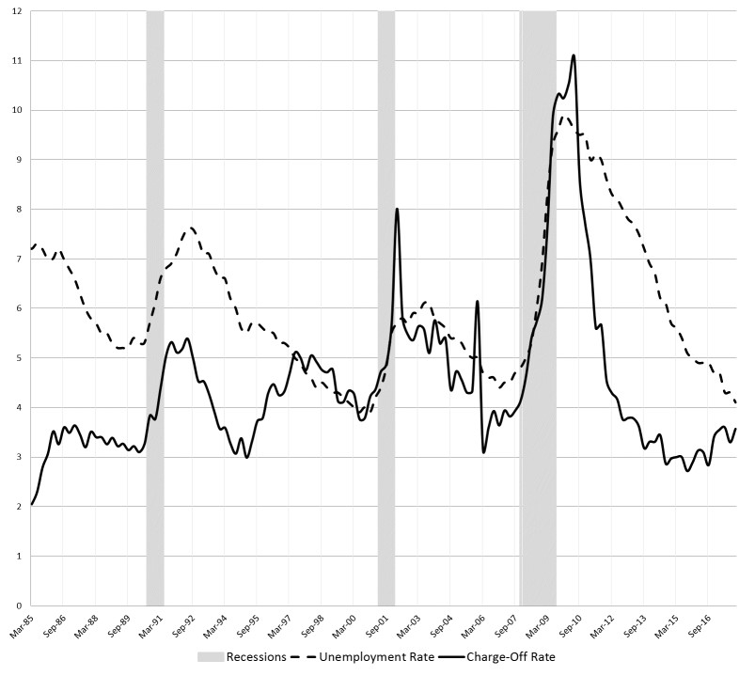

Note: Net charge-off rates represent the historical performance of the 100 largest U.S. commercial banks.

Figure 2: Net Charge-Off and Recovery Rates
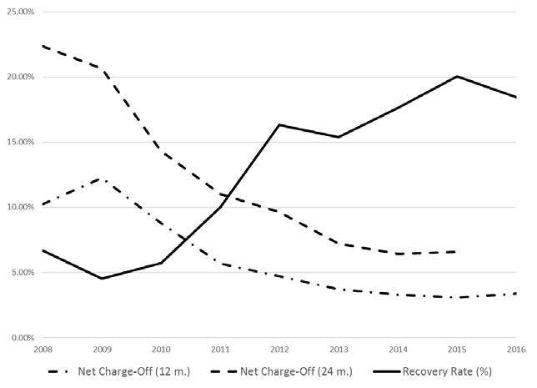

Note: Net Charge Offs are aggregated 12 months and 24 month forward looking rates.

Figure 3: Median Allowance, Net Charge-Off and Coverage Rates as % of Portfolio Balances
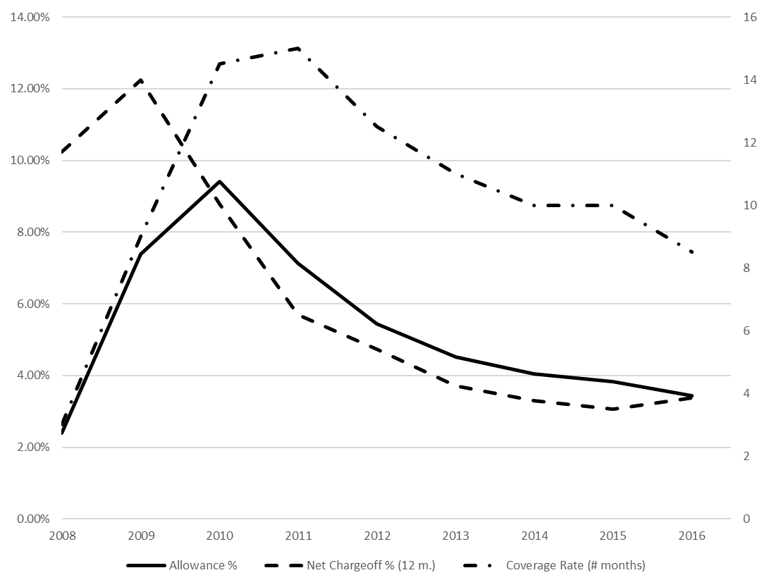

Note: The coverage rate is defined as the number of months of forward looking (realized) net charge-offs covered by current allowances. Allowance and net charge-off are reported as percentage of portfolio balances.

Table 3: Stylized Examples of Credit Card Payment Performance
Period: | 0 | 1 | 2 | 3 | 4 | 5 | 6 | 7 | 8 | 9 | 10 | 11 | 12
Example 1:  Net period payment |  | 10 | 10 | 10 | 10 | 10 | 10 | 10 | 10 | 10 | 10 | 10 | 10
New period charges |  | 0 | 0 | 0 | 0 | 0 | 0 | 0 | 0 | 0 | 0 | 0 | 0
Balance at t | 100 | 90 | 80 | 70 | 60 | 50 | 40 | 30 | 20 | 10 | 0 | 0 | 0
Remainder balance  FIFO | 100 | 90 | 80 | 70 | 60 | 50 | 40 | 30 | 20 | 10 | 0
LIFO | 100 | 90 | 80 | 70 | 60 | 50 | 40 | 30 | 20 | 10 | 0
Life of the Loan  FIFO |  |  |  |  |  |  |  |  |  |  | 10
LIFO |  |  |  |  |  |  |  |  |  |  | 10
Example 2:  Net period payment |  | 10 | 10 | 10 | 10 | 10 | 10 | 10 | 10 | 10 | 10 | 10 | 10
New period charges |  | 60 | 60 | 60 | 60 | 60 | 60 | 60 | 60 | 60 | 60 | 60 | 60
Balance at t | 100 | 150 | 200 | 250 | 300 | 350 | 400 | 450 | 500 | 550 | 600 | 650 | 700
Remainder balance  FIFO | 100 | 90 | 80 | 70 | 60 | 50 | 40 | 30 | 20 | 10 | 0
LIFO | 100 | 100 | 100 | 100 | 100 | 100 | 100 | 100 | 100 | 100 | 100 | 100 | 100
Life of the Loan  FIFO |  |  |  |  |  |  |  |  |  |  | 10
LIFO |  |  |  |  |  |  |  |  |  |  |  |  | 12+
Example 3:  Net period payment |  | 10 | 10 | 100 | 100 | 100 | 100 | 100 | 10 | 10 | 10 | 10 | 10
New period charges |  | 60 | 60 | 60 | 60 | 60 | 60 | 60 | 60 | 60 | 60 | 60 | 60
Balance at t | 100 | 150 | 200 | 160 | 120 | 80 | 40 | 0 | 50 | 100 | 150 | 200 | 250
Remainder balance  FIFO | 100 | 90 | 80 | 0
LIFO | 100 | 100 | 100 | 100 | 100 | 80 | 40 | 0
Life of the Loan  FIFO |  |  |  | 3
LIFO |  |  |  |  |  |  |  | 7
Note: For simplicity, we don’t explicitly consider finance charges in these stylized examples.

Figure 4: Examples of Account Performance: FIFO, LIFO, Balance, and Monthly Pay Rate
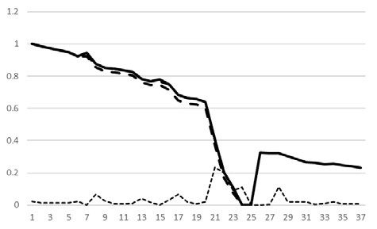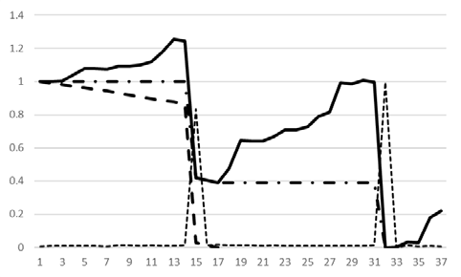

Figure 4.a

Figure 4.b

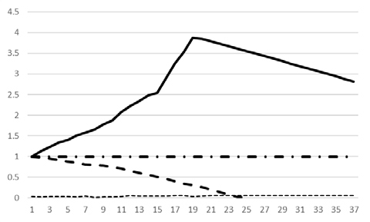  Figure 4.c | 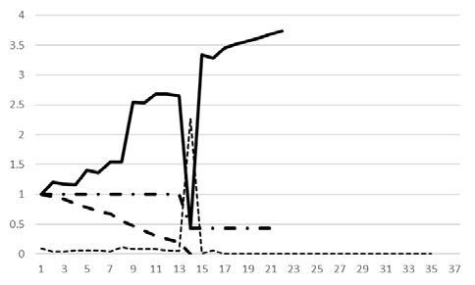  Figure 4.d
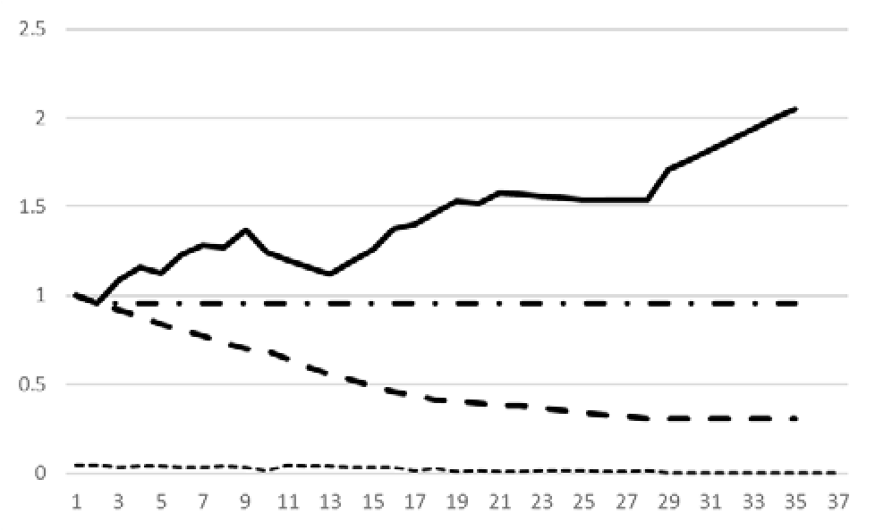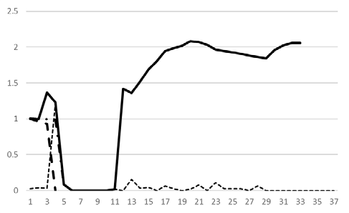

Figure 4.e

Figure 4.f

Note: For simplicity, all relevant quantities are normalized by the account balance at month 0. The life of the loan is defined as the number of months until the loan balance becomes zero or the number of months until loan default (either under FIFO or LIFO). For example, in figure 4.a life of loan is 24 months under FIFO and LIFO; in figure 4.c life of loan is 25 months under FIFO and 37+ months under LIFO; in figure 4.e life of loan is 35 months and coincides with the time of default.

Figure 5: Kaplan-Meier Cumulative Default Curves (Months into the future) at the Portfolio Level and Across Portfolio Segments
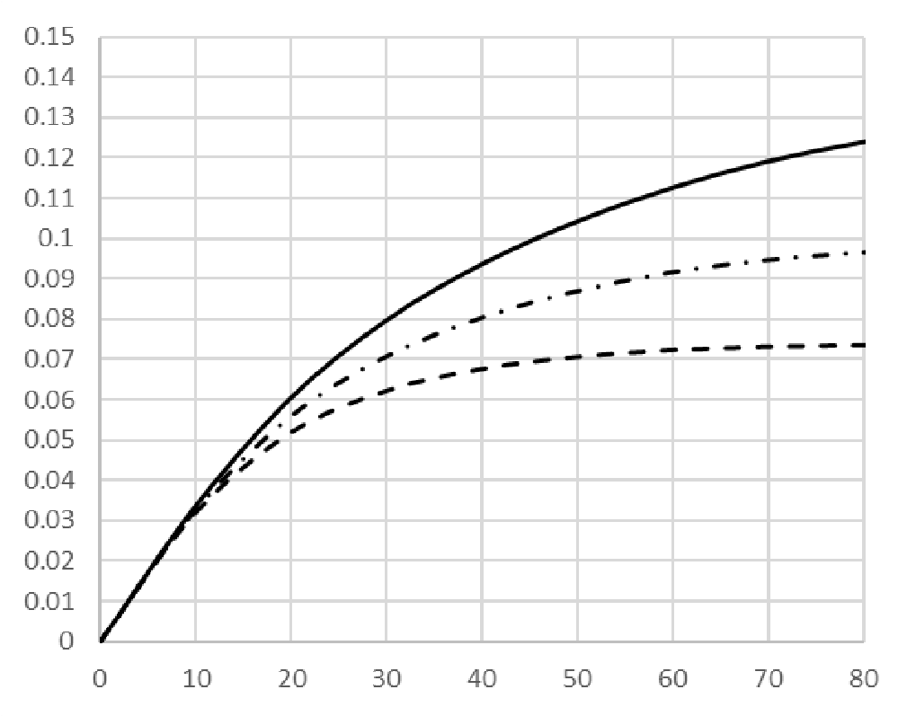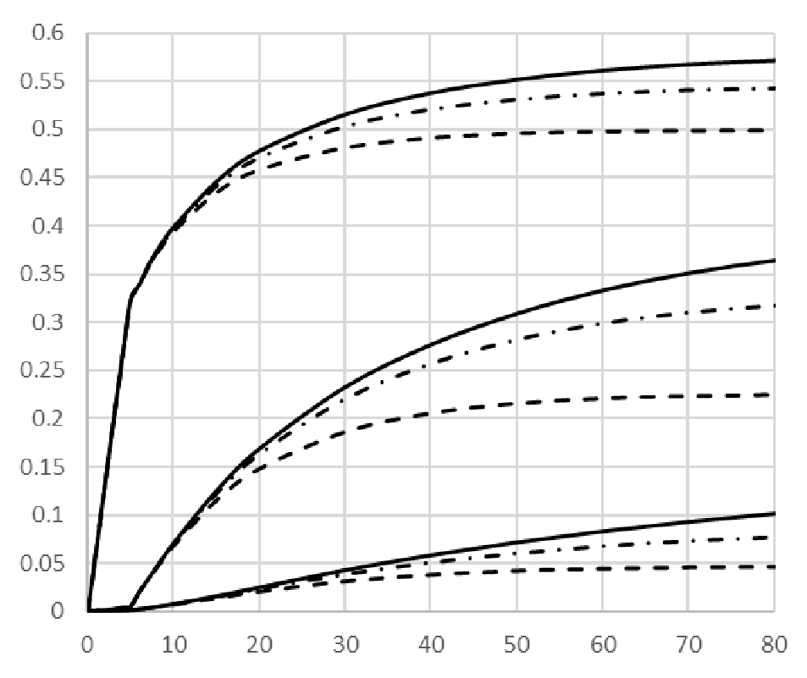

Figure 5.a: Portfolio Figure 5.b: Low- and High-Risk Revolver and Delinquent
Segments (with associated increasingly steeper cumulative default curves).

Note: Account K-M curves depict the traditional cumulative default curves at the account level, while FIFO and LIFO K-M curves depict default of the loan under specific payment allocation rules.

Figure 6: Five-Year Spell Cumulative Default Curves Across Cohorts at the Portfolio Level and Across Segments.
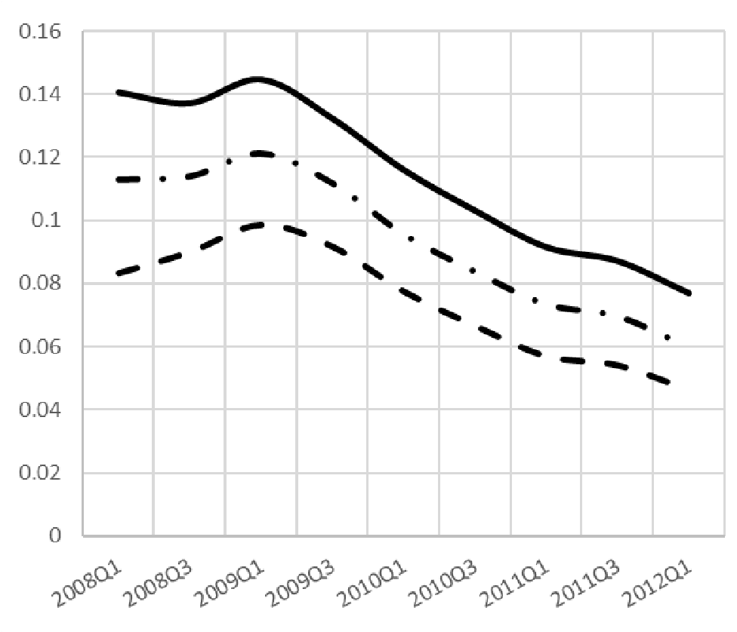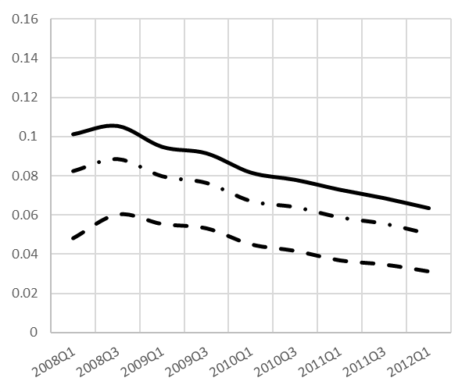

Figure

6
.a
:

5

Y
ears
Cumulative
D
efault
,

Portfolio

Figure

6
.b.
:

5
Years
Cumulative
Default
,

Low
-
Risk
Revolver
Segment

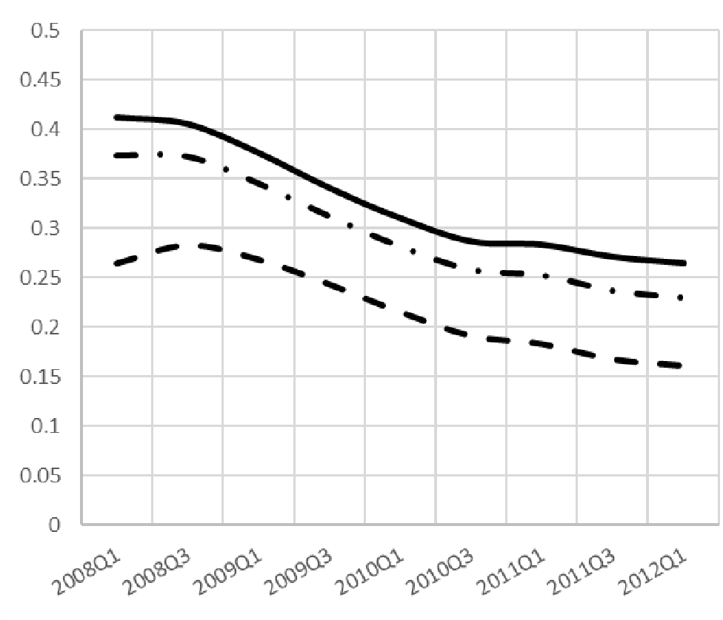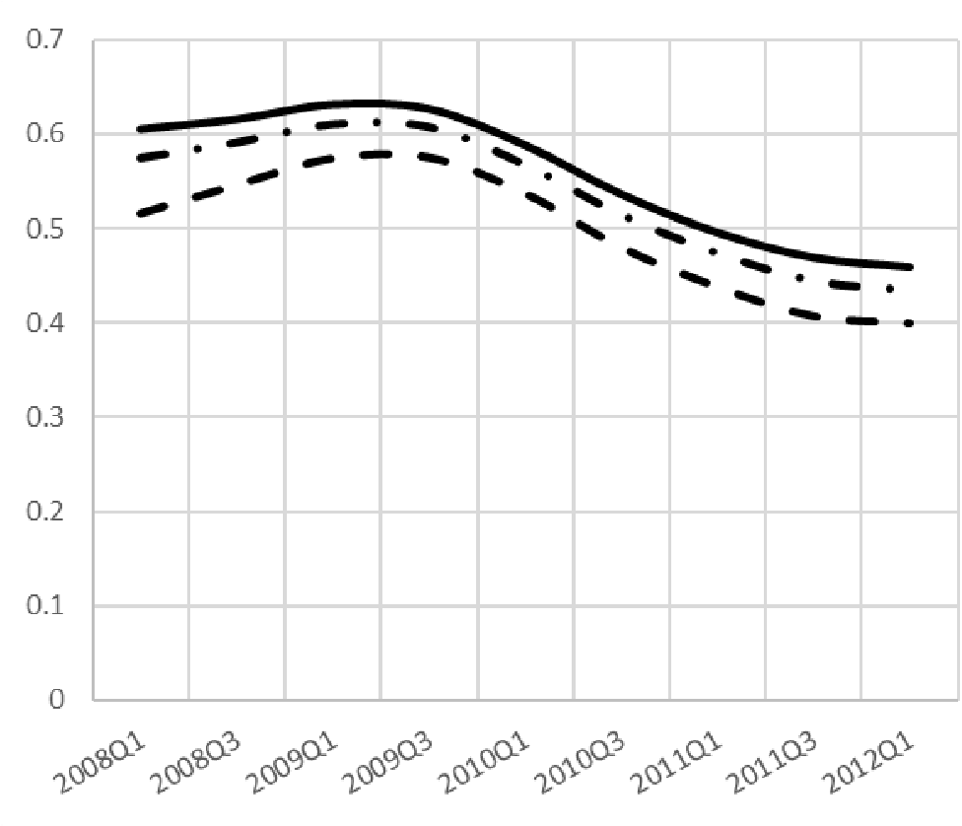
Figure

6
.c
:

5
Years
Cumulative
Default
,

High
-
Risk
Revolver
Figure

6
.d
:

5
Years
Cumulative
Default
,

Delinquent
Segment. Segment.

Note: The figures track 5-year cumulative default rates, including account default, and loan default under FIFO and LIFO payment allocation rules, across different cohorts and for different risk segments. For example 2008Q1 denotes the cohort with march 2018 as its initial reference month 0.

Figure 7: Average Account Balance Curves and Evolution of Portfolio Balances
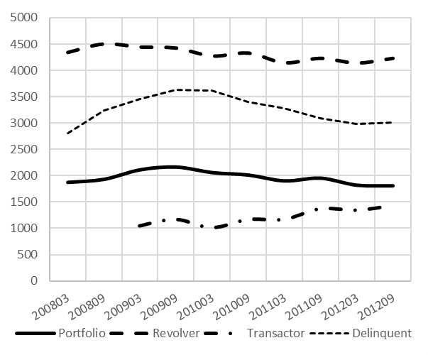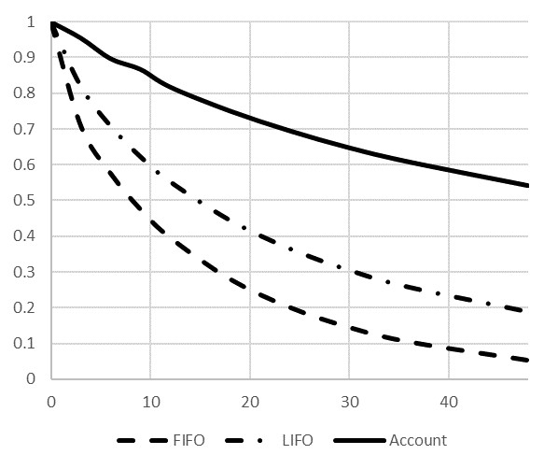

Figure 7.a: Average account balance across Figure 7.b: Evolution of portfolio balances as a
cohorts/segments. percentage of initial balances, up to 60 months into the
future.

Note: Figure 7.a presents average account balances across cohorts at the portfolio level and for specific risk segments. Figure 7.b follows the evolution of portfolio balances as a percentage of initial balances at the account level and at the loan level for specific payment allocation rules. The evolution balances in figure 7.b are consistent across cohorts, so we report only the aggregated evolution of balances across cohorts.

Figure 8: Evolution of the Remainder of Month 0 Balance at the Portfolio Level and Across Segments (as a % of Initial Balance)
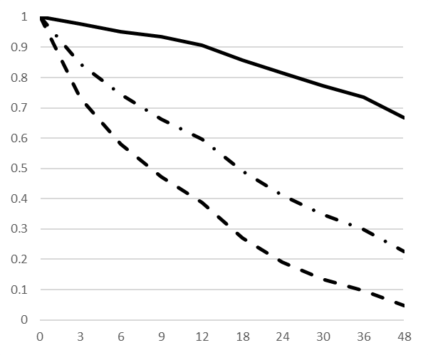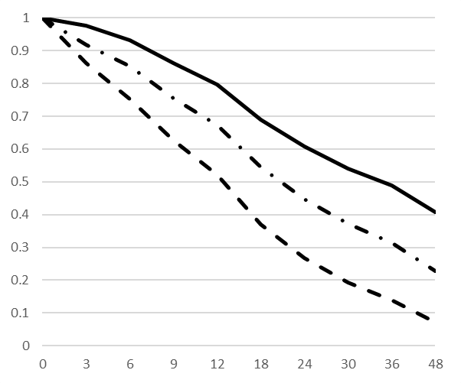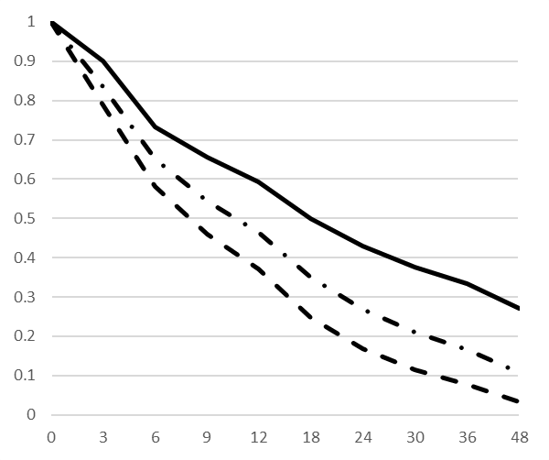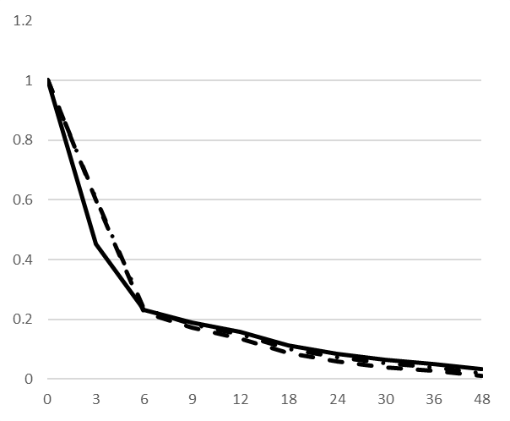

Fig
ure

8
.a
:

Low
-
Risk

Segment

Fig
ure

8
.b
:

High
-
Risk Segment

Fig
ure

8
.c
:

Low
-
Delinquency Segment

Fig
ure

8
.d
:

High
-
Delinquency Segment

Note: The figures follow the evolution from month 0 of balances across segments of the portfolio as a percentage of initial balances at the account level and at the loan level for specific payment allocation rules. These figures are consistent across cohorts so we report only the aggregated evolution of balances across cohorts.

Figure 9: Portfolio Loss Curves Across Cohorts
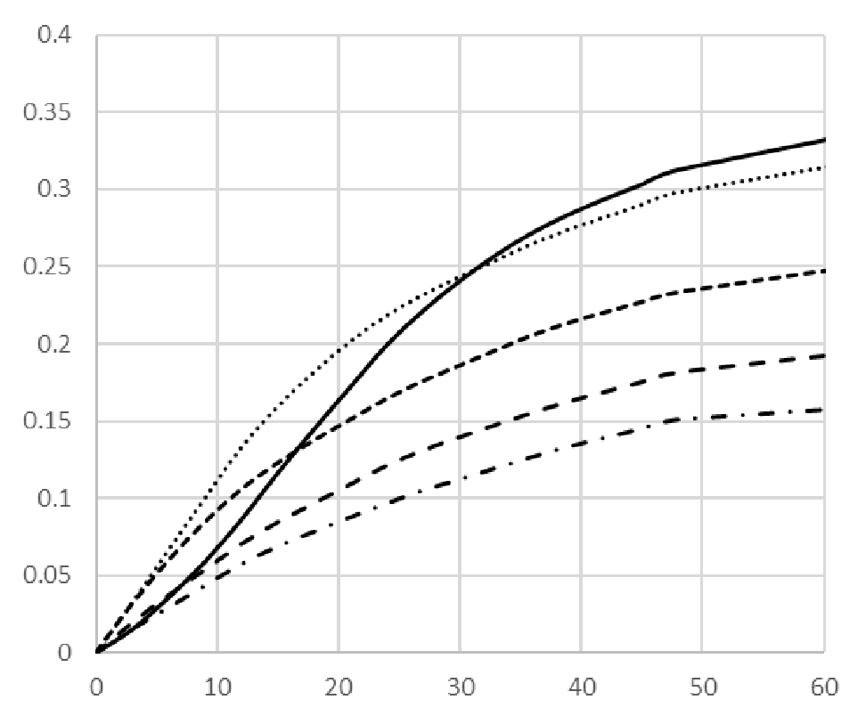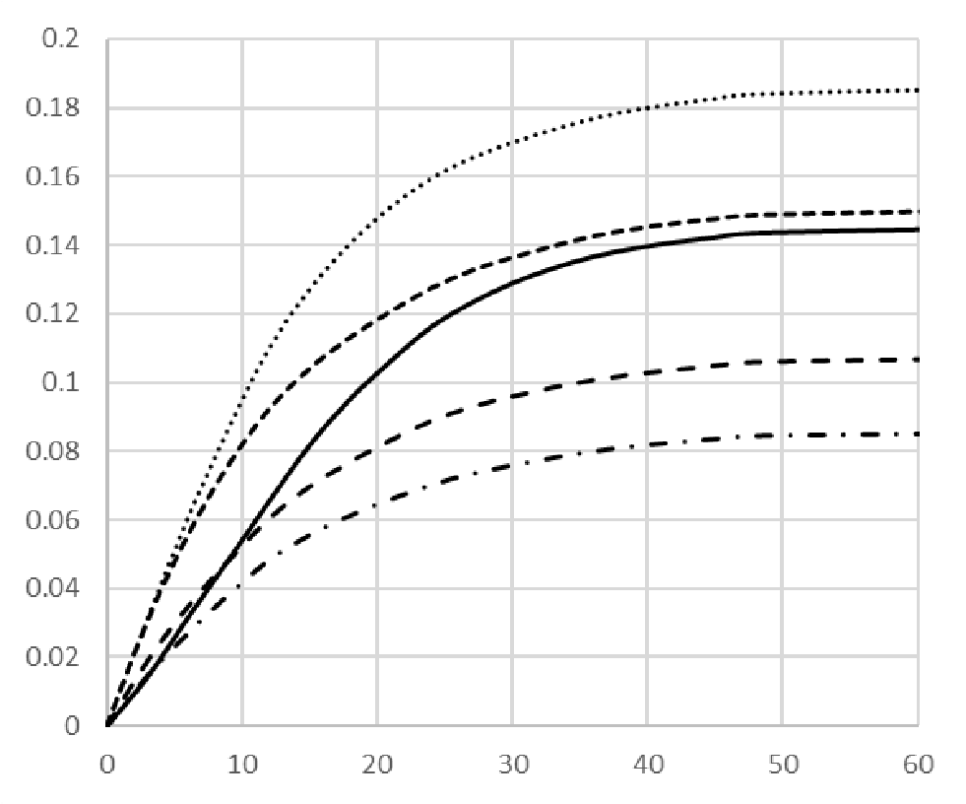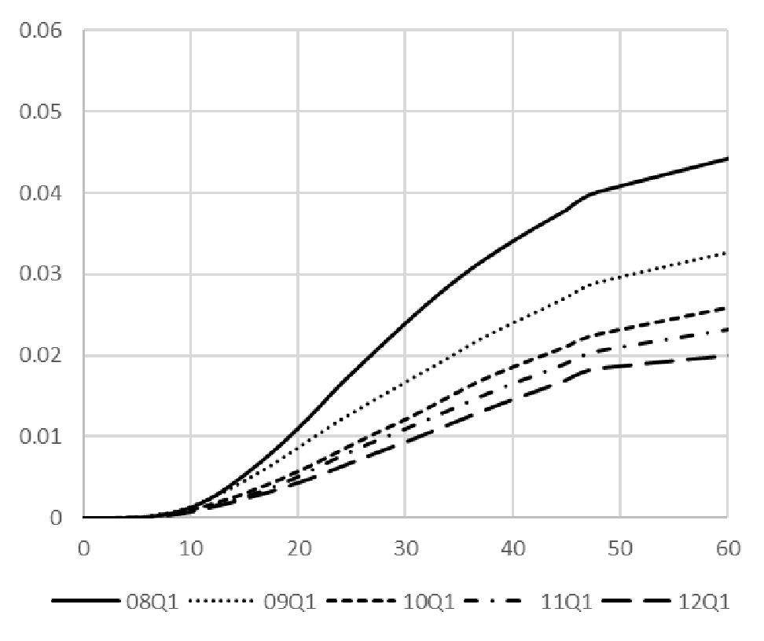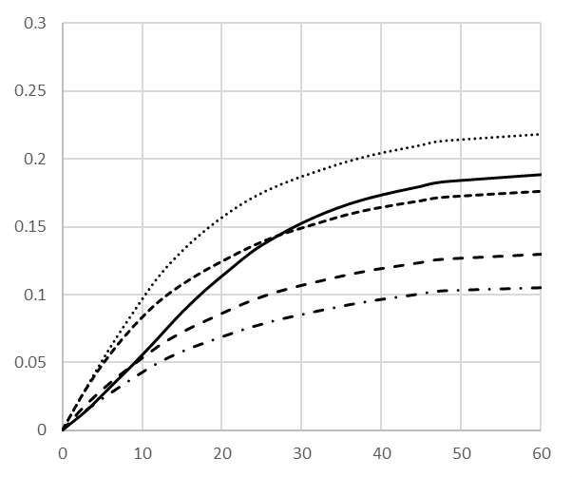

Figure

.a
9
:

Account Loss Curves

Figure

9
.b
:

FIFO

Loss Curves

Figure

9
.c
:

(
LIFO

Loss
–

FIFO

Loss)

Figure

9
.d
:

LIFO

Loss Curves

Note: 08Q1, 09Q1, 10Q1, etc. represent, respectively, cohorts with reference month as March of 2008, 2009, 2010, etc.

Figure 10: Portfolio Loss Curves Across Segments Low-Risk and High-Risk Revolver, High Delinquent
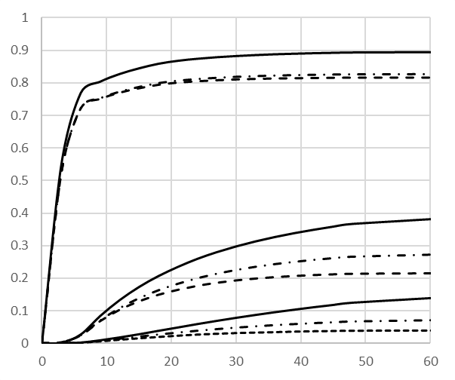

Note: The figure depicts loss curves for the delinquent, high-risk and low-risk revolver segments. Curves are rank ordered by risk, so there is no need to differentiate across curves with additional notation.

Figure 11: Portfolio Loss Curves Across Cohorts and FIFO/LIFO Coverage Ratio
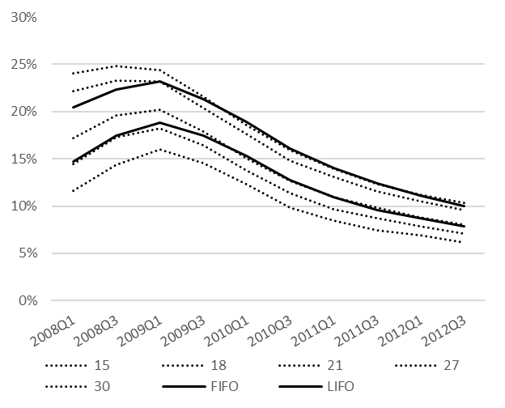
Note: The figure depicts loss curves across cohorts for different time spells (15, 18, etc.) in months. Loss curves ordered, with longer spells are associated with higher loss severities. FIFO and LIFO loss curves are computed for the life of the loan. The intersection of portfolio/segment loss curves with FIFO/LIFO loss curves provides a measure of the coverage ratio for different cohort years (i.e., a measure of how many future months of actual portfolio loss are covered by the corresponding allowance).

Figure 12: Loss Curves Across Cohorts and FIFO/LIFO Coverage Ratio
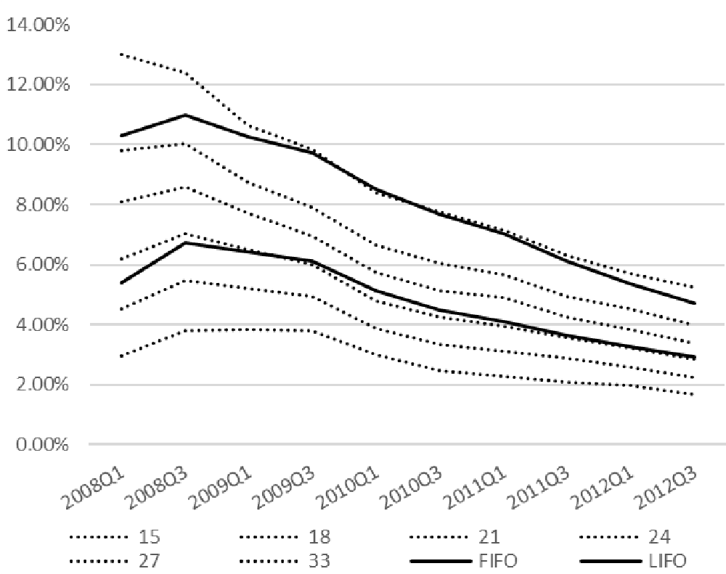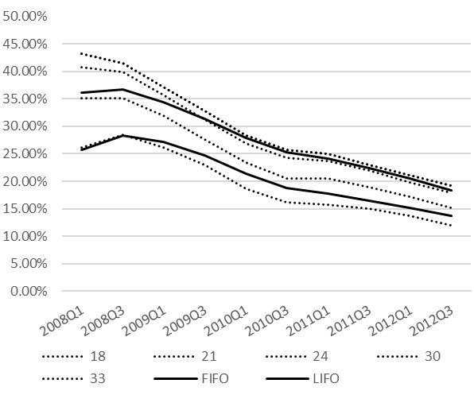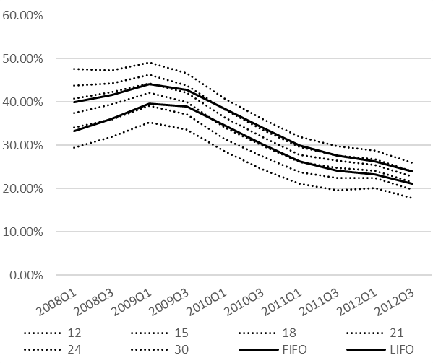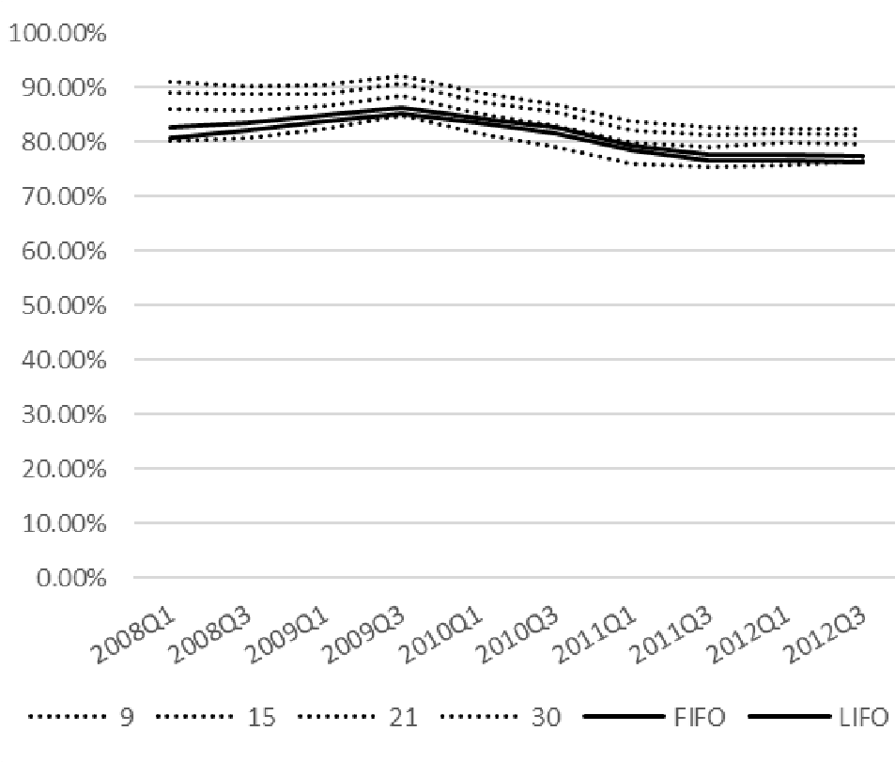

Figure

12
.a
:

Revolver,
Low
-
Risk Segment

Figure

12
.b
:

Revolver,
High
-
Risk Segment

Figure

12
.c
:

Low
-
Delinquency Segment

Figure

12
.d
:

High
-
Delinquency Segment

Note: The figure depicts loss curves across cohorts for different time spells (15, 18, etc.) in months. Loss curves ordered, with longer spells are associated with higher loss severities. FIFO and LIFO loss curves are computed for the life of the loan or up to 5 years forward. The intersection of portfolio/segment loss curves with FIFO/LIFO loss curves provides a measure of the coverage ratio for different cohort years.

VII. References

Banerjee, P., and J. Canals-Cerdá. “Credit Risk Analysis of Credit Card Portfolios Under Economic Stress Conditions,” Banking and Finance Review, 5:2 (December 2013).

Board of Governors of the Federal Reserve System. “Dodd–Frank Act Stress Test 2018: Supervisory Stress Test Methodology and Results,” June 2018, www.federalreserve.gov/publications/files/2018-dfast-methodology-results-20180621.pdf.

Board of Governors of the Federal Reserve System, Federal Deposit Insurance Corporation, National
Credit Union Administration, Office of the Comptroller of the Currency. “Joint Statement on the New Accounting Standard on Financial Instruments — Credit Losses,” June 17, 2016.

Board of Governors of the Federal Reserve System. “Frequently Asked Questions on the New Accounting Standard on Financial Instruments — Credit Losses.” Web link: www.federalreserve.gov/supervisionreg/topics/faq-new-accounting-standards-on-financialinstruments-credit-losses.htm.

Board of Governors of the Federal Reserve System. “Regulatory Capital Rules: Implementation and
Transition of the Current Expected Credit Losses Methodology for Allowances and Related Adjustments to the Regulatory Capital Rules and Conforming Amendments to Other Regulations,” proposed rule by the Comptroller of the Currency, the Federal Reserve System, and the Federal Deposit Insurance Corporation on May 14, 2018. Web link: www.federalregister.gov/documents/2018/05/14/2018-08999/regulatory-capital-rulesimplementation-and-transition-of-the-current-expected-credit-losses.

Canals-Cerda, J. “Pro-Cyclicality of Capital and Portfolio Segmentation in the Advanced Internal Ratings-Based Framework: An Application to Mortgage Portfolios,” Journal of Risk Model Validation,12:3 (September 2018), pp. 1–27.

Canals-Cerda, J., and S. Kerr. “Forecasting Credit Card Portfolio Losses in the Great Recession: A Study in Model Risk,” Journal of Credit Risk, 11:1 (March 2015) pp. 29–57.

Financial Accounting Standards Board. “Accounting Standards Update No. 2016-13, Financial Instruments — Credit Losses (Topic 326): Measurement of Credit Losses on Financial Instruments,” June 2016.

FR Y-14M Capital Assessment and Stress Testing, Domestic Credit Card Data Collection.
https://www.federalreserve.gov/apps/reportforms/reportdetail.aspx?sOoYJ+5BzDYnbIw+U9pka3 sMtCMopzoV

Financial Accounting Standards Board, Transition Resource Group for Credit Losses. “Memo No. 5 Determining the Estimated Life of a Credit Card Receivable.” June 2017 TRG Meeting.

Kalbfleisch, J. D., and R. L. Prentice. 2002. The Statistical Analysis of Failure Time Data. 2nd ed. New York: Wiley.

Kaplan, E. L., and P. Meier. 1958. Nonparametric estimation from incomplete observations. Journal of the American Statistical Association 53: 457–481.

Banking regulators have issued Implementation and transition guidance. See BOG, May 2018, BOG, June 2016 and BOG “Frequently Asked Questions on the New Accounting Standard on Financial Instruments – Credit Losses.” ³ BOG, June 2018.
ASU 2016-13, example 10 states: “Bank M estimates the expected credit losses over the remaining lives of the funded credit card loans … Bank M does not record an allowance for unfunded commitments on the unfunded credit cards because it has the ability to unconditionally cancel the available lines of credit.”
These submissions are commonly known as FR Y-14M reports and consist of Domestic First Lien Closed-end 1-4 Family Residential Loan, Domestic Home Equity Loan, and Domestic Credit Card data collections. A link to available public information about the data is included in the reference section.
ASU 2016-13 indicates that reserves on credit card portfolios need to be established over the remaining lives of the funded credit card loans.
Canals-Cerdá and Kerr (2015) conduct a comprehensive study of the relationship between unemployment and the risk of credit card portfolios. See also Banerjee and Canals-Cerdá.
See FASB, ASU 2016-13, p. 138.
Transactor accounts are usually referred as accounts that carry no debt from month to month and incur no finance charges.
See FASB Memo No. 5, June 2017.
Banks have access to all individual card transactions and detailed information on payments, promotions, interest rates, and finance charges; our data are not as granular in this regard.
See Kaplan and Meier (1958), or Kalbfleisch and Prentice (2002).
Figure 1 also indicates that the downturn was followed by a long period of low credit card charge-off rates.
This is consistent with prior research by Canals-Cerdá and Kerr (2015).
Most banks will freeze or close an account after 90 days past due, while the Basel II framework assumes that default occurs at 180 days past due. We choose 150 days as the trigger of default to minimize potential problems of missing data reported by the banks that may arise if a bank moves an account to a collections system.
Data source: https://www.federalreserve.gov/releases/chargeoff/chgtop100nsa.htm

