Limiting Credit Portfolio Loss Without Probability Measures
Jo˜ao Pires da Cruz,^{1,2} C´atia Silva,¹ Kanshukan Rajaratnam,³ Peter Beling,⁴ and George A. Overstreet Jr.⁵
1
Closer Consulting, Av. Eng. Duarte Pacheco Torre 1 15-1 1070-101 Lisbon, Portugal
2 Center for Theoretical and Computational Physics, University of Lisbon,
Campo Grande, Edif´ıcio C8 1749-016 Lisboa, Portugal
3
Dep. of Finance & Tax and the African Collab. for Quant. Finance & Risk Research, University of Cape Town, Rondebosch 7700, South Africa
4
Department of Systems and Information Engineering,
University of Virginia, 151 Engineer’s Way, Charlottesville, VA 22904, USA
5
McIntire School of Commerce, University of Virginia,
125 Ruppel Drive, Charlottesville, VA 22903, USA
(Dated: July 17, 2017)
Event space stability is fundamental to assume that frequency data collection can converge into a probability measure. But, on the contrary, a credit portfolio is an everchanging reality based over an everchanging environment. Thus, methods that collect default frequencies and, from that, assume it as probability measures can be looked as erroneous and apart from the mathematical first principles that would support theoretically the data collection. Here we will show a study, based on the principle that default probabilities cannot be measured, to build credit portfolios with limited maximum loss. For that, we will assume the control of other parameters and allow the expected default frequency to vary over a wide band of values (four orders of magnitude) and, from that, determine the credit spread for which the maximum loss is determined. Additionally, it is assumed that some debtor selection process exists, but it can be any process that separates credit debtors in the portfolio from the general applicants. In other words, credit is not given to anyone. With this we can reduce significantly the uncertainty associated with the credit portfolio management without ignore probability theory first principles.
Keywords: Advanced Analytics, Intensity Models, Risk, Credit Risk

INTRODUCTION
Surprisingly or not, credit risk is far from being a closed problem. It is remarkable that the current state of technology can discover planets light-years away from Earth using machine learning techniques but a solution to an everyday problem is still looked as a proxy to a proper solution which seems impossible to attain. Here, we will address the problem by eliminating the sources of uncertainty that an incorrect probability measure brings using other parameters of a portfolio to establish a proper risk measure.
In simple words, credit risk relates the possibility of financial losses due to changes in the credit quality of the debtor, with the most severe change being the default event, i.e., the event in which the debtor stops fulfilling its credit obligations. The problem can be reduced to measuring the probability of such an event to occur, which seems a simple task, conceptually speaking, but is a mathematical conundrum.
We can distinguish credit models into two separate classes[1, 2]: the structural models and the intensity models.
Structural models are inspired by the Merton model[3], assuming that the total value of the assets of the debtor follows a Brownian Motion. With that in mind, if the debtor cannot pay back, the creditor will take possession of the company. Meaning, in option jargon, that the amount of debt at the default instant can be looked as the strike for an option over the company that compares with the firms equity. This gives access to a complete set of financial mathematical tools, based on martingale theory, applied to the valuation of firms’ assets. The expression ‘structural’ comes from the fact that risk is directly related with variations of the financial structure of the firm. Several similar approaches can be adopted based on the same fundamental Brownian Motion assumption, like taking a variable time to default[4] or grouping loans in a portfolio to correlate latent structural changes with systemic risk factors[5], the latter being the model that supports the IRB approaches to the Basel Accords[6, 7].
Independently from the indisputable success of this type of approach, there is one issue yet to solve: as it is possible to see from stock market price time series, equity values do not follow Brownian Motions[8] and, consequently, neither do assets or liabilities, since they are subtracted into equity value. Empirical evidences of asset and liability distributions[9] show resilient powerlaw distributions in time, which are not consistent with Markovian processes. Also, grouping loans in a portfolio with the goal of making empirical measures will carry the assumption that both the systemic risk and the asset value are Gaussian distributed at the instant of the measure and that is also not true[8]. Practical approaches, like Basel[6, 7], use the concept of unconditional probability of default which, in a non-stationary system, is an even worse solution than measuring a wrong correlation between two non-Gaussian distributions. In summary, despite the interest of structural models since they provide a causality to credit risk, they are poorly supported in mathematical terms and usually provide erroneous results.
Intensity models, on the other hand, are less dependent on the causality of default events and more on the intensity of events in time. How we model that intensity is the issue. If we consider the economic system as having the same possible states through time, we could model the intensity of defaults based on historical data and consider it constant through time. Again, we can not assume that because every empirical and theoretical evidence shows us otherwise. For the same reason, we also cannot model it as a Brownian Motion based stochastic process[10], because the parameters must come from similar measures. So, apparently we cannot use an intensity model unless we could capture the future behavior of the intensity based on economic states that do not exist yet and that is, obviously, an impossible task.
Nevertheless, credit has been a profitable business for centuries, long before mathematical modeling, option theory or sophisticated probability measures. That has been the motivation for the work we present here. Most of credit portfolios in the past were built without any probability based selection process and they were profitable and accessible to a wide band of customers. Our goal is to provide a quantitative support to such way of building a portfolio and provide the tools for its fine tuning. Here we will present a model that minimizes the lack of mathematical support for probability measures by keeping these measures as free variables and using the remaining portfolio parameters as the adjustable ones. In section II we will describe the model and its foundations, in section III we shall present empirical results followed by a brief discussion on section IV.

MODEL
As a first step, we should not trust any selection process, but that leads us to a no-solution. We do want to build a credit portfolio because we know from the past that it is possible to build a profitable credit portfolio. Our problem, which is a quantitative problem, is about getting a number that translates into a decision to give credit. So, the alternative is to trust every selection process, as long as there is one. The reason behind this lack of criteria of what is a good process and what is a bad process will be clear below. We do not aim to decide that one process leads to a better quality than the other, because it is not possible to know that a priori. What we want to achieve with the statement ‘as long as there is one’ is temporal independence. Let us imagine that we decide to give credit to anyone and not to use any selection process whatsoever. Obviously, we would get a huge rate of default but that effect could be solved by setting a proper spread. The problem would come from the effect known as the critical behavior of economic agents[8], due to the growing nature of the economic system. This means that a portfolio can be washed out by avalanche effects in economy, since one bankruptcy can lead to another, that can lead to another, and so on. In other words, default in the portfolio, in this case, depends on history. To make this clear, imagine the network generated by economic relations and refer to the caption of Fig. 1.
a)
b
)
FIG. 1. Representation of the economic network assuming that the filled nodes are in the portfolio. a) If the top node of the network defaults, then all the first neighbors will have the impact of the default. Since we did not perform any selection, the probability of having one of the fist neighbors is high and the default of the top node will impact on the entire network. Under this circumstances we cannot say that the default from time bin to time bin is independent. b) On the other hand, if we have some process of selection, then our portfolio only includes part of the network and the severity of the systemic events must be considerably high for us to drop the independence assumption.
Thus, when we decide to give credit without selection criteria, what we capture is also the dependency between the default events. Then, statistics measures will fail if we take debtors as independent. To achieve some independence between debtors in our portfolio we need to have selection, any selection, as long as it is made with the aim of avoiding defaults. Since we got rid of the selection problem and we gain independence between the default events by assuming that there is one (or more) selection process, we still have the stability problem, i.e., how to predict the future if the number of states in the system is not stable? Again, the obvious solution is to not predict. And that is exactly what we will do. But first we need to put some math in the explanation. Let us begin with assumptions:
- (Certainty) Everybody defaults on a perpetual loan;
- (Independence) The possibility of an event of default at one instant is independent from the possibility of the event of default in the previous instant.
The first assumption is the basis for the usage of a hazard and survival rate, there is a ‘stream’ of defaults that will fall in time bins in the future. How they will fall, we do not know but we will take as certain that they will fall independently from each other because there is a selection process.
Let N(t) be the number of defaults in the time interval [0,t]. N(t) is a counting process sustained by assumption
1. It is a process that increases in unit steps at isolated times and is constant between these times. It can be shown[11] that, with probability one, N(t) is a (homogenous) Poisson process[12] with parameter λ. Hence
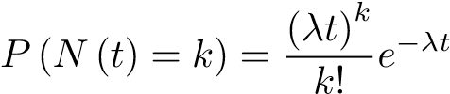. (1)
To show a duality between the waiting time until a fixed number of defaults and the number of defaults that happen in a fixed length of time (which we represent by N), let W (k) be the distribution of the waiting time until the k-th event occur. If W(k) ≤ t then we observed the k-th default before instant t occur. Then, at least k events occur during the time interval [0,t], i.e. N (t) ≥ k. Using the duality we can say that
P (W (k) ≤ t) = P (N (t) ≥ k), (2)
and
P (W (k) > t) = 1−P (W (k) ≤ t) = P (N (t) < k), (3)
which leads to
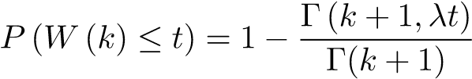. (4)
where Γ(a,b) is the upper incomplete gamma function and Γ(a) is the gamma function. Thus, the probability density function of W(k) in time will be given by deriving P in order of time and
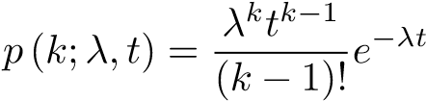, (5)
which is a Gamma(k,λ) probability density function.
So, we stopped looking at the default as a timeless default rate measured over the portfolio and now we are looking for the default of one credit in a time horizon. What did we gain from that? Statistical consistency. When we divide the number of defaults by the number of total credits, a change in the latter means the same as a change in the surrounding conditions of the portfolio. In other words, we are comparing things that are not comparable, like throwing a dice with 6 sides and, afterwords, a dice with 12 sides. They are both dice, and any ratio would give a result between 0 and 1, but they are not the same system and we should not merge results into the same measuring apparatus. By ignoring the total credits in the portfolio and measure through time, we ‘close’ the space of events. We will have defaults that distribute themselves in time because we cannot predict the future. Moreover, we assume that everybody defaults sometime in the future, like an irresistible attraction. With that, all underlying assumptions that govern statistics and probability theory are present and verifiable. We should note that k is not necessarily an event of default. And, in fact, we will not take it as such. k can be taken as a ‘distance in wealth to default’. As if it was steps in a ladder that we should step down to reach the floor, which in this case represents default. This is, in practice, the best way to see k because default events should be rare events and caused by those steps in the ladder. The greater the number of steps in the ladder to default, the more effective is the selection process.
Now, we have two parameters governing our probability density function: k and λ. We will only calculate the former from the data. Why? Take Fig. 2. 1/λ is equal to the expected time to default and to the peak in the distribution[12]. The distributions in the figure all have the same λ but different k. k is a short term parameter in the sense that it can be measured from the very short term events. The greater k, more steps to default and less probable to default on the first instants of the credit. In terms of credit selection, this means we say that the debtor will not default on the next few months. Obviously, greater k means that the probability of default will be stretch in time and it will be less probable to have a default in the earlier instants of the credit. Since k can be measured in the first interval of time (in 1/λ time units) and k depends on the selection, it can be easily measured numerically taking empirical data without major concerns about the stability of environment. It is all about internal processes.
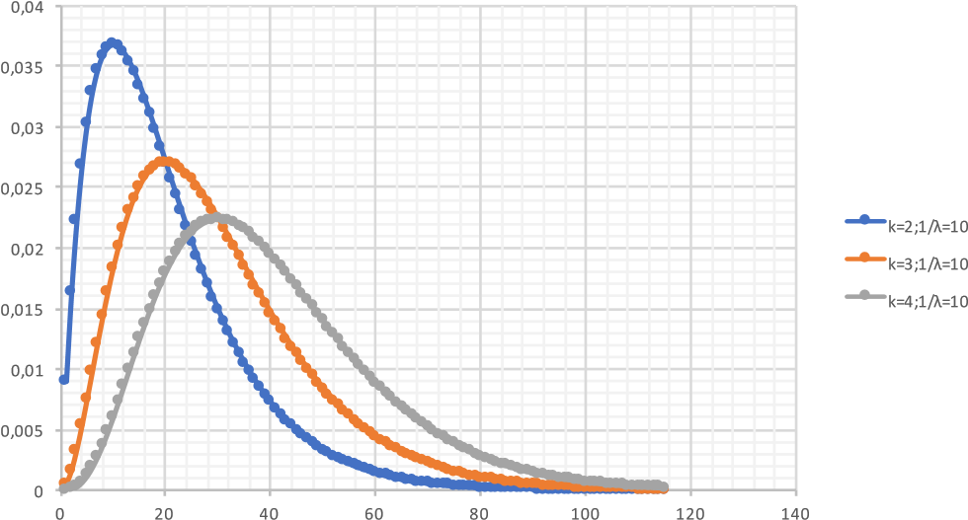
FIG. 2. Influence of k in the probability density function with λ fixed (arbitrary units of time).
Having measured the parameter that reflects selection, k, we are left with the parameter that reflects the market, λ. The goal of risk management is to be able to quantify independently from market conditions and that is what we will do in the next steps. First, let us fix a value for λ, for now, and start to look at the credit contracts. Let us take the a non-perpetual credit contract that can be looked as time sequence of interest at maturity deals, with fixed rate, r, a start date, t₀ and a maturity M (see Fig. 3 a)). With this in mind we know that the value of the contract at an instant t = 0 as
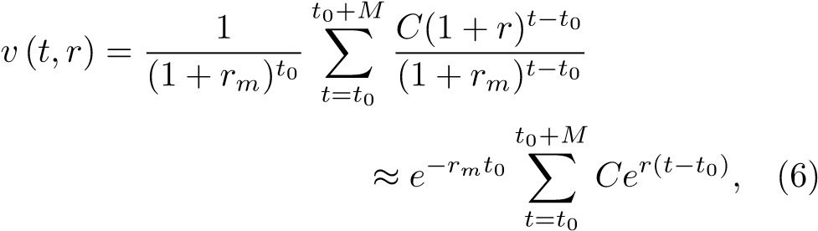
where r_{m} is the market interest rate that we consider as constant for simplicity sake and, also, and C represents the nominal amount of the loan that we also consider fixed and credit risk free. Even if we consider it as variable, the amount would not change due to customer risk changes so, for simplicity, we will take is constant.
Now, considering the expression for the probability of default, Eq.(??), the time variable used here is not the same. The time in the expression of the probability of default is the time from the selection, i.e., from the origination of the contract. To keep both times compatible we write the probability as
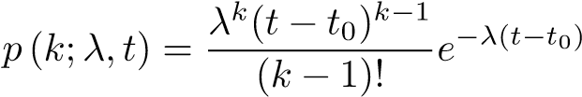, (7)
and the expected value of the contract in time is written as
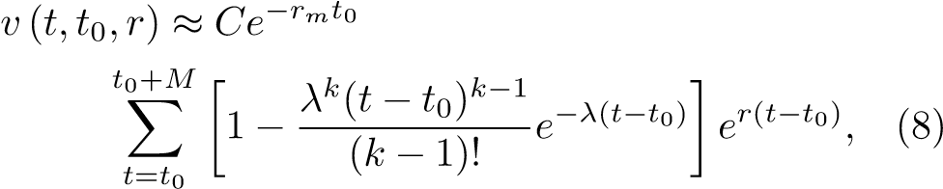
where the value of C is depreciated with the probability of receiving.
Now, let us decide (see Fig. 3 b)) to have one more contract each instant in time, with exactly the same rate, the same nominal balance and the same maturity and build a portfolio that way. The total value of the portfolio will be given as
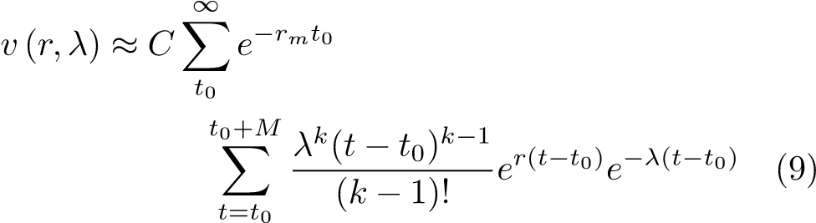
t
t
0
t
=0
t
0
M
+
a)
t
t
0
t
=0
t
0
+
M
t
t
0
t
=0
t
0
+
M
b
)
FIG. 3. Contract cashflow representation, a) the normal standard contract and b) representation of new contracts in the portfolio just sliding the start date through time.
Making the approximation to continuous summing,
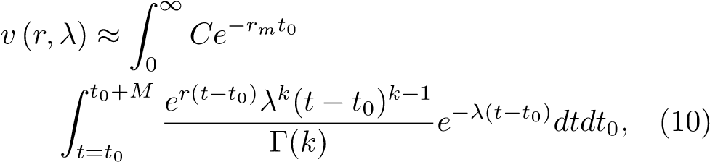
which gives the solution
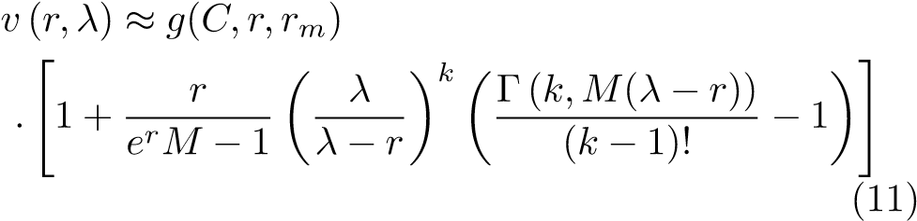
where Γ(.,.) is the upper incomplete gamma function, Γ(.) is the normal Gamma function that converts to factorial when the argument is an integer and g(t₀,r_{m}) is a function of the nominal value of the contracts and the market interest rate which here we will ignore since it does not depend of credit risk (neither λ or k) and we will just bear in mind that there is a present value of the portfolio at instant t = 0, that depends on several factors, but not on the ability of the customers to repay the loan. And we are able to do it since every term in Eq.(6) is multiplicative. Now, we are interested on the behavior of the portfolio in terms of credit risk, specially how it behaves with variations of λ. We can see this effect in Fig. 4. Since λ has the nature of an inverse characteristic time, large λ corresponds to a short characteristic time to default and, conversely, small λ leads to a large characteristic time to default. So, as λ becomes smaller, the characteristic time to default approaches maturity.
λ has the tendency to grow as market conditions get worse, since the time to default gets lower. But in that case, for the contracts that survived until the characteristic time the probability of default becomes significantly smaller. This means that, as long as the business flow remains constant, with new contracts being added to the portfolio at a constant rate, (that is what the integration in t₀ means), the time diversification that the business continuity allows implies that we can limit the possible loss of the portfolio without the need of measuring λ or the associated probability. From Fig. 4 it is clear that the value of the portfolio has a maximum loss (minimum value) that can be controlled by average rate and maturity definition almost independently from the market conditions. The reason why we say ‘almost’ will be described in the next section.

EMPIRICAL EVIDENCES
To test the analytical conclusions of the model, we chose a portfolio of specialized credit (machinery leasing, including cars) form the Portuguese market , where about 75% of the credits are given to companies and 25% to individuals. The portfolio had approximately 150000
0.2
0.4
0.6
0.8
1.0
Λ
0.985
0.990
0.995
1.000
v
H
r
,
Λ
L
0.2
0.4
0.6
0.8
1.0
Λ
0.94
0.96
0.98
1.00
v
H
r
,
Λ
L
FIG. 4. Top: Depreciation of portfolio value with λ with constant maturity and variable rate. Top line 0.4% per period (ex. 5% year is 0.4% a month), middle 0.8% and bottom 1.6%. Bottom: Depreciation of portfolio value with λ with rate constant and variable maturity. Top line 48 units of time
, middle 36 and bottom 12
contracts for credit over a wide diversity of equipment, from airplanes to construction machinery, but about half of the contracts are light vehicles. The average initial outstanding is 128000 euros. In figure Fig. 5 we have the characterization of the average rate and average maturity of the portfolio. The portfolio was analyzed considering contracts that where originated since 2006 until 2014 and the analyzed cash-flow was the one that ended until 2018.
The date of default for each contract was considered to be the first date at which default occurred and from date forward the contract is considered as in arrears, in spite of any eventual cure or colateral collection. This means that total loss is assumed from the date of default onward, with future cashflows being assumed as zero. The default profile in the portfolio is shown on Fig. 6, where we can see it closely follows a Gamma fit with the parameters k and λ that are presented in the caption.
To calculate the variations on the value of the portfolio the following procedure was used. All outgoing cashflows, i.e. the initial amounts, were taken as zero because the flow by itself is risk free, and therefore all credit risk is embedded on the inflows. The reason why we did it was because, theoretically, all contracts starting in the future would have present value near zero, depending on the rate considered in the discount of the cashflows. So
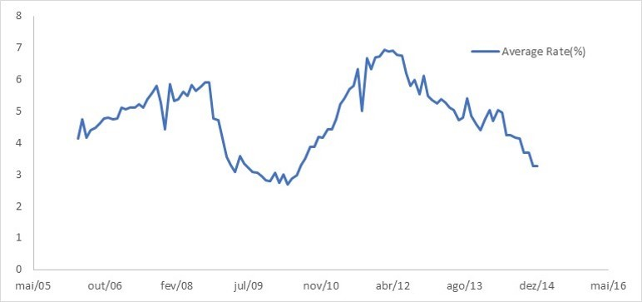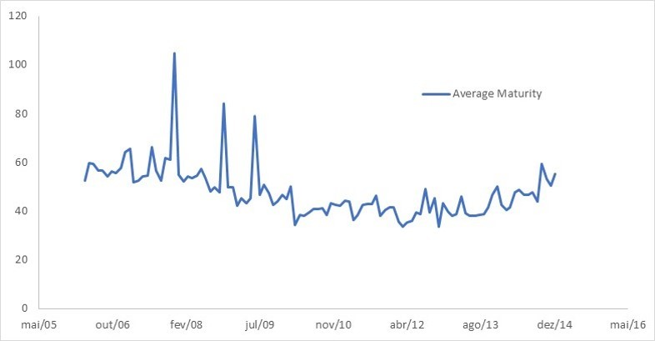
FIG. 5. Top: Evolution of the average rate through the years Bottom: Evolution of the average maturity of the contracts over the years
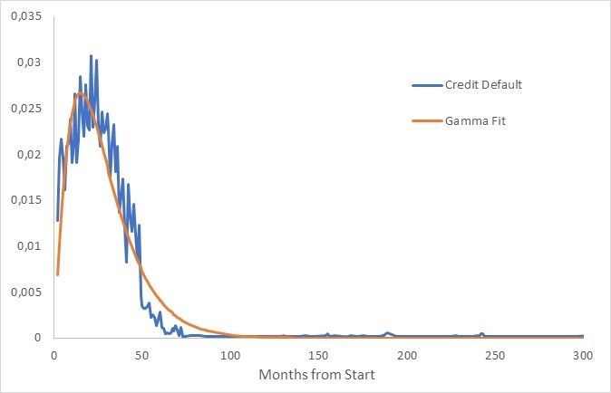
FIG. 6. Gamma fit of the default profile in the test portfolio. The parameters obtained by minimized squared differences were k = 2.18 and λ = 0.0777 or, in time units, a characteristic time to default of t_{c} = 12.87 months
we decided to zero the outflows and normalize the value of the portfolio by the average inflow per contract. The reason why we average the inflow per contract is related to the sovereign debt crisis that affected the Portuguese economy. Due to the way in which rules were implemented, there was a need to restrict credit and lead to a reduction of the portfolio to about 60% of the values observed before the sovereign debt crisis (2010). We will come back to this in on the next section. In summary, in terms of credit risk we will look at the average inflow of the contracts knowing that all cashflows after the first default are considered zero. The value was normalized to the average inflow by month to be comparable with the macroeconomic numbers that suffered a similar normalization treatment. The results are presented in Fig. 7.
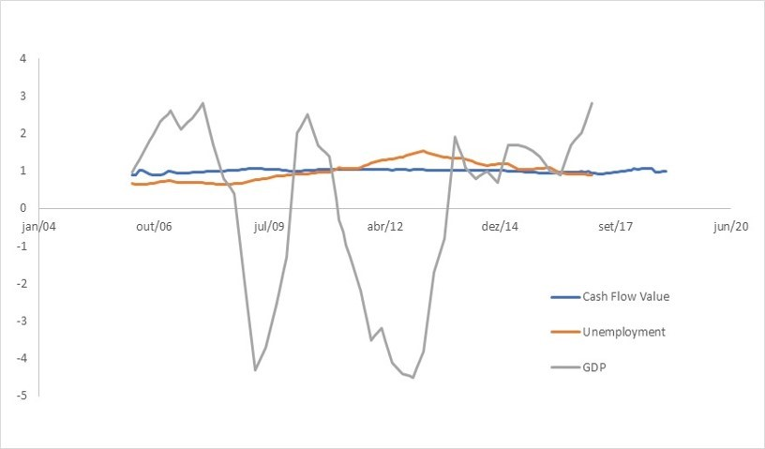
FIG. 7. Average cashflow value variation between 2006 and 2018 compared with unemployment variation and GDP variation in Portugal
From this analysis, we can say that the analytical results presented in section II, namely Eq.(11), are confirmed. The macroeconomic variables seem to have no effect whatsoever on the portfolio value in average terms. This result is particularly significant if we take into account that the Portuguese economy went through considerable turmoil due to the Portuguese state bankruptcy and subsequent bailout, with IMF and ECB intervention, that lead to a very strict austerity program[13] from 2011 forward.

DISCUSSION & CONCLUSION
Why are these results expectable? The fact is that we can only have a probability measure if we can have a stable number of possibilities and that cannot happen unless we consider the time frame for which we can consider that everyone will eventually ‘die’. And this is a very important condition necessary to assume that there is a natural tendency for a credit to default, and that it will happen in some bin of time in the future. From this assumption, it is simple to obtain a Gamma distribution for this behavior by aggregating the Bernoulli trials in each time bin.
Considering the cashflow and the continuity the portfolio and taking Fig.2 , it is straightforward that when the peak of the distribution comes near the origin, that is, the characteristic time to default shortens than the oldest contracts that did not default are less probable to default while the new contracts are more probable to default. On the opposite, when the characteristic time to default gets longer, then the newer contracts get less probable to default while the oldest get more probable. In terms of analytical expression that is translated by Eq.(11). The empirical evidence was given by a portfolio that would be considered as an high risk portfolio, i.e. credit awarded mostly to companies with some individual credit in the mix.
This result is important when compared with the generally accepted Basel and impairment rules. From the analytical and empirical result we should reach the conclusion that the value of a portfolio is considerably stable in terms of average contract value, as long as business keeps rolling at the same rate. But the generally accepted procedure is to measure probabilities by considering the default rate at one instant in time and, then, average it through the past instants. That is not a probability measure since it does not fill the Kolmogorov axioms that any text book on probability theory explains. What happened to the bank from which the portfolio was taken (whose name cannot be disclosed) was that the probability measure would give a rise in the probability of default (PD in the Basel jargon) because the portfolio volume dropped by 40% during the Portuguese crisis, but the risk of the customers did not change, like the value of the portfolio, also, does not change if the same comercial policies were to be maintained, instead of contracting the portfolio to save Tier 1 capital.
Also, since impairment rules are to be calculated through the life of the contract, we can see here by both analytical and empirical results that with constant commercial policies there is no room for impairment in a stable portfolio. Thus, the new rules for impairment calculations[14], resorting to macroeconomic projections for impairment calculations, do not make sense considering the results from the last section and the arguments presented in this section.
There are some considerations that we need to take into account. First, the assumption of the independence of the defaults from instant to instant. We stated that the selection of the credits would give the independence and we argue with the economic network. Theoretically, there are conditions of such severity that the independence assumption drops and the above results are no longer valid. Nevertheless, we should take into account that the Portuguese conditions were quite severe and that the empirical data corroborates the analytical result. Second, there is no guarantee that a commercial policy can be kept under any market conditions without significantly changing the selection process. Nevertheless, the suggested strategy is that a bank should work with parameters that are not probability measures, namely interest rate and maturity. Finally, the value of the portfolio is not immune to interest rate conditions in the market. The goal in this work was to look exclusively to credit risk without considering interest rate risk, for which there already is a panoply of hedging instruments.

ACKNOWLEDGEMENTS
The authors would like to thank J. Meireles for the help in this work.
- D. Lando, Credit Risk Modeling: Theory and Applications, Princeton Series in Finance (Princeton University Press, 2009).
- M. B. Gordy, Journal of Banking & Finance 24, 119
(2000).
- R. C. Merton, The Journal of finance 29, 449 (1974). [4] F. Black and J. C. Cox, The Journal of Finance 31, 351
(1976).
- O. Vasicek, Probability of Loss on Loan Portfolio (KMV, 1987).
- B. C. on Banking Supervision, Basel II: International Convergence of Capital Measurement and Capital Standards: A Revised Framework (2006).
- B. C. on Banking Supervision, Basel III: A global regulatory framework for more resilient banks and banking systems (2011).
- J. P. da Cruz and P. G. Lind, Physica A 391 (2010).
- J. P. da Cruz, H. Cruz, P. Beling, K. Rajaratnam, and G. Overstreet, Presented at CSCC XIV (2015).
- P. Scho¨nbucher, Portfolio losses and the term structure of loss transition rates: a new methodology for the pricing of portfolio credit derivatives, Tech. Rep. (Working paper, September, 2005).
- N. G. Van Kampen, Stochastic processes in physics and chemistry, Vol. 1 (Elsevier, 1992).
- J. Kingman, “Poisson processes,” in Encyclopedia of Biostatistics (John Wiley & Sons, Ltd, 2005).
- Portugal, Memorandum of Understanding On Specific Economic Policy Conditionality, Tech. Rep. (European Commission, 2011).
- G. L. Barnaby Black and J. Licari, Probability-Weighted Outcomes Under IFRS 9: A Macroeconomic Approach, Tech. Rep.

