A credit evaluation model based on random walk for guaranteed loan among enterprises
Xinhai Liu (1,2) Xiangfeng Meng (2)
- The CEIBS-World Bank China Center for Inclusion Finance,
Shanghai, China
- Financial Intelligence Research Center, Peking University, Beijing,
China

With the financial complexity increasing, the risk of an enterprise is not only caused by the financial health of itself, but also by the financial situation of other enterprises connected with financial relations. New risk management tool is required to measure such kind of linked risk from other enterprises. Guaranteed loan among enterprises is a typical example for linked risk management. Guaranteed loan is a popular approach for enterprises to raise money from banks without any collateral in China, covering 1/7 of the whole loan market. The complex guarantee relations have formed a densely connected guarantee network, with nodes representing enterprises and edges representing the guarantee relations. When the economy is down, the default of several enterprises in the guarantee network could cause a wide spread of the default risk. Under this situation, an enterprise will be exposed with the credit risk due to the default risk spreading. Thus a new challenge is put forward about the credit risk evaluation of enterprises. We define the credit risk of an enterprise caused by other enterprises as the outer credit risk. However, the existing credit risk models are unable to measure the outer credit risk of enterprises.
In this paper, we propose a quantitative model based on the random walk theory to evaluate the outer credit risk of an enterprise. The basic idea is that the outer credit risk of an enterprise is determined by how close the enterprise is to the default enterprises. The outer credit risk caused by default enterprises will spread to the normal enterprises along with the guarantee relations, with its influence gradually weakened as it spreads increasingly farther. Thus the overall influence of all the default enterprises on an enterprise forms the outer credit risk that the enterprise is exposed with. We apply our model to the real data of the guaranteed bank loans and compared it with other strategies. The experiments show that our model is effective in measuring the outer credit risk of enterprises, which can provide a new risk management tool for real application.
Experiment Results: We adopted the enterprise network with loan guarantee links in January, 2008 for risk prediction while we evaluate the results with enterprise network in January, 2009. We carried out the two kinds of experiments on the real data. In the first experiment setting, we tested the prediction results for the top 20 enterprises with high risk score and compared them with other ranking algorithms such as OutDegree,
PageRanking and Betweeness, our algorithm is much better than others. In the second experiment setting, we used three evaluation measures for prediction: precision, recall and F1, to test our algorithm on all enterprises. Though, the testing result is not so good as it in the first experiment setting, the performance still makes sense (The precision is 7.12%; the recall is 15.79; the F1 is 9.81% ).
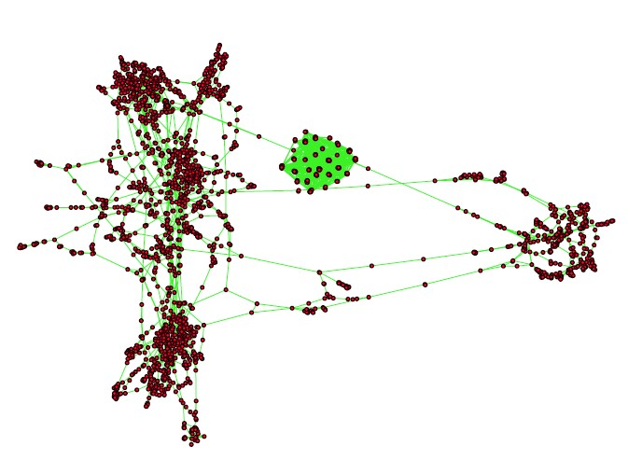
Figure 1 The financial network with different enterprises guaranteed each other.
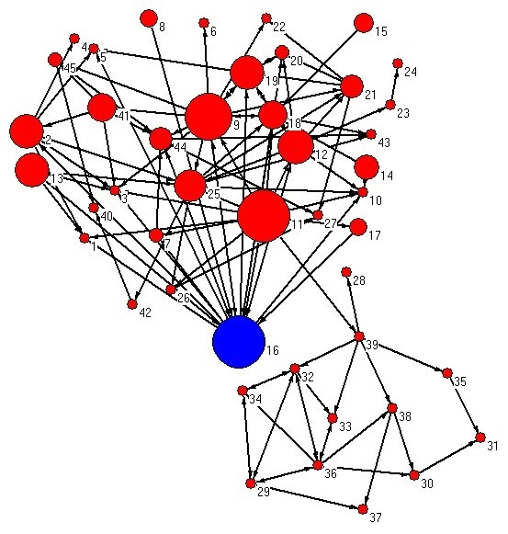
Figure 2 The risky enterprise predicted (with blue color) by our algorithm in the financial network.

