Causal regularization for Stable Scoring Card Model
Kun Li ¹ Fanglan Zheng ¹ Jiang Tian ¹ Xiaojia Xiang ¹
Abstract
Credit scoring models to predict the probability of default for credits in commercial banks are usu ally estimated on independently and identically distributed (i.i.d) hypothesis. However, this as sumption is too idealistic to commonly appear in the real scenarios, due to the agnostic sample selection bias. This inevitably leads to the fact that scorecard model’s stability and generalization often fail across different domains. Moreover, the data in new domain is usually not available when training a model, which makes transfer learning infeasible due to lack of prior information of new distribution.
In order to solve the above issues, we bring causal ity into predictive modeling and propose a novel stable scorecard model, namely SSCM, in this manuscript (ms). As far as the specific loss func tion is concerned in SSCM, it consists of two terms, weighted cross-entropy and global con founder balancing, respectively. The latter, de fined as a rigorous regulation in identifying and screening causal variables, is well recognized. Both of them are jointly optimized in an effective manner. It leads to the stabilization of predictors, whose conditional probability distribution remain invariant across different domains. Accordingly, a predictive scorecard is formed with outstanding robustness, and interpretability as well. Further more, the effectiveness of our SSCM is validated by mathematical analysis and model evaluation. Experimental results on synthetic and real world datasets show obviously that SSCM outperforms the traditional correlation-based scorecard.
At present, SSCM has already been applied to multiple business, including credit card applica tion and precision marketing, in a China nation wide financial holdings group.
¹Everbright Technology Co. LTD, Beijing, China. Correspon dence to: Kun Li <likun3@ebchinatech.com>.
Credit Scoring and Credit Control Conference XVII, Online, Credit Research Centre, University of Edinburgh Business School, 2021.
1. Introduction
Due to its desirable features (e.g., interpretability and robust ness), scorecard model based on logistic regression (LR) is the most commonly used binary classification technique, especially after Basel Accord II was implemented in 2007 (refer to (Basel Committee of Banking Supervision, 2007)). More formally, scorecard is a linear regression model to generate a single aggregated risk indicator of a group of variables, which is statistically significant to be predictive in distinguishing between goods and bads.
Credit scoring models are usually estimated on indepen dently and identically distributed (i.i.d) hypothesis (Ander son, 2007). That is, both training and testing data originate from the same distribution. Accordingly, the model learned from the training data is expected to make predictions with smallest empirical error on testing data. In many real-world applications, however, sample selection bias induced by preferential selection of units for data analysis does occur very often, which is governed by unknown factors such as treatment, outcome and their sequence. It inevitably results in the violation of this hypothesis. Even more, the testing data is not available when training a model, which is re ferred as agnostic selection bias. Thus, model’s stability and generalization will no longer exist across different domains.
Sample selection bias is commonly existing in almost all of the empirical studies, including machine learning, statistics, finance, bio-informatics, medicine, social science, etc. As a classic example, one version of bias selection was first studied in econometrics and led to the celebrated method for correcting sample selection bias. Its intuitive insight is that if we can estimate the probability that an observa tion is selected into the sample, we can use this probability estimate to correct the model. Recently, several typical methods based on domain adaption have been proposed to solve the above problem, including feature space transfor mation (Fernando et al., 2013; Ma et al., 2014; Long et al., 2018), invariant feature learning (Ganin & Lempitsky, 2015; Hoffman et al., 2017), etc. In brief, their key idea is to re-weight samples by density ratio of the training to the test data, so that its conditional probability thus become closely aligned with that of testing data (Yang & Pan, 2010). How ever, these methods require lots of prior knowledge of the test data, which may be not available in the real scenarios.

That is to say, an essential issue of agnostic selection bias will be always involved.
More recently inspired by causal inference, covariant learn ing algorithms have been proposed to identify causal fea tures (Peters et al., 2015). It’s well observed that causal features are insensitive to agnostic selection bias, due to the rigorous regularization on confounding effect. The corre sponding conditional distribution of causal features remain invariant across different domains. Likewise, domain gener alization as a representative method aims to learn invariant representation of feature data (Muandet et al., 2013). In practice, however, two major challenges still exist. First, limited by low extension, the current causal algorithms are not applicable for high-dimensional data, because of the intolerable temporal and spatial computational complexity. Then, it’s difficult to select causal features in a single train ing session, since their exploration process is quite iterative and time-consuming. Driven by causal inference, it is im portant and urgent to redesign a LR-based scorecard model to solve classification problem with agnostic selection bias.
In this ms, we propose a stable scorecard model (namely SSCM) with casual regularization motivated by (Shen et al., 2018; Kuang et al., 2018) , for risk prediction on agnostic test data in credit. Mathematically, the objective function of SSCM is composed of two terms, weighted cross-entropy and causal regularizer, separately. The former measures how far SSCM approximates original data distribution, while the latter is finely designed to balance confounder distribution through global sample reweighting. Both of them are jointly optimized for dimension reduction as well as identifying causal variables. Moreover, it is proved that our SSCM is able to make stable prediction from theoretical proof and empirical experiments. The extensive experimental results on synthetic and real credit data demonstrate the success of SSCM in learning with agnostic biased data,
The rest of this manuscript is structured as follows. First, in Sect. 2, problem formulation and theoretical analysis of stable scorecard model is provided. Then Sect. 3 gives the details of our experimental results on synthetic and real credit data, and finds that our method performs well in a wide variety of setting relative to the traditional scorecard in the literature. Finally, conclusions are presented in Sect. 4.
2. Stable ScoreCard Model
This section consists of three parts. First, we formulate the target problem of causal classification. Then, the details of the causal regularization, including objective function and optimization are given. Finally, we propose the whole diagram of our SSCM with binning and binarization for variable pre-processing,
2.1. Target Problem Formulation
The typical classification problem on data with agnostic sample bias can be described, as follows. Let X ∈ R^{n×p} and Y ∈ {0, 1}^{n×1}represent the features and label in a given training data D = (X, Y ), respectively. Here n is the number of samples and p is the number of features. The traditional LR classifier is to learn a classifier f_{θ}(·) with coefficient θ, which is a compound function of a Sigmoid and a linear function. It’s difficult to make stable prediction across agnostic environment, since the joint probability dis tribution of feature and label on (X, Y ) varies. Besides, we are not able to estimate the distribution shift with training data merely, just due to lack of prior knowledge.
Let’s assume that there exists a conditional probability P(y|s), which satisfies P r(Y^{e} = y|S^{e} = s, V ^{e} = v) = P r(Y^{e} = y|S^{e} = s) = P(y|s) for each unknown sam ple environment e. Following this assumption, the initial features X = {S, V } can be thus separated into two parts, causal features S and noisy features V or confounders. Ac cordingly, the key problem is to learn the stable function P(y|s) or more precisely, to identify the causal features. Without losing any generality, we assume all the features are binary (i.e. X ∈ {0, 1}^{n×p}) for the ease of discussion and understanding. Categorical and continuous features can be converted to binary ones through binning and one-hot encoding. The details of this preprocessing step will be discussed in section 2.3.
Under the paradigm of causal inference, we regard each feature X_{j} as a treated variable (i.e. treatment), all the re maining features X_{−j} = X \ X_{j} as confounding variables (i.e. confounders), which are from X by replacing its j-th column as 0. I_{j} means the jth column of identity matrix I (I ∈ {0, 1}^{n×p}), and I_{ij} refers to the treatment status of unit i when setting feature j as treatment variable. If a fea ture is given as treatment, the corresponding sample is thus defined as treatment. To estimate the causal contribution of a given X_{j} on outcome y, the fundamental strategy is to remove the confounding bias induced by the different distributions of confounders X_{j} between the treated and control groups. Accordingly, the difference of outcome y in these two groups implies the causal contribution of X_{j} . As for the linear LR classifier, the key task is to jointly identify the causal coefficients β ∈ R^{n×1}for all features and learn a classifier f_{β}(·).
2.2. Objective Function and Optimization
Variable balancing techniques are always used for causal estimation in the existing studies (Shen et al., 2020). To con sistently estimate the causal effect, confounder distributions need to be balanced to overcome bias originated from non random treatment assignment. Some confounder balancing approaches use moments to characterize distributions, and

balance them between treated and control groups by ad
justing weight of samples W by minimize the following term
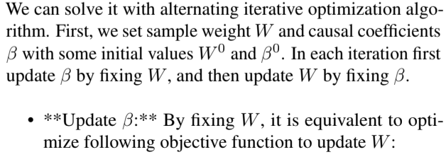
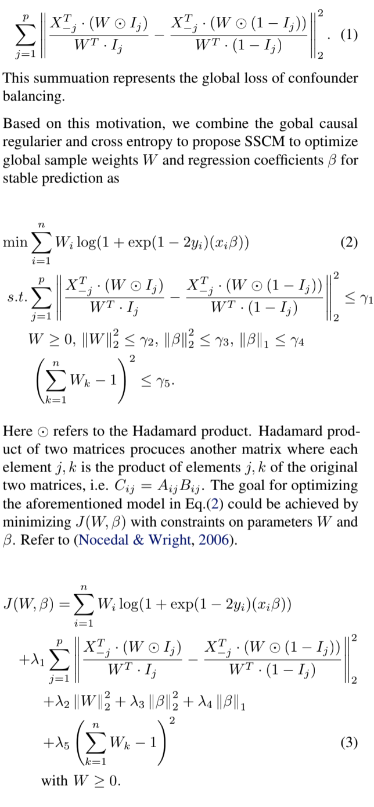
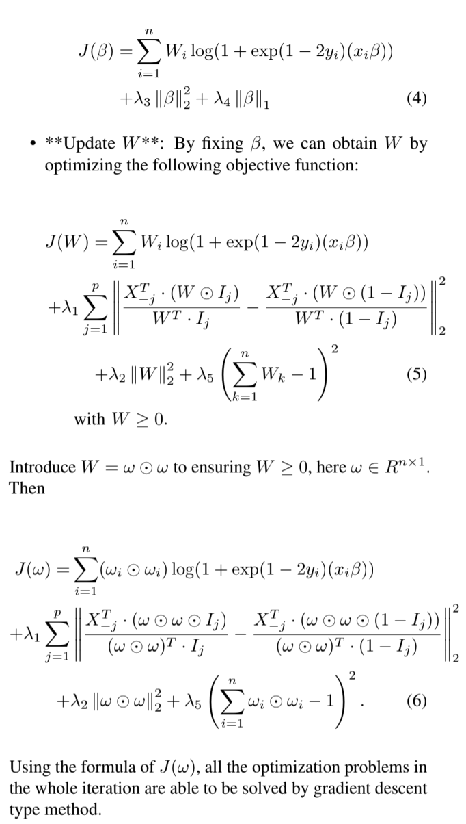
2.3. Data preprocessing for casual regularization
The traditional scorecard model is the use of LR to translate relevant data into numerical scores that guide credit deci- sions. Variables are seldom represented in their original form. They are usually segmented into grouping intervals, with the aim of creating bins for the model that maximize the correlation with these variables. Variable transformation through binning is an essential part of traditional scorecard, usually measured by Weight of Evidence (WOE). As for continuous variables, discretion can be accomplished via binning. The style of binning is always inspired by score- card construction methods. For categorical variables, no binning is needed and the histogram estimator can be used directly. After the original variables are transformed into

WOE variables, the information value of each variable is calculated for the following feature selection. Then a tradi tional scorecard could be obtained by LR model.
To satisfy the assumption in the target problem formulation mentioned in Section 2.1, a binary encoder applied for all the variables passed feature selection is necessary. It is also acceptable and appropriate for the detection of causal relations. The workflow of the traditional scorecard model and SSCM is summarized in Fig. 1. However the binary encoder, such as one-hot and dummy encoding, introduces the additional relation of encoding variables transformed from the same original variable. To avoid this bias, define the index set S_{j} = {i} for each variable X_{j} after binary encoding with X_{i} and X_{j} encoded from the same original feature, and
X_{−j} = X \ X_{Sj}, (7)
which are from X by replacing its each i-th column (i ∈ S_{j} ) as 0. The index sets S_{j} can be prepared quickly with the binary encoding. The whole algorithm of causal regularized logistic regression in SSCM is summarized in Algorithm 1.
Algorithm 1 Causal Regularized Logistic Regression in SSCM
Input: Positive tradeoff parameters λ_{i} > 0 (i = 1, 2, ..., 5), Binary encoded Variables Matrix X, index sets S_{j} and la bels Y .
Output: Causal Contribution β and Sample Weight W
1: Initialize β⁽⁰⁾ and W⁽⁰⁾.
2: Calculate the current value of J(W, β)⁽⁰⁾ with Eq.(3) 3: Initialize the iteration variable t ← 0
4: repeat
5: t ← t + 1
6: Update β^{(t)} by gradient descent for Eq.(4) with fixed W^{(t−1)}
7: Update W^{(t)} = ω^{(t)} ω^{(t)} by gradient descent for Eq.(6) with fixed β^{(t)}and X_{−j} in Eq.(7)
8: Calculate J(W, β)^{(t)} = J(W^{(t)}, β^{(t)})
9: until J(W, β)^{(t)}converges or maximun iteration is reached.
10: return β, W
3. Model evaluation on both synthetic and credit data
In this section, the effectiveness of our SSCM is evaluated on synthetic and credit datasets, respectively. Since the objective function of SSCM stems from LR-based cross entropy essentially, we implement it and compare with LR only, in terms of AUC and KS statistics.
3.1. Experiments on Synthetic Dataset
Suppose the initial variables X = {C, V } with indepen dent Gaussian distributions as C, V ∼ N (0, 1). As de fined below, C and V are causal and noisy features, re spectively. X = 1 if X ≥ 0, otherwise X = 0, make it binary. Meanwhile, the outcome Y is a function of causal variables, Y = f(C) + N (0, 1). Similarly, we set Y = 1 if Y ≥ 0, otherwise Y = 0, to make it binary. In or der to test the stability of our SSCM on data with biased sample selection, we create a set of different joint distribu tion. It requires that P(Y |V ) varies across environments. Specifically, we vary P(Y |V ) via biased sample selection with a bias rate r ∈ (0, 1). For each sample, it is selected with probability r if V equal to outcome variable Y , oth erwise the corresponding probability is (1 − r). That is, V = r ∗ Y + (1 −r) ∗ (1 −Y ). Thus, r > 0.5 means Y and V are positively correlated, and r=0.5 corresponds to that Y and V are independent. Otherwise, they have negative correlation. As a result, agnostic sample biases are thus created, by varying the bias rate r.
We test the stability of out SSCM through fluctuation in area under the curve (AUC), with different bias rate X = {0.6, 0.7, 0.8} on the synthetic datasets. Without the loss of generality, sample size and variable dimension are n=1000 and p=20, respectively. Also, we need to adjust λ₁ according to r, so that the causal regularizer is much smaller than the weighted cross-entropy. For this reason, λ₁ is set to be [0.1, 0.02, 0.005], when r increases from 0.6 to 0.7, and eventually to 0.8. It can be seen clearly from Figure 2 that the performance of the traditional LR in terms of AUC presents substantial decrease across data domains with different bias rate. The noisy variables play major contribution to the performance of the traditional LR, re sulting in instability across environment. By contrast, our SSCM achieve a stable and precise prediction across differ ent settings. The global balancing regularizer can weaken the noisy correlation between variables and outcome, which is highly consistent with the above theoretical analysis.
3.2. Experimental results in credit
In real retail credit, it often takes a long period of time to accumulate business data. We have to use the early small sample dataset to learn a scorecard, then make prediction for the latter. Inevitably, it leads to agnostic sample selection across different environments. In order to test the perfor mance of our SSCM in credit, we execute the experiments with data settings across time. To be specific, we use one do main in a month and another in the subsequent two months for both training and testing from a new business line of credit in a China nation-wide financial holdings group. The former consists of 3,361 non-defaults and only 33 defaults (events or overdue), while 4,965 and 49 for the latter. Note
Traditional Scorecard Model Stable Scorecard Model Continuous

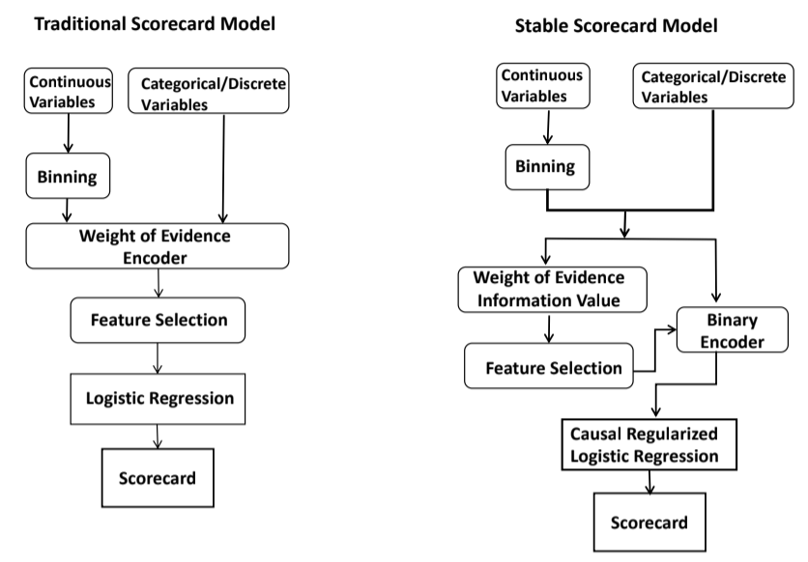
Figure 1. The workflow of the traditional scorecard model and Stable scorecard model building.
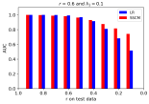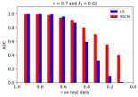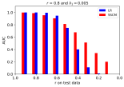
Figure 2. AUC of prediction on various test datasets by varying bias rate r on training dataset. λ₁ is set to be [0.1, 0.02, 0.005] so as to ensure that causal regularizer is a small term compared to weighted cross-entropy. The r of the x-axis presents the bias rate on the test dataset.
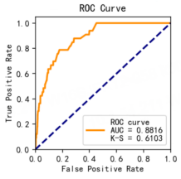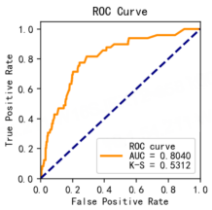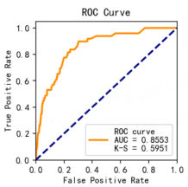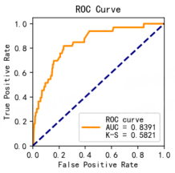
Figure 3. Model performance of traditional scorecard (TOP) and SSCM (BOTTOM), in terms of ROC and KS across different environment (the first months (LEFT) and the following two months (RIGHT)).

the latter IV the former IV
Var6 0.999 var6 0.868
Var3 0.435 var1 0.451
var1 0.406 var3 0.402
Var2 0.136 var9 0.245
Var9 0.104 var2 0.224
var8 0.101 var10 0.113
var0 0.089 var4 0.107
Var10 0.087 var0 0.103
var7 0.055 var7 0.053
Var5 0.016 var5 0.034
var4 0.015 var8 0.032
Table 1. Variables with IV in both former and latter domains are sorted in the descending order.
that the outcome variable is coded as 1 to indicate default (according to a default or definition chosen by the bank) and 0 to indicate non-default. Taking financial regulation and policy compliance into account, variable names of these do mains won’t be disclosed. For each sample, twenty variables are characterized as identity traits, consumption grade, net assets, loan amount, electricity, water, gas, property charges, mobile communication costs and etc.
According to Fig. 3, it is obvious that SSCM’stability across different domains in terms of AUC and KS statistics is remarkably improved due to causal regularization. Com pared to 0.08 in the standard scorecard, the difference of auc across the above two data domains reduces significantly to tiny 0.02 using our method. At the same time, we can also see clearly that KS statistic remains almost constant across different environment, varying merely from 0.58 to 0.59. Furthermore, in order to investigate the instability of score card in depth, we calculate information value more than a threshold 0.01 on these domains to measure the predictive variables. It can be seen from Table 1 that their absolute value and sorting change dramatically. Top three predic tors in the former domain are var6, var1 and var3 with the corresponding IV 0.868, 0.451 and 0.402, while var6, var3 and var1 with IV 0.999, 0.435 and 0.406 for the latter. That is to say, the agnostic sample bias in credit leads to the failure of model stability and generalization. And our SSCM can solve this issue effectively.
4. Conclusion
This manuscript proposes a stable scorecard model, SSCM in short, with causal regularization. Different from the tra ditional scorecard model, causal regularized logistic regres sion and a binary encoding process are introduced. With the help of our SSCM, the stability of the model performance over AUC and KS statistics on both synthetic and credit data is highly improved. Furthermore, it is applicable to multi
ple business scenarios, including credit risk management, precision marketing and other business.
Acknowledgements
The authors gratefully acknowledge the colleagues from China Everbright Bank for our valuable discussions on busi ness understanding and inspirations for the application de sign. The computing was executed on Everbright Data Haven (EDH), so we would like to express the deepest grat itude to the substantial help from EDH.
References
Anderson, R. The Credit Scoring Toolkit: Theory and Practice for Retail Credit Risk Management and De cision Automation. Number 9780199226405 in OUP Catalogue. Oxford University Press, 2007. ISBN AR RAY(0x3c10ae48). URL https://ideas.repec.
org/b/oxp/obooks/9780199226405.html.
Basel Committee of Banking Supervision, B. “progress on basel ii implementation, new workstreams and outreach. https://www.bis.org/publ/bcbs nl11.htm, 2007.
Fernando, B., Habrard, A., Sebban, M., and Tuytelaars, T. Unsupervised visual domain adaptation using subspace alignment. In 2013 IEEE International Conference on Computer Vision, pp. 2960–2967, 2013. doi: 10.1109/ ICCV.2013.368.
Ganin, Y. and Lempitsky, V. Unsupervised domain adap tation by backpropagation. In Proceedings of the 32nd International Conference on International Conference on Machine Learning - Volume 37, ICML’15, pp. 1180–1189. JMLR.org, 2015.
Hoffman, J., Tzeng, E., Darrell, T., and Saenko, K. Si multaneous Deep Transfer Across Domains and Tasks, pp. 173–187. Springer International Publishing, Cham, 2017. ISBN 978-3-319-58347-1. doi: 10.1007/ 978-3-319-58347-1 9. URL https://doi.org/10.
1007/978-3-319-58347-1_9.
Kuang, K., Cui, P., Athey, S., Xiong, R., and Li, B. Stable prediction across unknown environments. In Proceed ings of the 24th ACM SIGKDD International Confer ence on Knowledge Discovery & Data Mining, KDD 18, ´ pp. 1617–1626, New York, NY, USA, 2018. Associa tion for Computing Machinery. ISBN 9781450355520. doi: 10.1145/3219819.3220082. URL https://doi.
org/10.1145/3219819.3220082.
Long, M., Cao, Y., Cao, Z., Wang, J., and Jordan, M.

Transferable representation learning with deep adapta tion networks. IEEE Transactions on Pattern Analy
sis and Machine Intelligence, PP:1–1, 09 2018. doi:
10.1109/TPAMI.2018.2868685.
Ma, Z., Yang, Y., Sebe, N., and Hauptmann, A. G. Knowl
edge adaptation with partiallyshared features for event
detectionusing few exemplars. IEEE Transactions on
Pattern Analysis and Machine Intelligence, 36(9):1789–
1802, 2014. doi: 10.1109/TPAMI.2014.2306419.
Muandet, K., Balduzzi, D., and Scholkopf, B. Domain ¨
generalization via invariant feature representation. In
Proceedings of the 30th International Conference on In
ternational Conference on Machine Learning - Volume
28, ICML’13, pp. I–10–I–18. JMLR.org, 2013.
Nocedal, J. and Wright, S. Numerical Optimization:
Springer Series in Operations Research and Financial
Engineering. Springer, 2006. ISBN 9780387303031.
Peters, J., Buhlmann, P., and Meinshausen, N. Causal infer- ¨
ence using invariant prediction: identification and confi
dence intervals. Statistics, 78(5):947–1012, 2015.
Shen, Z., Cui, P., Kuang, K., Li, B., and Chen, P.
Causally regularized learning with agnostic data selec
tion bias. In Proceedings of the 26th ACM Interna
tional Conference on Multimedia, MM ’18, pp. 411–419,
New York, NY, USA, 2018. Association for Comput
ing Machinery. ISBN 9781450356657. doi: 10.1145/
3240508.3240577. URL https://doi.org/10.
1145/3240508.3240577.
Shen, Z., Cui, P., Zhang, T., and Kunag, K. Stable learn
ing via sample reweighting. Proceedings of the AAAI
Conference on Artificial Intelligence, 34(4):5692–5699,
2020.
Yang, Q. and Pan, S. A survey on transfer learning. IEEE
Transactions on Knowledge & Data Engineering, 22(10):
1345–1359, oct 2010. ISSN 1558-2191. doi: 10.1109/
TKDE.2009.191.

