Creating Provably Unbiased Machine Learning Models
Joseph L Breeden
Deep Future Analytics LLC
1600 Lena St., Suite E3,
Santa Fe, NM 87505 USA
breeden@deepfutureanalytics.com
Eugenia Leonova
Deep Future Analytics LLC
1600 Lena St., Suite E3,
Santa Fe, NM 87505
leonova@deepfutureanalytics.com
August 16, 2021
Abstract
Unintended bias against protected groups has become a key obstacle to the widespread adoption of machine learning methods. This work presents a modeling procedure that carefully builds models around protected class information in order to make sure that the final machine learning model is independent of protected class status, even in a nonlinear sense. This procedure works for any machine learning method.
The procedure was tested on subprime credit card data combined with demographic data by zip code from the US Census. The census data serves as an imperfect proxy for borrower demographics but serves to illustrate the procedure.
Keywords: Unintended Bias, Fair Lending, Multihorizon Survival Mod els, Machine Learning
1 Introduction
The greatest challenge to the widespread adoption of machine learning methods in credit underwriting is the risk of violating the Fair Credit Reporting Act (FCRA) [1] by providing recommendations that are adversely correlated to pro tected class status such as race, gender, religion, zipcode, etc. The challenge arises from the ability of machine learning methods to leverage superficially un related data to infer structure that is highly correlated to protected class status
1

2
even though the input data did not explicitly include any such factors. Past FCRA rulings indicate that a model’s forecasts cannot be adjusted after devel opment to remove bias. Rather the model must be developed initially to lack any prohibited correlations.
Our work creates a two-step modeling process to prevent the final model from having any structures, linear correlation or nonlinear dependence, related to protected class status. This is accomplished by first creating a model that predicts loan output using only prohibited information. This is used as a fixed input to a second model that only uses seemingly appropriate information but that could otherwise exhibit correlations to protected class status. When the model is used for loan underwriting, the first model on restricted information is replaced with a single average loss rate which serves as what would have been the intercept term of the model using appropriate inputs.
This seemingly simple procedure has some subtle consequences and bene fits and is ideally suited to unconstrained or uncontrollable machine learning models. Other groups have developed bias measurement toolkits intended to help researchers measure potential bias and adjust their models appropriately [30, 2]. Our goal is to develop a modeling procedure that cannot be biased as a consequence of its construction, guaranteeing that it would pass such tests.
The article begins with a discussion of bias in machine learning and unique challenges in lending. Section 3 describes the test data, including census data and performance of subprime credit cards. Section 4 describes the modeling methods used for this test. Sections 5 and 6 provide the model estimation details and test results.
2 Definitions of Bias
Concerns about bias in machine learning are literally everywhere. Examples of failures in the criminal justice system[37], hiring at Amazon[10], suggestions of problems with the Apple Card [22], and facial recognition [18] are just a few [26]. Notably, the defense of Apple Card against gender bias in the as signment of credit lines was that none of the inputs included gender. However, gender blindness does not guarantee gender neutrality, which is the essence of the problem in applying machine learning to credit risk modeling.
Mehrabi, et. al [25] put all the potential sources of bias into two broad categories: bias in the data or bias in the algorithm. Within these they define 23 kinds of bias. However, the bias problem in lending is actually different from all of those. Our data may faithfully represent what is in society and have no knowledge of protected class status, and yet correlate to such status in violation of FCRA. This is an unintended ethical bias [34]. So how do we remove an ethical bias with no knowledge of the ethical conflict? The truth is that we cannot. Judging a model on ethical bias after it was created without knowledge of protected class status is a doomed approach, and yet how regulators appear to be approaching the problem. To prevent ethical bias, we must know that we are biased or at least where we have risk of bias. Having color-blind data does

3
not protect us from creating models that are color-biased.
With linear methods, we generally feel safe in saying that no information on protected class status was given to the model, so the results are unbiased. The same cannot be said of machine learning [11, 27], especially when given alternate inputs. Big Data and sophisticated modeling approaches create sig nificant risks of unfair treatment [26]. Unfortunately, a linear mindset underlies US regulations.
One such example showed that the digital footprint of an online borrower was as predictive as FICO score, yet all of those digital footprint data elements probably correlate to protected class status [3]. Excluding protected data is insufficient to assert that the final model’s forecasts do not correlate to protected status. Simple linear correlation is the standard for finding discrimination.
We refer to this as an unintended bias, because the model developer may take no actions specifically intended to create such bias and may themselves be unaware of the presence of bias. The unawareness of bias can easily occur, because except for mortgage reporting requirements, lenders are actually pro hibited from collecting data on protected class status in a way that would allow a credit risk model developer to conclusively test the models. The best that can be done today is to guess ethnicity from last names, as regulators have been attempting, and yet that process is prone to being unfair as well.
The task then becomes creating a model that is ethically unbiased even though the data set provides no information against which to test for bias. To be blunt, that is practically impossible for the most well-meaning human agent. For an automated algorithm, failure is assured, eventually. The solutions will be legal as much as statistical [23].
For the present research, we imagine a world where protected class status is included in the data set, so that we can intentionally prevent bias and test for success. This is true in applications outside of lending, so we hope that someone with Amazon’s hiring data or criminal justice data would test our approach. In this case, we will use US Census data by 5-digit zip code as a proxy for who the borrowers might have been.
3 Data
Data was obtained from a Near Prime to Subprime credit card portfolio, defined as less than 700 FICO. The data sample contained 146,500 accounts originated between 2005 and 2019, which were split half for testing and half for training. Averaged across the observed period from 2007 through 2019, the default rate was 6.2%. We specifically avoided data from the SARS-CoV-2 (COVID-19) pandemic. Performance data during this period was strongly affected by job losses but also government support programs and lender forbearance programs that are not well-captured in the data. In addition, these programs are not yet closed at the time of this research, so the ultimate default outcomes are not yet known [7].
The later analysis will create models using only that information available at

4
origination to predict later defaults. The portfolio data included the following metrics:
• Original score
• Original interest rate
• Subcategory
• Credit limit
• Balance transfer
• Total loan balance
• Total deposits
• 5-digit Zipcode
Total loan balance and total deposits refer to the complete relationship of the borrower with the lender across all products.
The US Census data was obtained from the 2010 census, which had the best overlap to the available loan data. The following fields were extracted, specifically because they would not be FCRA compliant.
• Median age
• Male to female ratio
• Persons per household
• Asian fraction
• Black fraction
• Native American fraction
• Native Hawaiian fraction
• Hispanic fraction
The origination data from the loan portfolio was matched by 5-digit zipcode to incorporate the census data. We cannot know the actual age, gender, or ethnicity of the borrower, but simply assigned the probability or average of these values from the census data for the area where they reside.
Table 1 shows the correlations between the assigned census values and the loan data. In almost all cases statistically significant correlations are found, even though those correlations are slight. Correlations to interest rate and credit limit are excusable when the same data correlates to the original credit bureau score used for underwriting.
This table is not evidence of bias. At most it is evidence of a cultural problem that non-white ethnic groups in the US are poorer than corresponding

5
white borrowers. Notably, in almost every case, when the percentage of an ethnic group rises and bureau scores decline, interest rates rise and credit limits decline. The movement of interest rates and credit limits relative to bureau scores is financially reasonable. The correlation between ethnicity and bureau score is where the cultural problem lies.
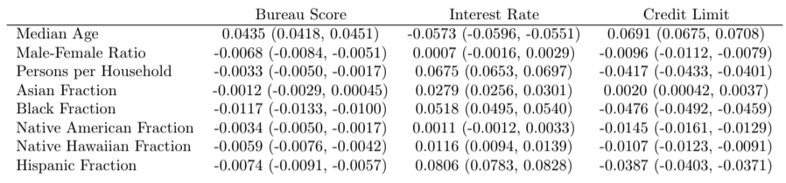
Table 1: Correlation coefficients were computed between census measures and loan data in the corresponding zipcodes. 95% confidence intervals are shown
The challenge faced by lenders is proving a lack of bias. The portfolio an alyzed here used underwriting methods that passed regulatory review on the basis that they did not have any protected class status inputs, the models were linear, and the sensitive factors in the model were to the borrowers’ past finan cial performance as measured at the credit bureaus. In a world of alternate data and machine learning, even when everything is done properly, residual correla tions to protected class are almost certain unless explicit preventative measures can be taken.
4 Model Development
A significant amount of research is being conducted on how to identify and mitigate disparate impacts from machine learning. Current methods can largely be grouped into two approaches. The first is to modify the input data to prevent models from finding biases [20, 39, 38, 11, 17]. The second approach modifies the learning algorithm to add constraints that would enforce fairness conditions. [28, 12, 16, 21, 36].
Correlation is a simple linear measure. A simple even-ordered polynomial relationship between the default outcome and a restricted input could discrimi nate against borrowers and yet slip past a linear correlation test. To comply with the spirit of the law and the ethics behind the law, our approach seeks to make sure that nonlinear methods such as the many machine learning approaches do not find pockets of predictability relative to restricted inputs.
To achieve nonlinear independence between credit risk modeling and re stricted inputs, we propose the follow analysis steps:
1. Perform Age-Period-Cohort analysis to quantify lifecycle and environ ment.
2. Create a scoring model via regression or machine learning using only re stricted inputs and APC functions as a fixed offset.

6
3. Create a second scoring model via regression or machine learning using only apparently acceptable inputs with the restricted scoring model and APC functions as a fixed offset.
4. Create the forecasts from the second scoring model with the restricted scoring model inputs set to zero.
The first step using Age-Period-Cohort analysis allows us to normalize the default performance for changing macroeconomic environments, seasonality, and the lifecycle versus age of the account. This is optional as part of creating a score, but it serves both to stabilize the score estimation through different phases of the economic environment and to allow the model to predict calibrated probability of default using macroeconomic scenarios [9].
The second step of building an APC Score[] using only restricted inputs and with the APC lifecycle and environment as fixed inputs is designed to provide a worst-case model. What is the most structure that can be explained statistically due to restricted inputs, even though we know that these inputs are correlated to financially reasonable inputs such as bureau scores, as seen in Table 1? To be clear, this model will never be used in underwriting. It is created only so that the next model can be unbiased.
The third step creates another APC Score, this time with the restricted model and APC lifecycle and environment all as fixed inputs. The traditional credit risk factors considered in this step will therefore be explaining only that structure not previously captured by product lifecycle, economic environment, seasonality, and protected class status.
Forecasts from this model would be unacceptable, because the model in cludes the restricted model. However, the restricted model is a separable com ponent of the model that will be mean-zero from the estimation process. Simply setting the restricted model input to 0 at the time the model is run would elim inate any influence in the forecast from those restricted inputs. The model will be age, gender, and ethnicity-blind to the extent that the restricted model cap tured those sensitivities. The better the restricted model, the more unbiased will be the final forecasts in step 4.
For comparison in the results section, we also created a credit risk model without the restricted model inputs, in order to represent how models are cre ated today. We will compare the traditional approach to the use of a restricted model to see how much forecasting accuracy degrades from this process.
4.1 Age-Period-Cohort Analysis
Age-Period-Cohort models [29, 24, 15, 4] are a kind of vintage analysis and are closely related to panel survival models. The advantage of APC in modeling lending data comes from the ability to explicitly set constraints on the linear trend ambiguity between age, vintage, and time functions. We know from the work by Holford [19] that once the constant and linear terms are appropriately incorporated, the nonlinear structure for F, G, and H is uniquely estimable.

7
The target variable for this study is the probability of default (PD) where default is measured as being ≥ 90 days past due. PD is measured relative to the previous months’ active accounts. Attrition is not explicitly modeled, because consumer credit cards are more likely to go dormant than be closed by request of the cardholder. Account closure is most often initiated by the lender in moments when they seek to reduce their risk from those dormant credit cards becoming unexpectedly active or stolen.
_{P D(t) =} Def aultAccounts(t)
_{ActiveAccounts(t − 1)} (1)
Loan performance can be described in an APC model as
_{log(}P D(a, v, t)
_{1 − P D(a, v, t}) = F(a) + G(v) + H(t) + (a, v, t) (2)
F(a), referred to as the lifecycle, measures the loan’s default risk as a func tion of age of the loan, a. G(v) captures the unique credit risk of each vintage as a function of origination date, v. H(t) measures variation in default rates by calendar date t to capture environmental risks such as macroeconomic impacts and seasonality.
In the present context, these functions were estimated nonparametrically via Bayesian APC [33]. Nonparametric estimation is appealing for capturing details in the vintage and environmental functions. Because the lifecycle, credit risk, and environment functions are summed, only one overall intercept term may be estimated. By convention, the estimates are constrained so that the mean of the vintage function G(v) and mean of the environment function H(t) both equal 0. The relationship t = v + a also requires that an assumption be made about how to remove the linear specification error. Consistent with earlier work[6], this is accomplished using an orthogonal projection onto the space of functions that are orthogonal to all linear functions. The coefficients obtained are then transformed back to the original specification.
4.2 APC Scoring
Previous work [5] has shown that the vintage function G(v) may be replaced with an account level credit score. A panel logistic regression model may be created with F(a) + H(t) as fixed inputs. ”Fixed” means that the coefficient for those inputs is unchanged during the model estimation. This has the effect of letting F(a) + H(t) specify the mean of the distribution at each forecast month and the logistic regression model estimates the distribution of account risk centered about that mean.
8
where s_{ij} are the available attributes s_{j} at origination for account i. The c_{j} are the coefficients to be estimated. Vintage dummies are included with coefficients β_{v}. To avoid colinearity problems between the APC and scoring components, the lifecycle and environment functions from the APC analysis, F(a)+H(t) are taken as fixed inputs when creating the logistic regression model in Eq. 3.
4.3 Stochastic Gradient Boosted Trees
For the present study, any machine learning method might be employed. Neu ral networks of various forms have many proponents within credit risk modeling, partly because they can be structured to improve credit decision explainability[35]. For this demonstration project we have chosen to use stochastic gradient boost ing due to its popularity among credit risk modelers and broad success in data science.
The credit score is built as a decision tree with each split optimized accord ing to fitness function that is controlled by the stochastic gradient boosting algorithm. Conceptually, one could describe boosting as a process of build ing subsequent models on the residuals of previous models, though for model types that have no explicit measure of residuals [32, 31]. Gradient boosting [13] computes the gradient of a fitness function in order to provide weights to each model trained. Stochastic gradient boosting [14] combines bagging with gradient boosting, building an ensemble of ensembles of trees where different gradient boosted ensembles are built for each data sample.
4.4 APC + SGB Trees
To maintain parity with the APC Scoring approach, the stochastic gradient boosted trees were also created with a fixed input using the lifecycle and en vironment from APC [8]. This approach combines the discrimination power of SGB Trees with the adaptation through time of vintage analysis and is proving highly effective as a method to combine scoring and long-range forecasting.
In the study of unintended bias, the APC + SGB Trees also provides a natural approach to include the structure of the restricted model as a separable component to be dropped out later.
5 Model Estimation
All of the models created for this study begin with an Age-Period-Cohort anal ysis of the data to normalize for trends due to product lifecycles and macroe conomic trends. Figures 1 through 2 show the functions estimated on subprime credit card data.
The lifecycle function was estimated as log-odds of monthly default and then transformed to monthly probability of default for display purposes. It shows a peak risk around 36 months from origination and decreasing risk thereafter

9
as the riskiest accounts have previously defaulted. The initial default spike represents fraud or other underwriting failures.
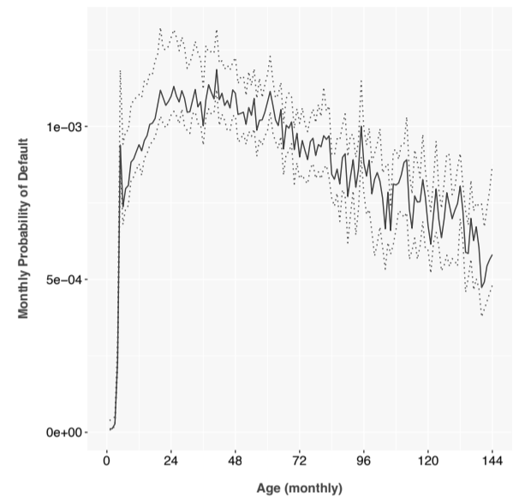
Figure 1: APC lifecycle function estimated on the subprime credit card portfolio.
The vintage function shows the risk of each monthly vintage relative to the average lifecycle and is therefore centered about 0. This shows a risk peak in 2007-2008 as was common in the industry. The portfolio also shows rising risk in the most recent years, again as has been seen in other portfolios. Both peaks could be a combination of macroeconomic adverse selection [6] and increased risk appetite by the lender.
The environment function begins with the peak of the 2009 recession and shows steady macroeconomic improvement throughout the history. Defaults also show a distinct seasonal pattern throughout the history. Again, the environment function is measured relative to the lifecycle and is therefore mean zero.
The first scoring model estimated used the APC Scoring approach for lo gistic panel regression with standard credit risk inputs, Table 2. In a business application, credit limit would not be included as an input factor, because the score would be intended to advise the assignment of credit limits. In this ret rospective analysis, credit limit highlights that some information was used in underwriting that was not otherwise available at the time of this retrospective.
Tables 3 and 4 show the coefficients for the model built on restricted inputs. The coefficients of this model are marginally significant, but it is not subject to regulatory scrutiny so we left everything in to maximize possible sensitivity.
The rest of the models were built using the same framework and variable

10
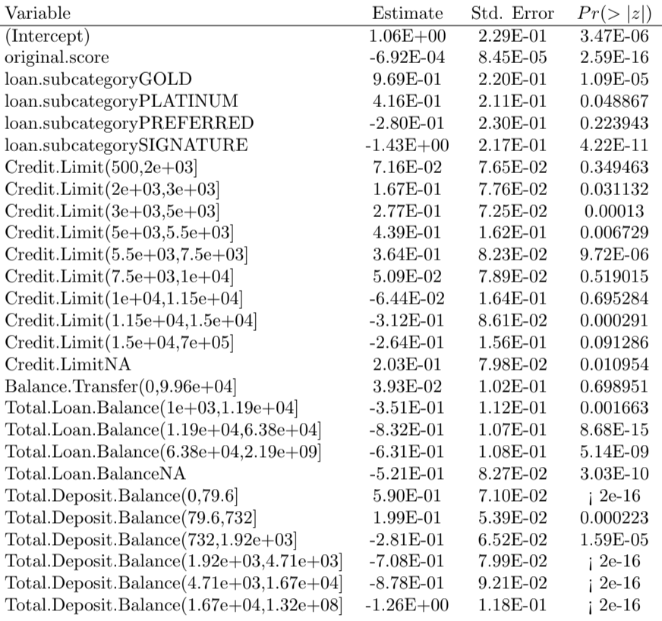

Table 2: Regression output from the APC Scoring model using standard credit risk modeling inputs.

11
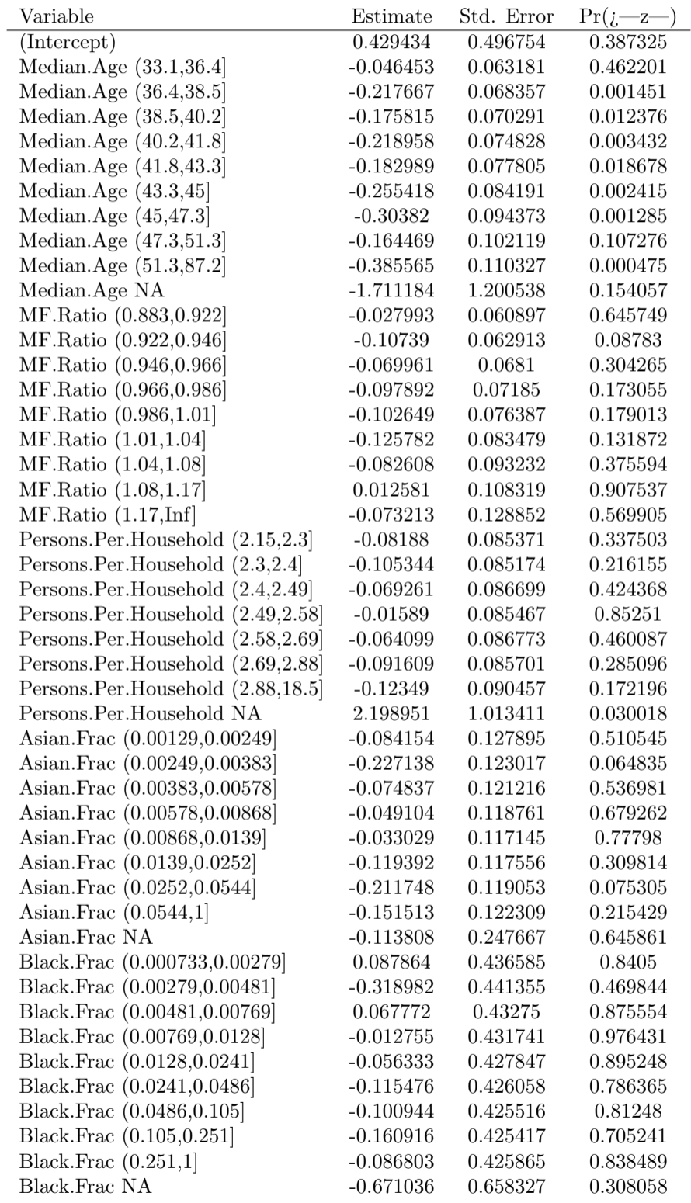
Table 3: Coefficients for the APC Score built on restricted coefficients, part 1.

12

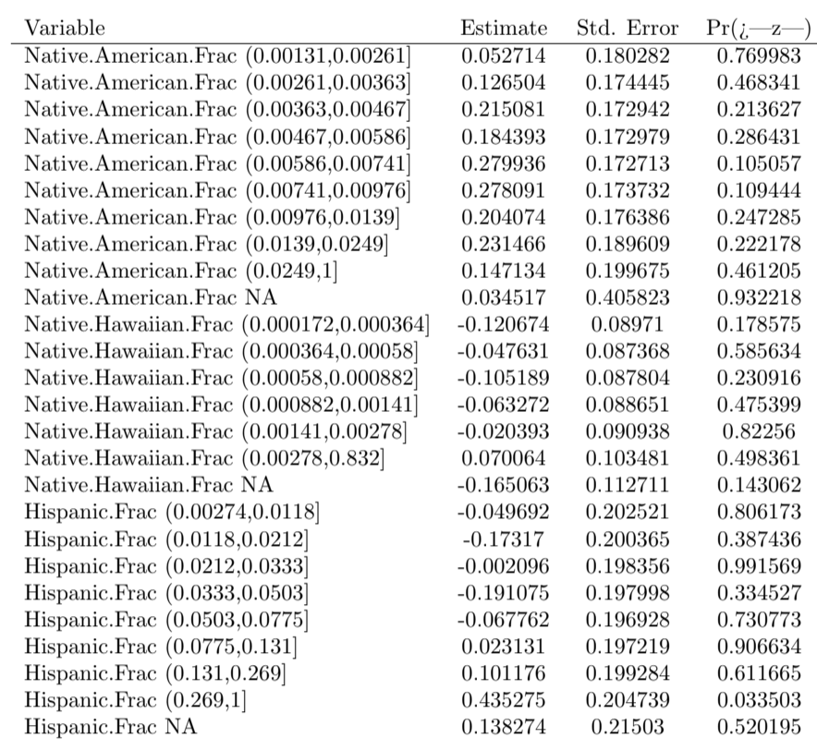
Table 4: Coefficients for the APC Score built on restricted coefficients, part 2

13
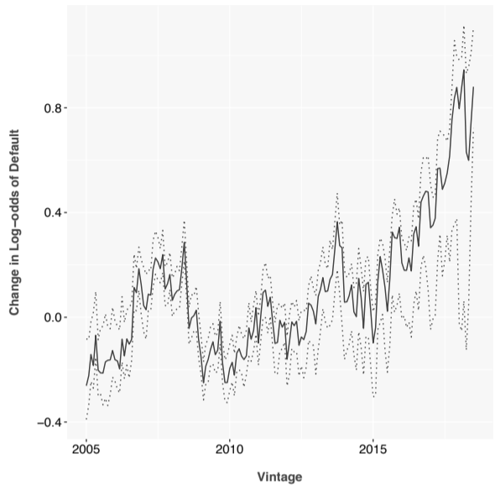
Figure 2: APC vintage function estimated on the subprime credit card portfolio.
sets as described previously. Table 5 describes all of the models built and tested here.
6 Results
All of the models were tested by creating 36-month forecasts from the origination date and using the actual lifecycle and environment as input. In a real-world test, the environment would be replaced with a macroeconomic model using macroeconomic scenarios as inputs. In the current context, macroeconomic models and scenarios are not germane to the topic of unintended bias.
ROC curves are shown in Figures 4 and 5, which are cumulative over the 36 month period for both forecasted and observed defaults. AUC and Gini coefficients were estimated from the ROC analysis, as shown in Tables 6 and 7 for in-sample and out-of-sample results, respectively.
The model built from restricted inputs alone is immediately less predictive than those using financial inputs. This is almost certainly due to the weak association between census data and the performance of an individual borrower, and because previous borrower performance in repaying debt really is the best predictor of future performance. We knew going into this analysis that census data was not sufficient to completely test unintended bias in a portfolio, but as a proxy it serves to demonstrate the process.

14 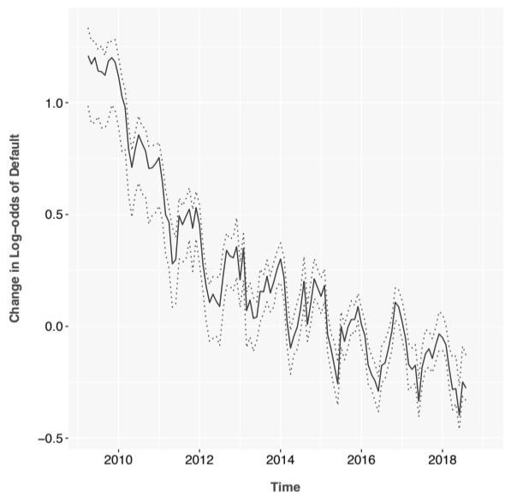
Figure 3: APC environment function estimated on the subprime credit card portfolio.
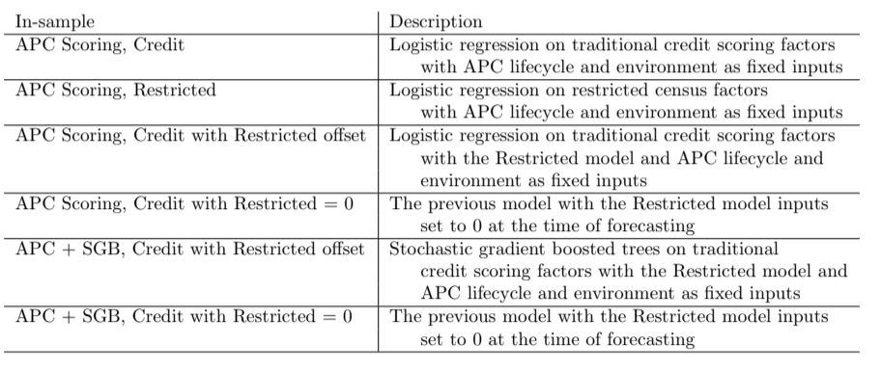
Table 5: Descriptions of the models and forecasts created for testing.

15 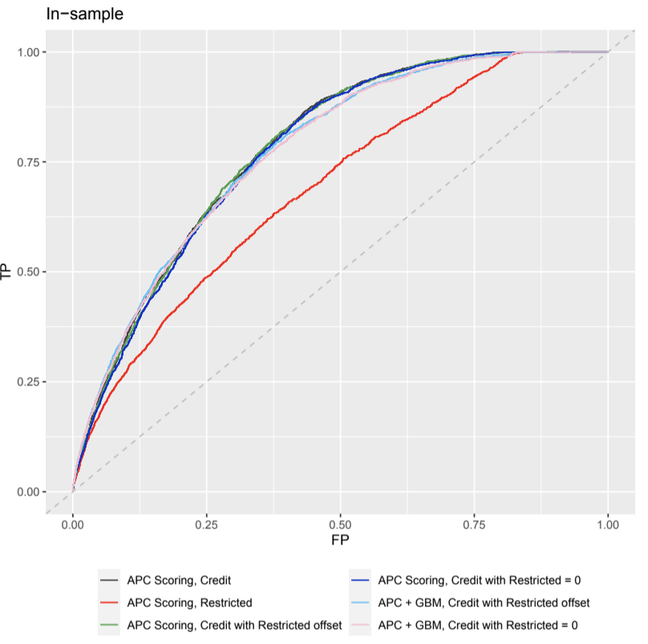
Figure 4: ROC curves for cumulative 36-month forecasts for the in-sample data set. FP is the false positive rate. TP is the true positive rate.
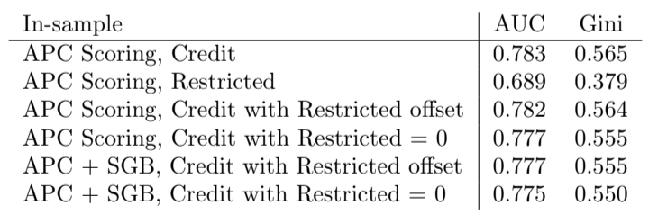
Table 6: AUC and Gini coefficients for each of the models tested cumulatively over a 36-month forecast on the in-sample data set.

16
Note that the forecast results degrade only slightly when the Restricted model is set to zero for forecasting. With actual borrower demographics, this degradation would probably be significantly increased. Comparing the models with the Restricted inputs and with those set to zero provides a quantitative comparison of the cost to lenders and society of enforcing our ethical standards. Just like clean water and safe roads, society should pay these costs to create the world we would wish to live in. This analysis simply provides a way to quantify that investment.
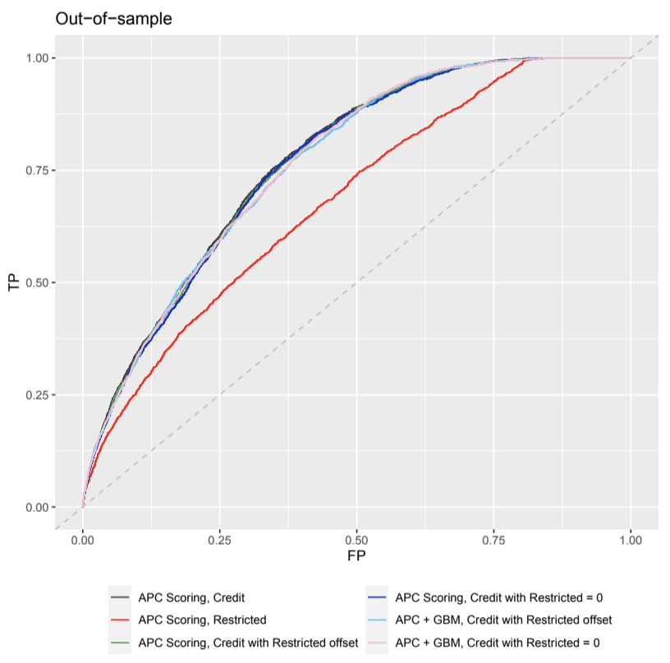
Figure 5: ROC curves for cumulative 36-month forecasts for the out-of-sample data set. FP is the false positive rate. TP is the true positive rate.
The results show only slight degradation when moving to out-of-sample per formance. This has been observed previously in the context of building a score with APC lifecycle and environment as fixed inputs and is theorized to be due to the normalization provided by those inputs.
We also note that APC Scoring and APC + SGB Trees have nearly identi cal results. This is easily explained by considering the available credit scoring inputs. By binning the input data, the logistic regression of APC Scoring is

17
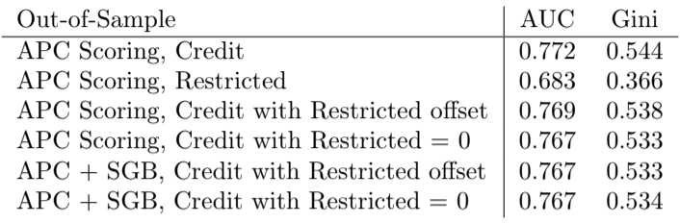
Table 7: AUC and Gini coefficients for each of the models tested cumulatively over a 36-month forecast on the out-of-sample data set.
able to match the nonlinearity of stochastic gradient boosted trees. Also, the inputs are so simple that no important interaction terms are present. With a more complex data set containing many more interaction terms, we would expect APC + SCB Trees to exhibit an advantage.
7 Conclusions
This paper develops a modeling procedure that can create theoretically unbiased models so long as the training data is tagged with the protected class status against which one wants to prevent bias. The procedure is admittedly quite simple and yet highly effective. Most importantly, it avoids processes that have been shown to violate FCRA regulations, such as renormalizing the forecasts after model creation. We also find side benefits such as being able to quantify how much forecast accuracy is given up in the process of becoming provably unbiased.
The application to a subprime credit card portfolio was effective because of the high default rate in the data and having a significant population of borrowers whom we wish to protect from discrimination. Combining borrower data with zipcode level census rates was not guaranteed to work, but the data actually showed plenty of useful structure.
The best test of this procedure will be to consider actual borrower demo graphic characteristics. If such data sets are not available in lending, perhaps applications outside of lending would provide a safe and effective demonstration.
References
[1] Fair credit reporting act. Federal Trade Commission, September 2012. 15 U.S.C. S 1681.
[2] Rachel KE Bellamy, Kuntal Dey, Michael Hind, Samuel C Hoffman, Stephanie Houde, Kalapriya Kannan, Pranay Lohia, Jacquelyn Martino, Sameep Mehta, Aleksandra Mojsilovi´c, et al. Ai fairness 360: An extensi ble toolkit for detecting and mitigating algorithmic bias. IBM Journal of Research and Development, 63(4/5):4–1, 2019.

18
[3] Tobias Berg, Valentin Burg, Ana Gombovi´c, and Manju Puri. On the rise of fintechs–credit scoring using digital footprints. Technical report, National Bureau of Economic Research, 2018.
[4] Joseph L. Breeden. Reinventing Retail Lending Analytics: Forecasting, Stress Testing, Capital and Scoring for a World of Crises, 2nd Impression. Risk Books, London, 2014.
[5] Joseph L. Breeden. Incorporating lifecycle and environment in loan-level forecasts and stress tests. European Journal of Operational Research, 255(2):649 – 658, 2016.
[6] Joseph L. Breeden and Jose J. Canals-Cerd´a. Consumer risk appetite, the credit cycle, and the housing bubble. Journal of Credit Risk, 14(2):1–30, 2018.
[7] Joseph L. Breeden, LiMing Brotcke, Bin Duan, Andy Johnson, Charles Maner, and Paul ONeal. Impacts of covid-19 on model risk management. MRMIA Best Practices, 1:85–125, 2021.
[8] Joseph L Breeden and Eugenia Leonova. When big data isnt enough: Solv ing the long-range forecasting problem in supervised learning. In 2019 International Conference on Modeling, Simulation, Optimization and Nu merical Techniques (SMONT 2019). Atlantis Press, 2019.
[9] Joseph L. Breeden and Lyn C. Thomas. The relationship between default and economic cycle for retail portfolios across countries: identifying the drivers of economic downturn. Journal of Risk Model Validation, 2(3):11 – 44, 2008.
[10] Jeffrey Dastin. Amazon scraps secret ai recruiting tool that showed bias against women, Oct 2018.
[11] Michael Feldman, Sorelle A Friedler, John Moeller, Carlos Scheidegger, and Suresh Venkatasubramanian. Certifying and removing disparate im pact. In proceedings of the 21th ACM SIGKDD international conference on knowledge discovery and data mining, pages 259–268, 2015.
[12] Benjamin Fish, Jeremy Kun, and Ad´am D Lelkes. Fair boosting: a case study. In Workshop on Fairness, Accountability, and Transparency in Ma chine Learning. Citeseer, 2015.
[13] Jerome H Friedman. Greedy function approximation: a gradient boosting machine. Annals of statistics, pages 1189–1232, 2001.
[14] Jerome H Friedman. Stochastic gradient boosting. Computational statistics & data analysis, 38(4):367–378, 2002.
[15] Norval D. Glenn. Cohort Analysis, 2nd Edition. Sage, London, 2005.

19
[16] Gabriel Goh, Andrew Cotter, Maya Gupta, and Michael P Friedlander. Satisfying real-world goals with dataset constraints. In Advances in Neural Information Processing Systems, pages 2415–2423, 2016.
[17] Moritz Hardt, Eric Price, and Nati Srebro. Equality of opportunity in supervised learning. In Advances in neural information processing systems, pages 3315–3323, 2016.
[18] Agneta Herlitz and Johanna Lov´en. Sex differences and the own-gender bias in face recognition: A meta-analytic review. Visual Cognition, 21(9- 10):1306–1336, 2013.
[19] T R Holford. The estimation of age, period and cohort effects for vital rates. Biometrics, 39(2):311–324, 1983.
[20] Faisal Kamiran and Toon Calders. Classification with no discrimination by preferential sampling. In Proc. 19th Machine Learning Conf. Belgium and The Netherlands, pages 1–6, 2010.
[21] Toshihiro Kamishima, Shotaro Akaho, Hideki Asoh, and Jun Sakuma. Fairness-aware classifier with prejudice remover regularizer. In Joint European Conference on Machine Learning and Knowledge Discovery in Databases, pages 35–50. Springer, 2012.
[22] Will Knight. The apple card didn’t ’see’ gender-and that’s the problem, Nov 2019.
[23] David Lehr and Paul Ohm. Playing with the data: what legal scholars should learn about machine learning. UCDL Rev., 51:653, 2017.
[24] W.M. Mason and S. Fienberg. Cohort Analysis in Social Research: Beyond the Identification Problem. Springer, 1985.
[25] Ninareh Mehrabi, Fred Morstatter, Nripsuta Saxena, Kristina Lerman, and Aram Galstyan. A survey on bias and fairness in machine learning. ACM Computing Surveys (CSUR), 54(6):1–35, 2021.
[26] Cathy O’neil. Weapons of math destruction: How big data increases in equality and threatens democracy. Broadway Books, 2016.
[27] Anya ER Prince and Daniel Schwarcz. Proxy discrimination in the age of artificial intelligence and big data. Iowa L. Rev., 105:1257, 2019.
[28] Goce Ristanoski, Wei Liu, and James Bailey. Discrimination aware clas sification for imbalanced datasets. In Proceedings of the 22nd ACM in ternational conference on Information & Knowledge Management, pages 1529–1532, 2013.
[29] Norman B. Ryder. The cohort as a concept in the study of social change. American Sociological Review, 30(6):843–861, 1965.

20
[30] Pedro Saleiro, Benedict Kuester, Loren Hinkson, Jesse London, Abby Stevens, Ari Anisfeld, Kit T Rodolfa, and Rayid Ghani. Aequitas: A bias and fairness audit toolkit. arXiv preprint arXiv:1811.05577, 2018.
[31] Robert E Schapire. The boosting approach to machine learning: An overview. In Nonlinear estimation and classification, pages 149–171. Springer, 2003.
[32] Robert E Schapire and Yoav Freund. Boosting: Foundations and algo rithms. Kybernetes, 2013.
[33] Volker Schmid and Leonhard Held. Bayesian age-period-cohort modeling and prediction - bamp. Journal of Statistical Software, Articles, 21(8):1–15, 2007.
[34] Nicole Shadowen. Ethics and bias in machine learning: A technical study of what makes us good. In The Transhumanism Handbook, pages 247–261. Springer, 2019.
[35] Zebin Yang, Aijun Zhang, and Agus Sudjianto. Enhancing explainability of neural networks through architecture constraints. IEEE Transactions on Neural Networks and Learning Systems, 2020.
[36] Muhammad Bilal Zafar, Isabel Valera, Manuel Gomez Rodriguez, and Kr ishna P Gummadi. Fairness constraints: Mechanisms for fair classification. arXiv preprint arXiv:1507.05259, 2015.
[37] Aleˇs Zavrˇsnik. Algorithmic justice: Algorithms and big data in criminal justice settings. European Journal of Criminology, page 1477370819876762, 2019.
[38] Rich Zemel, Yu Wu, Kevin Swersky, Toni Pitassi, and Cynthia Dwork. Learning fair representations. In International Conference on Machine Learning, pages 325–333, 2013.
[39] Indre Zliobaite, Faisal Kamiran, and Toon Calders. Handling conditional discrimination. In 11th IEEE International Conference on Data Mining, ICDM 2011, Vancouver, BC, Canada, December 11-14, pages 992–1001, 2011.

