Credit Assessment Model for Small Business & Medium Enterprises - An Expert Knowledge Based Optimization Approach
Dr. Edward Xiao-Ming HUANG
Group Risk, Shawbrook Bank, UK
Abstract: With regard to credit assessment, SMEs often fall in the cracks that they are not big enough to attract the attention of the credit rating agencies while too big, more importantly having too few default cases, to allow data-driven statistical credit scoring model to be developed satisfactorily in a challenger bank. SME credit risk assessment and credit decisions traditionally relied on judgement based on the underwriter’s knowledge of the firm, the industrial sector, the market and/or the economy. However, such a process suffers from the lack of transparency and consistency, lack of institutionalized knowledge sharing and memory, high ‘key person’ risk and in extreme cases becomes more vulnerable to fraud. Therefore, developing a consistent credit assessment methodology and establishing an effective credit assessment process will become not only a business necessity but a competitive advantage.
An expert panel judgement based slotting approach was proposed, developed and implemented as a part of the integrated credit grading and IFRS9 impairment forecasting system. Such slotting models were developed and optimized with a combination of expert panel’s knowledge, judgement and an optimization technique to maximize the model efficacy. A more systemic framework and procedure were introduced to ensure the expert panel’s knowledge and judgement extraction, processing and summation were effectively executed. These models have been implemented into real-life operation since start of 2018, working satisfactorily.
Keywords: SME, Credit assessment, Expert panel judgement, Knowledge extraction, Forced ranking, Slotting approach, Optimization, Challenger banks
1. Introduction
Credit risk management is at the heart of banking and financial service industry. Without an effective credit risk management in place, there would be no credit lending business. The latest credit crunch during 2008-2009 just served as another reminder of how important a good credit management practice is to the health or even the survival of the banking / financial service industry and its knock on impact on the economy at large.
Lessons were learnt and regulators have introduced various measures to tighten up the strings. Credit scoring or grading system allows a bank to properly and systematically assess a borrower’s creditworthiness (be a consumer or a business obligor) which will then serve as the cornerstone for the bank’s decisions from operational such as underwriting approvals, limit setting or pricing to strategic such as risk appetite, asset concentration, capital sufficiency or portfolio growth strategy. Implementation of the Basel AIRB approach and the IFRS9 impairment forecast standards have made a credit grading system indispensable for a bank to demonstrate its basic risk management capacity,

to establish its reputation in the market place and to gain the confidence of the regulator. Without it, a bank will not only lack the infrastructure & mechanism to make effective risk-reward trade-off decisions but also face the capital penalty imposed by the Prudential Regulation Authority (PRA) via Risk Management & Governance scalar (BoE, 2015a) which will make the bank less competitive.
Small and medium sized enterprises (SMEs) play a critical role in an economy. In UK, they have accounted for over 99% of the businesses, provided 60% of employment and produced 52% of turnover (Rhodes, 2018). SME is a more vibrant, innovative and profitable sector in the economy than the large corporations but more vulnerable too, particularly under an economic downturn or recession, due to their limited financial strength and weaker ability to raise fund when needed. This weaker ability to raise fund is also due to the fact that banks are less likely to have established effective credit risk assessment mechanism to get SME’s creditworthiness assessed consistently and effectively in order to make appropriate lending decisions.
For banks, SME sector represents a major opportunity for business growth and would benefit from the SME supporting factor (EBA, 2016) with less capital requirement as introduced by government post the 2008-2009 credit crisis as a measure to encourage SME lending and to stimulate the economy. SME credit risk assessment and credit decisions have traditionally relied on expert judgement based on individual underwriter’s knowledge of the firm, the business sector and the market. Such a process would clearly suffer from short-comings such as lack of transparency and consistency, no institutionalized knowledge sharing and memory, high ‘key person’ risk, difficulty for auditing and in extreme cases and being more vulnerable to fraud. Therefore, developing a consistent credit assessment model and establishing an effective process will become not only a business necessity but also a competitive advantage.
SME entities can be broadly divided into the following sub-segments:
- Micro Business
- Small Business
- Medium Enterprise
Although the exact criteria adopted for SME categorisation may vary by country and by bank, within EU the general definitions (European Commission, 2015) are summarized in Table 1 as a guideline.
Table 1. SME definitions by European Commission
Company Category | Employee Number | Turnover | Balance Sheet
Micro | < 10 | <= 2 million euro | <= 2 million euro
Small | < 50 | <= 10 million euro | <= 10 million euro
Medium | < 250 | <= 50 million euro | <= 43 million euro

For financial statement audit exemption purpose in UK, the definition of Small Business for periods beginning on or after 1 January 2016 is specified as employee number <50, turnover < £10.2 million and / or balance sheet < £5.1 million (those with at least two of the three conditions met can potentially be exempted for audit). This is important because companies not satisfying such definitions (and hence classified as medium enterprises) will have their annual financial statement
audited and the information recorded with the Company House which is accessible by a bank when assessing the firm’s credit risk.
Large corporations are undoubtedly the focus of the market and are better researched by the commercial credit rating agencies such as Moody’s, S&P and Fitch. On the other hand, micro businesses predominately consist of sole traders, partnership or SPV entities. For all practical intents and purposes, such customers can be treated as individual borrowers in terms of credit rating. Credit risk assessment can often be performed on the owner (or directors) as if he/she is an individual loan borrower. For these micro businesses, methodologies in scenario 1-4 as shown in Table 2 below will offer a solution for assisting the credit rating model decision.
Small Businesses and Medium Enterprises are the ones falling in between which are not big enough to attract the interest of credit rating agencies (partly due to lack of financial statement information) while too big (and hence too few) to allow data-driven statistical credit scorecards to be effectively developed. These SMEs present much more a challenge to banks in their endeavour to build an effective credit assessment solution. The credit crisis of 2008-2009 led to the conclusions that 1) credit rating agencies need to investigate and significantly enhance their scores, and 2) purely statistical and quantitative methods (even when available) would have their limitations and should not completely replace expert judgement (Brunnermeier, 2009). Therefore, in the foreseeable future, expert judgement based approach will continue to play an important role in which the expert judgemental view extraction, processing and summation become the indispensable foundation of the solution.
A bank can select a methodology suitable for its own circumstances and a particular portfolio. The credit risk modelling methodology selection logic is summarized in Table 2 where Scenario 5 will be the focus of discussion in this paper.
Table 2. SME Credit Assessment Methodology Options
Scenario | Portfolio  Homogeneity | Sufficient Samples | Peer Group Availability | Effective  Bureau Score Availability | Recommended  Methodology
1 | Yes | Yes | N/A | N/A | Statistical credit scorecard
2 | Yes | Marginal | N/A | Yes | Bureau score calibrated to in house behavioural data
3 | Yes | No | Yes | N/A | Statistical scorecard built on data augmented by peer group
4 | Yes | No | No | Yes | Bureau score inferred default probability
5 | Yes | No | N/A | No | Expert knowledge based model approach

Notes: 1) ‘N/A’ stands for not applicable; 2) ‘Marginal’ indicates that data sample is not sufficient for building a statistical scorecard but enough for calibrating the bureau score to internal default behaviour measured by probability of default. 3) ‘Sufficient Sample’ refers to portfolio sample size (particularly the number of defaults) which can be used for statistical model building.
The rest of the paper will be organized as following: Section 2 describes the general business setting in which the approach has been developed and implemented, Section 3 provides a literature review
on credit assessment methodologies related to SME, Section 4 lays out the expert knowledge extraction and modelling framework and process, followed by Section 5 which describes in more details the modelling methodology including the risk driver weighting optimization. An illustration is shared to demonstrate how a model performance diagnostic analysis can be done. Section 6 will close the paper with a discussion and conclusion.
2. Business Settings
Several challenger banks were established in UK in recent years, encouraged by the government’s call for challenging how the traditional high-street banks operate and to improve the competition and credit offering in the financial services sector. UK financial services has been predominated by the Big Five (Barclays, HSBC, Lloyd’s Banking Group, RBS and Santander) for decades which enjoy all the benefits associated with large scales. The big banks however were hit hard during the 2008-2009 credit crunch, penalized heavily for their previous inappropriate activities and the scale benefits have also been eroded by the unwieldy IT systems, compliance issues, regulatory changes and costly real estate. Challenger banks in contrast tend to follow a simpler business model and/or serve a specialist niche market, they would benefit from higher margins and a lower cost-to-income ratio largely due to lack of extensive branch network (KPMG, 2016).
However challenger banks would have to face the realities that their IT system / data warehouse are under developed, credit grading system is premature or even non-existent and as a result, they tend to attract very high capital add-ons imposed by the regulator in the name of Risk Management and Governance (RM&G) scalar (European Banking Association, 2015). At the same time, new accounting standard IFRS9 went live at the start of 2018 and it requires comprehensive and intensive impairment modelling across different asset classes. While big banks typically had 4-5 years to prepare and get ready for the change, some challenger banks only had around 2-3 years to do so not to mention they might have to build the credit grading system from virtually scratch. Some
challenger banks today still find themselves struggling to get the IFRS9 forecasting process settled down as an effective business-as-usual activity and those serving SME portfolios may well have encountered the similar challenge as we did, hence the methodology presented in this paper would provide a valuable alternative to reach a SME credit assessment solution.
The bank in concern is one of the challenger banks and offers the services of on-line savings, consumer loans, 2nd charge mortgage, commercial Buy-to-Let, asset finance, structured finance, development finance and asset backed lending / working capital solutions, etc. It enjoyed rapid business expansion through organic growth and acquisitions in recently years. During the period of 2016-2017 the bank embarked on a program of developing a credit grading system and IFRS9 impairment forecast solution where the credit grading system was designed to have the capability of assessing each credit account (for retail lending) and obligor or owner-party (for SME lending) for its creditworthiness through a credit grading process. The credit grading should best reflect the bank’s own portfolio behaviours or the experts’ knowledge where default sample size was limited. The expert knowledge based optimization approach and process presented in this paper was developed for building the SME portfolio credit grading models. These SME obligors are required by the bank’s
credit policy to go through an annual credit review process, therefore the expert judgemental views and essential risk driver information can be refreshed at least on an annual basis.
3. Literature Review
Altman published his seminal work (Altman, 1968) on leveraging financial ratios to derive a Z-score as the foundation to predict corporate bankruptcy where a multiple discriminant statistical methodology was employed. Altman demonstrated that corporate bankruptcy behaviour can be predicted quantitatively with success on the basis of five ratios: X1 = working capital/total assets, X2 = retained earnings/total assets, X3 = earnings before interest and taxes/total assets, X4 = market value equity/book value of total liabilities, X5 = sales/total assets. A limitation of the study was that the firms examined were all publicly held American manufacturing corporations for which comprehensive financial data were obtainable, including market price quotations. The model has since been adapted several times (Altman, 1983; 2002; Altman, Hartzell and Peck, 1995) for different populations of companies other than American manufacturers quoted on the Stock Market. The Z’- Score and Z”-Score (Altman, 1983) are the adapted versions of Z-Score for private companies in manufacturing and non-manufacturing sectors respectively. While these Z-Scores demonstrated various successes over the years in predicting a firm’s bankruptcy, they also have noticeable limitations. As indicated by the author (Altman, 1970), the model is not probabilistic but descriptive comparative. It should be used as a warning device rather than as a definitive prediction tool since the score indicates the proximity of a firm to one group or the other (Teodori, 1989). Johnson (1970) and Joy and Tollefson (1975) pointed out the excessive broadness of the so-called grey area within which misclassification would be too high. A more recent review (Altman, etc, 2014) based on an analysis of 34 scientific papers published from the year 2000 in leading financial and accounting journals and using a large international sample of firms to assess the classification performance of the model in bankruptcy and distressed firm prediction revealed that results for Z-Score Models have been somewhat uneven, i.e. in some studies the model has performed very well whereas in others it has been outperformed by competing models. The analysis also shows the classification accuracy may be considerably improved with country-specific estimation. Rama (2012) performed an empirical test on how well the Z-Score predicted on 227 South African JSE listed companies using data from the 2008 financial year to calculate the Z-score and measuring success or failure of firms in 2009 and 2010. The results indicated that the Altman (1968) model is a viable tool in predicting company failure for firms with positive Z-scores and where Z-scores do not fall into the grey area. The results also suggested that the model is not reliable when the Z–scores are negative or lie in the grey area. El-Zayaty (2003) found ratio models to be poor predictors of bankruptcy of 132 businesses predicted to fail while only 5 were discontinued over a five-year period. Ohlson (1980) indicates that qualitative data, which are ignored in the ratio models, can provide at least as good predictions as traditional financial ratios.
Statistical logit model (similar to those commonly applied in consumer credit scorecard development) is another class of SME credit modelling approach. This approach has been adopted where a pool of SME sample with sufficient default and non-default cases are available for a particular market and financial ratios are used as predictors to estimate the statistical model. Examples include Ohlson (1980), Beaver (2005), Altman and Sabato (2007) for U.S. SMEs; Altman
and Sabato (2005) for Australia and Italy; Pederzoli and Torricelli (2010) for Italy’s Emilia Romagna region; Fantazzini and Figini (2009) for Germany; Fidrmuc and Heinz (2009) for Slovakia. Likewise, Moody’s RiskCalcTM (Falkenstein, Lea and Carty, 2000) also adopts the similar approach in estimating private firm default risk based on financial ratios only.
Artificial intelligence and data mining methodologies, e.g. Artificial Neural Net (ANN) or Support Vector Machine (SVM), have been evolved over the last two to three decades, initially developed and applied mainly in engineering and then spread across many other areas including financial services. While their applications in consumer credit risk scorecard development are limited due to the fact that such methodologies are often a ‘black-box’ which does not provide necessary insights and transparency in explaining the key risk drivers when a customer’s application for loan is rejected, there have been some studies in exploring these cutting-edge approaches in predicting SME bankruptcy, such as Derelioglu and Gurgen (2009), Ciampi and Gordini (2013), Brédart (2014), Zhang, Hu and Zhang (2015). Li, Niskanen, Kolehmainen and Niskanen (2016) presented a hybrid approach of logistic regression and ANN in predicting SME bankruptcy.
Although these more advanced modelling approaches can potentially lead to improved performance compared to conventional Z-Score approach, they share the common fundamental features as Z Score, i.e. 1) they rely on the availability of sufficiently large pool of SME samples (both bankruptcy and non-bankruptcy cases); 2) they are based on financial ratios only and hence neglect the expert knowledge and judgemental views which can be critically important too; 3) each model is built for a particular market or geography and may not be generalized; 4) they are predicting bankruptcy rather than the Probability of Default (PD) as required by Basel or IFRS9. In short, such models are not always readily available or cannot be easily developed by a challenger bank to reflect its own SME portfolios’ credit quality, not to mention that the bank’s own expert experiences and knowledge gained from their niche markets are ignored.
For a challenger bank which operates in SME niche markets with limited data history and few actual default cases, the aforementioned data-driven statistical or quantitative approaches will not apply easily and effectively, and hence expert judgement based modelling becomes necessary. Historically, bankers have relied on loan officer’s expert experience and judgement in assessing an obligor’s credit quality. A typical expert system for assessing credit quality would include 5 dimensions, i.e. character (reputation), capital (leverage), capacity (earning volatility), collateral, and conditions (economic cycle). Evaluation of the 5Cs is performed by individual human expert and hence would be subjective, inconsistent and inefficient. This system is ambiguous as well because it does not specify weighting scheme to rank order the significance of the 5Cs (and their component risk drivers) in predicting Probability of Default (Allen, DeLong and Saunders, 2003). Some institutions may simply give equal weighting to all the dimensions and their component risk drivers to help rank order the credit risk, the higher the total score, the higher the credit risk. This is clearly not so effective and can be improved. Therefore, a methodology is called upon to systematically extract a bank’s collective expert knowledge on SME credit quality assessment and to optimize the weighting assignment across different dimensions and their component risk drivers to maximize the efficacy of the model.

4. Expert Knowledge Extraction and Modelling Approach 4.1 Process and framework
The expert knowledge extraction process and the modelling framework have been designed with the following considerations in mind which would lead to a more robust and effective credit assessment model:
1) Credit risk assessment entity is properly defined. The entity can be the borrowing obligor itself or the business entity which provides the credit guarantee (or called owner-party). Each owner-party can have multiple obligors and if one obligor is defaulted, all associated obligors may be defaulted. In this case, all these obligors will share the same credit risk assessment. For simplicity, we use ‘obligor’ in this paper to represent both obligor and owner-party as appropriate.
2) Obligor samples should be selected randomly across the full spectrum of a portfolio and split into development and validation samples assuming the total number of obligors is sufficiently large.
3) Expert panel members are carefully selected to represent the best collective knowledge of the bank on the SME obligors. The expert panel typically consists of 4 to 8 senior staff in credit management and underwriting from both the 1st line business division and the 2nd line Group Risk function. Sometimes, experienced client managers and managing directors may also be included in the panel where their knowledge and experience make them qualified. The panel size of 4 to 8 members is to ensure effective panel discussions and challenges before final collective expert view is reached.
4) Credit risk drivers are systematically assessed and selected. The studies reported in the literatures were found to follow varying frameworks in identifying risk drivers, for instance, categorizing them into Leverage, Liquidity, Profitability, Coverage and Activity dimensions which are all financial ratios (Altman and Sabato, 2007); classifying by Industry Risk, Business Risk, Financial Risk and Management Risk (Gumparthi, Khatri and Manickavasagam, 2011); and the most generic framework being Character, Capital, Collateral, Capacity and Condition (5Cs) which is a popular framework for credit assessment for as long as credit lending has existed (Anderson, 2007). 5Cs framework is what we have adopted but the general process and approach presented in this paper can equally be applied to other risk driver frameworks.
5) Each risk driver is assessed and slotted into a particular level for an obligor according to the specified criteria or guidelines. The more levels are used the more granular differentiation between obligors can be achieved. On the other hand, human judgement is conceptual in nature and its expression is limited by the structure of our language. For instance, we may adopt 2, 3 or 5 levels without too much difficulty, but any more levels will make it very hard to differentiate:
- 2 levels: (High, Low) or (Good, Bad);
- 3 levels: (High, Medium, Low) or (Good, Average, Bad)
- 5 levels: (Very High, High, Medium, Low, Very Low) or (Very Good, Good, Average, Bad, Very Bad)
In our approach, we decided to adopt a 5-level structure which is believed to be most appropriate for our purpose. To enable a consistent relative weight assignment for each risk driver, we assume that all risk drivers would have their values ranging from 1 to 5 with 5 being the best and 1 the worst. Occasionally expert panel might decide only 3 levels can be realistically differentiated for a risk driver, we would then adopt values of 1, 3 and 5 respectively for the different levels of the driver.
6) Expert judgemental views are collected in an unbiased manner. Effective extraction of the expert panel’s judgemental view which best represents the bank’s business and client knowledge is fundamental to the success of a SME credit assessment model. Expert judgements are required in four aspects, i.e.
a. The panel should first discuss and agree on the particular set of risk drivers chosen to represent each risk driver category under the 5C framework;
b. Risk driver level assessment: define a risk driver using a quantified measure (e.g. financial ratio) where possible and set value band thresholds for each level to avoid ambiguity. Otherwise, risk driver and each level should be clearly described in a manner that different experts are likely to reach similar judgement as much as possible provided they are equally qualified and familiar with the firm.
c. Relative weightings of risk drivers and their categories: expert panel should agree on the relative weights between all risk drivers within the same category, e.g. Capacity, with all weights summed up to 100%. Then assign relative weights between the 5 categories, i.e. Character, Capital, Collateral, Capacity and Condition with all weights also summed up to 100%. Splitting the judgemental weighting assessment process into 2 stages will make the task more manageable. This process was found to be very beneficial by the experts themselves as it provides the opportunity for more effectively sharing their experiences and comparing thoughts to reach a collective institutional opinion. These judgemental weightings when appropriately assigned would serve as a better start point for reaching the optimized weighting estimates which is more likely to be global instead of local.
d. Relative creditworthiness assessment of an obligor compared to others: This task is to consider all the risk driver information agreed within the expert panel and then force-rank all the obligors (say N in total) from the best to the worst. A method of facilitating the panel to perform the force-ranking effectively is to split the full list of obligors into top 50% and bottom 50%, each group is further split into top 50% and bottom 50% until all the obligors are ranked. Panel members should actively discuss and challenge each other until a consensus is reached on the relative ranking order among all the obligors with their relative ranking being F_{i} (i=1,2,...,N).

7) With a mechanism to assess model efficacy. The credit assessment modelling for SMEs is to establish the relative weights assigned to all risk drivers so that the aggregated score derived from summation of all risk driver values multiplied by the associated weights will present the relative creditworthiness of an obligor, the higher the total score the better will the credit quality become. Like any other type of models, judgement based models can also suffer from errors due to:
a. Model misspecification (e.g. some significant risk driver is missing);
b. Sampling bias (obligors selected are not representative).
c. Data collection error (this is particularly true for judgement based modelling because both risk driver assessment for obligors and the forced ranking process rely on human judgement which is more vulnerable to data collection error given the nature of subjectivity).
For all practical intents and purposes, the model performance measure can be defined in a way that it reflects how well the predicted obligor ranking orders match the experts’ forced ranking orders. Where significant mismatch is found, expert panel should interrogate whether any misspecification or data collection error could have occurred and hence needs to be amended, or in rare cases the forced ranking order might need fine-tuning for justifiable reasons which were previously overlooked (this action should only be taken with caution though). This process will continue until the panel (both 1st line-of-defence and 2nd line-of-defence experts) believe the predicted obligor ranking order is a good reflection of obligors’ relative creditworthiness and hence the panel is willing to accept the model outcome and use it for business decisions.
8) Ideally, forced ranking can be performed on all the obligors in the portfolio across both the development and the validation samples. Obligors and the associated forced ranking information in the development sample is used for establishing and optimizing model weights while the similar information in the validation sample is used to validate the model. It is recognized however that performing forced ranking among many obligors by the expert panel is not necessarily a small task. This is particularly true for a progressive institution which tends to be under severe resource limitation while tackling multiple priorities, not to mention those expert panels consists of the most experienced specialists and senior managers who tend to be highly demanded in the business. In circumstances where forced ranking is not easily available for the validation sample, the minimum requirement would be to apply the developed model to the validation sample and rank the obligors based on the model scores. The expert panel should then review the scored ranking orders critically and accept the model only if the panel is fully satisfied.
Figure 1 summarizes the end-to-end process designed to reach the judgemental model which best reflects the expert panel’s collective knowledge and experience, independently challenged by 2nd line-of-defence credit experts, optimized for model efficacy, passed expert panel’s sanity check and ultimately accepted for business implementation. Note that the two
feedback loops are deliberately introduced to ensure the final results are independently challenged and have satisfied the diagnostic assessment of model performance.
Figure 1. Expert Knowledge Extraction and Parameterization Process
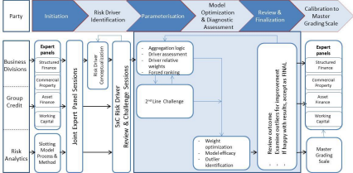
4.2 Weighting optimization
This section so far has described in concept how expert panel should brainstorm, challenge and agree on the relative weightings of all risk drivers by 1) agree on the relative weights between all risk-drivers within the same category and 2) assign the relative weight of a category against other categories.
Taking the 5Cs structure as the framework for expert judgement modelling, there are 5 categories, i.e. C=5. Let’s assume for each category c (where c=1,2,…, C), there are R_{c} risk-drivers. For each risk driver r(r =1,2, …, R_{c}) within the category c, a score s_{cr} (s_{cr}=1,2,…, S) is assigned by the experts to each obligor. In our selected 5-level scoring structure, S=5.
Therefore, the effective weight assigned by experts’ judgement to a particular risk-drive r in a ^{category c will be ̅} , where is the relative weight assigned to category c and is and
the relative weight assigned to the risk-driver r within the category c. Given ∑ , it can be seen that these effective weights ̅ (c=1,2,…,C; r=1,2,…, R_{c}) are
∑
.

already normalized, i.e. ∑ ∑ ̅
With these effective weights, the aggregated expert judgement score for an obligor i can be calculated as
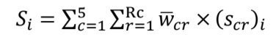 (1)
Note that we defined relative weights and respectively and explicitly in order to facilitate the expert judgment and knowledge extraction process. Once we have derived all the effective weight ̅ , for simplicity, we can actually re-label all the risk drivers across 5Cs as x_{k} (k=1,2,…,M) with ^{effective weights ̅} (k=1,2,…,M) where M is the total number of risk drivers (and the corresponding

effective weights); also re-label all the risk driver score s_{cr} (c=1,2,…C; r=1,2,…, R_{c}) as s_{k} (k=1,2,…,M). The aggregated score for obligor i can then be calculated as the weighted summation of all the risk driver scores:
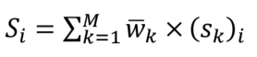 (2)
The effectiveness of these selected risk drivers and the judgement based weights can be measured by comparing the judgement score S_{i} based obligor ranking order against the expert panel’s forced ranking order.
While expert judgment based weights reflect the experts’ collective experiences and are expected to offer a good starting point for reaching the optimal model weights, no one would expect however human judgement can lead to the optimal solution by its own. This is where an optimization technique is introduced to fine-tune the weights so that the scored ranking order will match the forced ranking order as much as possible.
Optimization requires an objective function to be defined first. In the judgmental model weighting optimization case, we are actually seeking for the combination of weights ̅ ^{(or for simplicity ̅} ) that will maximize the rank correlation of two pairs of ranks, one being the scored rank pair of [Rank(S_{i}),Rank(S_{j})] and the other the forced rank pair of [Rank(F_{i}),Rank(F_{j})]. One measure of rank correlation is referred to as concordance coefficient (Kendall and Gibbons, 1990) which can be formally defined as: for the two pairs of ranks we define them as concordant if Rank(F_{i}) < Rank(F_{j}) when Rank(S_{i}) < Rank(S_{j}) or Rank(F_{i}) > Rank(F_{j}) when Rank(S_{i}) > Rank(S_{j}), or equivalently if [Rank(S_{i})- Rank(S_{j})] [Rank(F_{i})-Rank(F_{j})] > 0. Similarly we define them as discordant if Rank(F_{i}) < Rank(F_{j}) when Rank(S_{i}) > Rank(S_{j}) or Rank(F_{i}) > Rank(F_{j}) when Rank(S_{i}) < Rank(S_{j}), or equivalently if [Rank(S_{i})- Rank(S_{j})] [Rank(F_{i})-Rank(F_{j})] < 0. Where [Rank(S_{i})- Rank(S_{j})] [Rank(F_{i})-Rank(F_{j})] = 0, we can define it as a tie. The concordance rate can then be derived as the total concordance cases out of all cases where N is the total obligors and half a concordance case will be assigned when there is a tie. This is the objective function which we want to maximize. Kendall and Gibbons also demonstrated the tau coefficient can be used as the objective function which will lead to the same results.
To sum up, the specification of our optimization problem is as below:
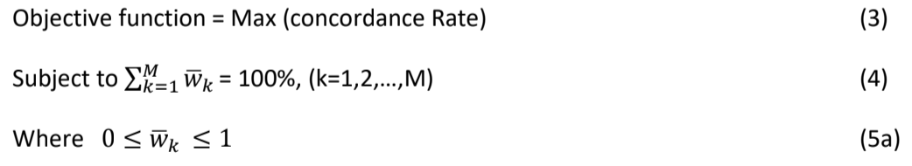
In practice, one may set up narrower boundaries of wk̅ around the corresponding expert judgemental weight value to ensure convergence or to speed up the process, so that (5a) can be modified into


5. Knowledge Based Modelling Illustrations
This section is to describe in more details of a model building process, using a case study as illustration, including the risk drivers to be considered, the initial expert judgemental weights assigned, the optimized weights and the diagnostic assessment performed to help reach conclusions. Nevertheless, the exact operational definitions of the risk drivers are omitted in order to protect the business confidentiality.
5.1 Risk Driver Identification
SMEs operate in many different sectors in the economy ranging from traditional manufacturing to services and to commercial buy-to-let specialists while services can be further split into financial and non-financial. While 5Cs provide a generic credit risk assessment framework, the underlying risk drivers and their relative weights could be different. Therefore, SME portfolios should first be segmented into categories which are homogenous enough to share the similar risk driver structure (i.e. risk drivers and relative weights), e.g. the Z-Score approach segments businesses into manufacturing vs. non-manufacturing. In fact, a more appropriate way to segment SMEs is to split into financial vs. non-financial vs. commercial IPRE (Income Producing Real Estate). This is because each of these three types of SMEs operates in a quite different manner and would not be regarded as homogenous. Financial SMEs refer to those non-banking financial firms or leasing companies that acquire financing from banks through structured finance, e.g. wholesale finance which enables financial firms to raise short-term finance and long-term capital to fund growth (FCA, 2016) or block discounting finance which allows leasing companies to raise funds against a future income stream from Hire Purchase or Lease agreements. Commercial IPRE are those buy-to-let specialists who purchased properties through mortgage and let for rental incomes. For the larger commercial buy to-let specialists (and hence expert judgement approach is applied), there have been evidences that it is more difficult to model an obligor’s default quantitatively, for that reason, regulators have offered an alternative that uses expert judgement based slotting approach for capital requirement in replacement of advanced internal model based (AIRB) approach (PRA, 2017) although such regulatory slotting approach does not differentiate between probability of default (PD) and loss given default (LGD) elements.
Within a homogenous SME segment, risk driver selection may or may not include product-specific factors depending on the business model and strategies. For banks which offer multiple financial products and operate in a customer-centric manner to encourage cross-selling and customer relationship management, it would be essential to credit rate an obligor as a business and hence risk-drivers may only include those factors that are related to the business as an entity. On the other hand, risk-drivers can also include, in addition, those factors that are bespoke to a particular financial product an obligor has borrowed from a bank if it operates in a produce-led manner.

The additional product-specific factors have the potential to enhance the model in its ability to differentiate good borrowers from those with higher risk but will lead to more complexity in implementation in a multi-product customer-centric organization. Given the business related factors include those that represent an obligor’s financial strength, capital sufficiency, management quality and general market conditions, etc. it is no doubt that these factors are the ones that would form the foundation of an obligor’s creditworthiness. Those product-specific factors such as loan type or location of asset etc. will play a relatively marginal role.
Without losing generality in our discussion, the potential risk drivers following the 5Cs framework could include those as below (note that this list is not meant to be exhaustive nor implying all of them should be included in a particular model):
CAPACITY: (measuring obligor’s ability to comply with obligation of repaying the loans)
- Total Sales
- Loan Size as % of Sales
- Current Assets/Current Liability Ratio
- Inventory
- Turnover
- Interest Coverage
- Debt to Income Ratio
CHARACTER: (measuring an obligor’s general trustworthiness and integrity)
- Years with the Bank
- Credit History
- Years’ Experience in Business
- Type of Legal Entity
- Senior Management Quality
CAPITAL: (measuring the difference between obligor’s assets and liabilities, assessing the financial commitment by the business owner or management team, considering both amount and quality)
- Client Contribution to Financing
- Total Debt/Equity (or Gearing Ratio)
- Long-term Debt to Capitalization Ratio
- Total Debt to Capitalization Ratio
- Quality of Capital
COLLATERAL: (measuring the amount and quality of assets that can be pledged as security in the event of default)
- Loan To Value Ratio
- Type of Collateral
- Presence of Additional Guarantees
CONDITIONS: (measuring the external environment the obligor operates in, e.g. market condition, competitive pressure, legal changes, etc.)
- General economic condition
- Sector Risk
- Key Buyer/Supplier Dependencies
A point to note about Collateral risk drivers: Loan to Value (LTV) ratio is commonly recognized as an important driver for the probability of default in a non-linear manner and credit risk tends to rise sharply when LTV is greater than 75%-80%. On the other hand, factors such as Type of Collateral and Additional Guarantees will help reduce the Loss Given Default (LGD), they are not expected to affect the probability of Default (PD) which is the basis for credit rating. Therefore, they are not recommended to be included as credit risk drivers.
A bank should select and define the risk drivers for its SME portfolio in a more operational manner to best reflect its experts’ collective knowledge and experiences, and to ensure clear guidelines / instructions are provided so that the credit managers or underwriters will find it easy to consistently apply the expert judgement based model in assessing an obligor’s credit risk. E.g. for a financial ratio risk driver, such as Interest Coverage, one may define it as:
Interest Coverage (IC) = PBIT / Interest Expense
Where PBIT is profit before interest and tax. Its scoring rule can be set as
If IC < 0.5, score = 1
Else if IC < 2.5, score = 2
Else if IC < 7.5, score = 3
Else if IC < 50.0, score = 4
Otherwise, score = 5
On the other hand, for a qualitative risk driver, such as Quality of Capital, one may define it as:
- If "High Risk of Capital Flight, e.g. Mainly Revaluation Reserve, High Dividend Payout Ratio, High Shareholder Concentration", score = 1;
- Else if "Above Average Risk of Capital Flight, e.g. Mainly Director's Loans, Above Average Dividend Payout Ratio, Above Average Shareholder
Concentration", score = 2;
- Else if "Average Risk of Capital Flight, e.g. Mainly Shareholder's Funds, Above Average Dividend Payout Ratio, Above Average Shareholder Concentration", score = 3;
- Else if "Below Average Risk of Capital Flight, e.g. Mainly Retained Profits, Below Average Dividend Payout Ratio, Below Average Shareholder
Concentration", score = 4;
- Else if "Low Risk of Capital Flight e.g. Mainly Share Premium & Retained
Profit, Low Dividend Payout Ratio, Low Shareholder Concentration", score =
5.
For a non-financial and non-commercial-buy-to-let SME lending portfolio, for instance, twelve key risk drivers were identified (some of them might contain sub-drivers further) including Interest Coverage, Gearing, Operating Margin, Net Worth Movement, Business Size (measured by turnover and net worth), Financial Flexibility, Single Debtor Concentration, Time since Established, Senior Management Quality and Profile (measured by senior management team experience, qualification, size, time with the company and finance director appointment), Arrears History, Quality of Capital (measured by factors such as share premium, retained profit, dividends pay-out ratio and shareholder concentration, etc.) and Loan to Value (LTV) ratio. Let’s label them as x_{k} (k=1, 2, … 12) for simplicity, not necessarily following the listed driver orders. Within the bank’s Integrated Credit Grading and IFRS9 Impairment Forecasting System, impact of economic conditions on an obligor’s default risk will be captured through the economic response model (ERM) and management overlays separately. For commercial confidentiality reasons, the exact risk driver definitions used in our model will not be presented in further details.
For more references of potential risk drivers, however, one can refer to Allen, DeLong and Saunders (2003), Bams and Ebrahimnejad (2009), Altman and Sabato (2007) and Samreen, Zaidi and Sarwar (2013). In particular, Allen, DeLong and Saunders (2003) has provided a comprehensive survey of financial ratio risk drivers cited in case studies across 18 countries while Bams and Ebrahimnejad (2009) also offered potential judgemental factors.
5.2 Expert Judgement and Weight Optimization
The non-financial and non-commercial-buy-to-let SME lending portfolio has hundreds of obligors in total. Collecting obligor information, systematically reviewing them to form judgemental views and then force ranking their credit risk orders would take significant efforts and time from the bank’s senior staff and management among their already very busy agendas. Hence, 30 obligors were randomly selected as the development sample and the expert panel performed post sampling checks to ensure they were satisfied that this sample included obligors across wide credit quality spectrum from very good to very poor. Following the approach described earlier in Section 4, the expert panel debated and assigned the judgemental weight against each risk category and then each identified risk-driver within. They also performed the forced ranking through the recursive 50:50 split process as described previously. The optimization approach, as stated in equations (3) – (5), was then applied to those expert judgemental weights and the results are shown in Table 3.

Table 3. Expert Judgemental Weights and Optimized Weights
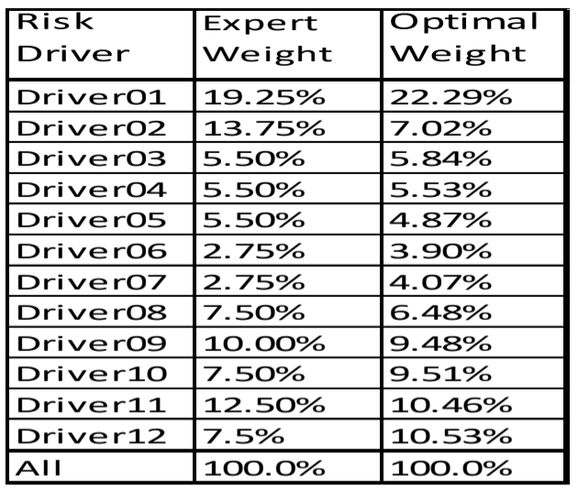
We found that Capacity and Character related risk drivers altogether would account for three quarters of the total weights in this particular optimized model, after neutralizing the economic condition effect.
The expert’s judgemental weights resulted in a concordance rate of 83.3%, a very good start point. The optimized weights improved concordance rate further to 87.9%. The model goodness-of-fit can also be seen in Chart 2 where the ranking orders derived from the expert judgemental weights vs. from the optimized weights are compared against the forced ranking orders. It is noticed that the optimized weights significantly improved the ranking prediction for those obligors which suffered from the most severe ranking mismatches under the expert judgemental weights. Therefore, we can conclude that the optimized weights will produce more consistent credit assessment results.

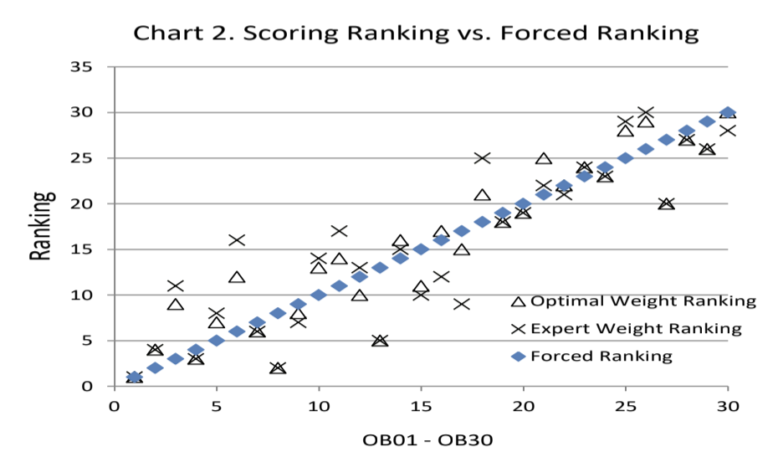
Detailed comparison and analysis at obligor level further confirmed that out of the 30 obligors, optimization approach improved ranking matches for 14 obligors while only 3 obligors’ ranking matches deteriorated slightly. Overall, the average absolute ranking difference has reduced by 26% from 3.5 to 2.6.

Table 4. Obligor Level Ranking Comparisons
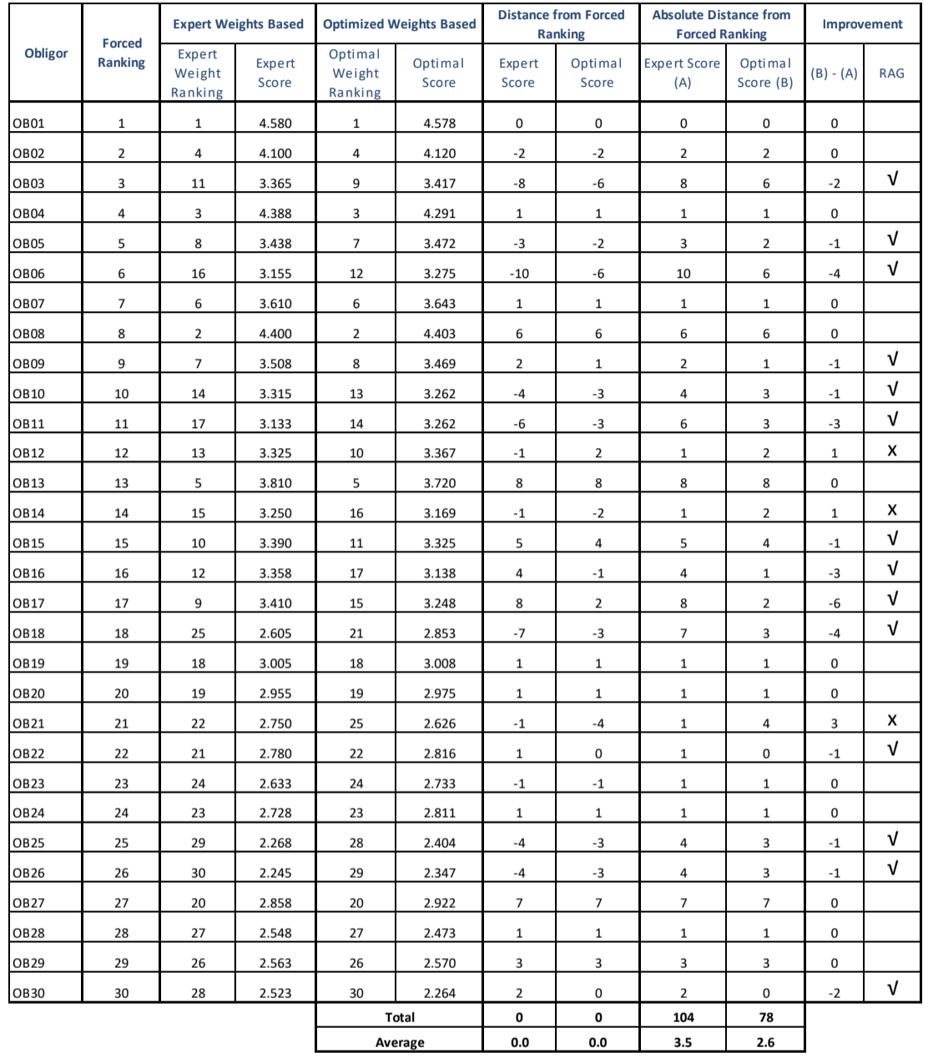
5.3 Expert Sanity Checks and Model Acceptance
Once the expert panel was satisfied with the ranking orders in the development sample derived by the optimized model weights, the model was applied to score an extended validation sample with 106 obligors from the portfolio (see Chart 3) and the relative rankings among the obligors were then subject to panel’s further sanity checks before their final acceptance of the model.
The panel was satisfied with the model performance and agreed that the score based ranking was a very good representation of their views of the relative credit qualities on the following basis:
1) There was no obvious reason to change the ranking order of any particular obligor;
17
2) Those concerned as the best were among the highest scored while those on the credit Watch List were among the lowest scored.
3) Not long after the validation scoring was performed, 4 obligors actually became struggling. Out of which, 3 were among the 10% lowest scored obligors. The other obligor had a mid ranged score but it managed to wound itself up leaving no creditors unpaid. These evidences although still limited did provide reassurance about the model efficacy.
Chart 3. Population Ranking by Optimal Score
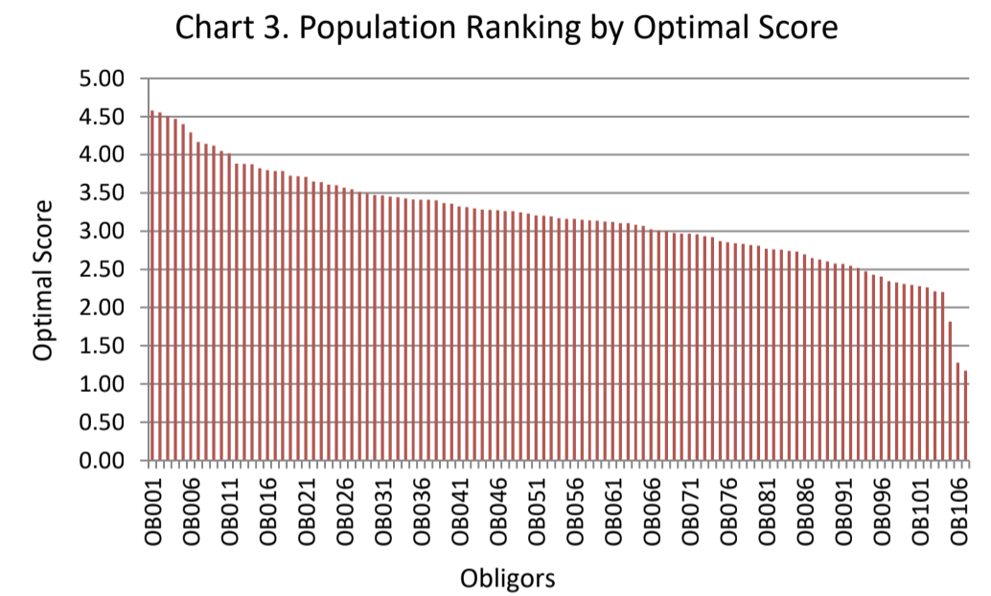
More broadly, as a further reassurance step of the overall model development program, a well established external consultancy in Europe on SME credit management was engaged to perform an independent review of and challenge to our approach in developing the expert judgement based models for the SME portfolios. We provided the consultancy firm with obligor profiles of 40 randomly selected samples for each test portfolio without the obligor names and their scores, neither the weights we assigned to the risk drivers. This was effectively a blind test, i.e. the consultancy would have no knowledge of who these obligors were and they did not know the optimal weights we had derived either. Two requests were made:
1) independently challenge the risk drivers we adopted for our SME portfolios and suggest driver changes if necessary should a critical driver was found to be overlooked or a driver was included against their expectation;
2) independently assign the relative weights to each of the risk drivers to reflect the consultancy’s subject matter experts’ experiences and judgements.
It was quite reassuring to receive the independent review report that stated the models were very comprehensive and all major risks were appropriately covered, hence seeing no reason why the drivers or sub risks needed to be amended. In fact, the independently assigned weights produced model scores which were highly correlated with our internally optimised scores, i.e. R²>85%.
Internal expert panel’s satisfaction supported by the external subject matter experts’ endorsement led to the successful approval and implementation of the model.

6. Discussions and Summary
SME businesses play an important role in the economy making significant contributions to the GDP and employment. But SME lending used to be a much neglected area in the financial services compared to large corporate lending on the one hand and retail lending on the other. This was to a large extent due to the lack of methodology and process to enable financial institutions to perform credit risk assessment in a streamlined and efficient and cost-effective manner. SME lending has been actively encouraged and promoted in recent years post the 2008-2009 credit crunch as a part of economic recovery strategy, this makes it more important than ever to develop an effective and easy to implement approach for SME credit risk assessment and rating. Although the industry has seen some efforts made by credit bureau, rating agencies and Fintech start-ups in developing a credit scoring solution for SME similar to those deployed for retail / consumer lending by leveraging pooled data, unpublished benchmarking exercises have demonstrated that these potentially accessible solutions still have some way to go before being accepted by the business with confidence when compared to the tailored solutions built on a bank’s own expert panel’s collective knowledge and experience enhanced by optimization technique. This is probably due to several reasons: a) such generic scoring models are developed more on the hard data such as financial ratios or bureau data, while soft data such as judgement on senior management quality and profile etc. are more difficult to obtain but they are critical; b) generic scoring model may not work best for a bank’s particular portfolio even if it works reasonably well for the business sector as a whole. This is a known fact for retail / consumer credit scores; c) such generic scoring models commonly rely on published bankruptcy records as the outcome measure while credit rating under the AIRB and IFRS9 framework and used for credit risk management requests the model to predict probability of default rather than bankruptcy although bankruptcy is one of the events qualifying for default; and d) some generic models are built with AI/ML algorithms such as artificial neural networks which remain as a ‘black box’ in addition to those limitations as above.
The methodology presented in the paper was designed to address the challenges faced by SME lenders, particularly the challenger banks which have rich specialist knowledge and experience in the niche SME market they serve but are deprived from obligor default history and sample volumes. This approach should be deployed into the client origination process for the new client credit assessment and then embedded into the credit review process including the annual reviews as the backstop. In this way, the credit assessment framework provides a systematic and consistent structure and guide for credit assessment data gathering, processing and scoring underlying the business-as-usual processes without extra managerial burdens. It will also help institutionalize and continuously enhance the bank’s collective knowledge on the individual clients and the portfolio as a whole, and create a clear audit trail.
This paper focuses on the methodology and procedures for identifying risk drivers with associated optimal weights which will produce a raw credit score to help rank order obligors for their credit risk. To integrate such a calculated raw score into the bank-wide credit grading system where credit risks are categorized into master credit grades with probability of default defined for each, more work actually have been done to establish the score range to credit grade mapping rules on the basis of expert knowledge, judgment, benchmark information and market intelligence, etc.. Such mapping
rules are important for integrating the model output into the credit grading system to support the credit management, IRB, IFRS9 and business strategies but are out of the scope of this paper.
Like any credit assessment solutions, the exact risk drivers and relative weights assigned by a bank should be kept as business confidential information which is only known to those who has a legitimate need to know. Users’ guide however should be produced, staff training offered and standard operating procedures (SOPs) defined to ensure the correct implementation and use of the model.
Also similar to other solutions, these expert judgement based models should be subject to quality assurance and periodic performance reviews. Given the nature of these models where the actual default events are still rather rare and model performance is mainly judged by experts, an alternative way to evaluate model’s efficacy can be introduced, e.g. divisional staff in the first line of defence perform the standard data gathering and credit assessment which are submitted to Group Risk experts for second line of defence review and challenge. Group Risk experts review the obligor profile information and credit report received, challenge the judgemental components if necessary based on their experiences and potentially latest market intelligence which will result in three possible outcomes: 1) accept the rating result; 2) challenge the judgement with change recommendations where appropriate and then accept the revised rating result; or 3) agree with the judgement or adapted judgement but still challenge the rating result based on other considerations. The last outcome is an indication that the model itself is not working well for this particular case. Model risk criteria can then be established to regularly track the Group Risk review outcomes and thresholds are set to trigger the need for formal model review and refresh.
A suite of these expert judgement based credit assessment models have been implemented as a part of the bank’s integrated credit grading and IFRS9 impairment forecast system which went live at the start of 2018, they have played and continue to play a significant role in strengthening the bank’s SME credit risk management capacity. It is expected that these models will find their value and role to play within the bank in the foreseeable future until commercially developed quantitative scoring solutions become available that will have satisfactorily addressed the aforementioned limitations and at an affordable price.
Acknowledgement
The author would like to express his appreciation of the colleagues from Group Risk, Business Divisions and Project Management Team in Shawbrook Bank for their roles in implementing the proposed methodology and procedures, particularly those who served as members of the expert panel whose extensive knowledge of and experience with the SME portfolios were invaluable to the success of the model development. Special thanks would go to Mr. Paul Donley who effectively served as the leading expert and to Mr. Ben Marshall and Mr. David Morris who contributed immensely towards the model implementation / embedding process. Nevertheless, all mistakes, if any, will remain solely to be mine.

References
[1] Allen, L, G. DeLong and A. Saunders (2003). Issues in the Credit Risk Modelling of Retail Markets, NYU Stern School of Business Working Paper No. FIN-03-007.
[2] Altman E.I. (1968). “Financial Ratios. Discriminant Analysis and the Prediction of Corporate Bankruptcy”. in The Journal of Finance. pp. 589-609.
[3] Altman E.I. (1970). “Ratio Analysis and the Prediction of Firm Failure: A Reply”. in The Journal of Finance. Vol. 25. No. 25. pp. 1169-1172.
[4] Altman, E. Corporate Financial Distress, John Wiley & Sons, New York, 1983.
[5] Altman E.I.. “Revisiting Credit Scoring Models in a Basel 2 Environment”. in Ong M. (2002). Credit Rating: Methodologies. Rationale and Default Risk. London Risk Book.
[6] Altman, E.I. and G. Sabato (2005). “Effects of the new Basel capital accord on bank capital requirement for SMEs”, Journal of Financial Services Research, Vol.28, pp.15-42.
[7] Altman, E.I. and G. Sabato (2007). “Modelling credit risk for SMEs: evidence from U.S. market”, Abacus, Vol.43(3), pp.332-357.
[8] Altman E.I.. Hartzell J.. Peck M. (1995). Emerging Markets Corporate Bonds: A Scoring System. Salomon Brothers Inc. New York.
[9] Altman, E., M. Iwanicz-Drozdowska, E. K. Laitinen and A. Suvas (2014) Distressed Firm and Bankruptcy prediction in an international context: a review and empirical analysis of Altman’s Z Score Model, July 9, 2014. (Unpublished paper)
[10] Anderson, R. (2007). “Credit Risk Assessment: Enterprise-credit frameworks”, Conference: Credit Scoring & Control X, Edinburgh, Scotland.
[11] Bank of England (2015a), PRA Policy Statement | PS17/15: Assessing capital adequacy under Pillar2, July2015. P.7.
[12] Bams, D.W. and A. Ebrahimnejad (2009). Developing a Commercial Credit Risk Rating Model: Case study of a petrochemical company. Credit Scoring and Credit Control XI Conference, Edinburgh, UK.
[13] Beaver, V. (2005). “Have financial statements become less informative? Evidence from the ability of financial ratios to predict bankruptcy”, Review of Accounting Studies, Vol.10, pp.93-122.
[14] Brédart, X. (2014). “Bankruptcy Prediction Model Using Neural Networks”, Accounting and Finance Research Vol. 3, No. 2; pp. 124-128.
[15] Brunnermeier, M. K., “Deciphering the Liquidity and Credit Crunch 2007-2008”, Journal of Economic Perspectives, Vol 23, Number 1, Winter 2009, pp.77-100.

[16] Ciampi, F. and N. Gordini (2013). “Small Enterprise Default Prediction Modeling through Artificial Neural Networks: An Empirical Analysis of Italian Small Enterprises”, Journal of Small Business Management, Vol.51(1), pp.23-45.
[17] Derelioglu, G. and F. Gurgen (2009) “A MLP based PD estimation model for SME credits”, Conference: The 24th International Symposium on Computer and Information Sciences, 14-16 September 2009, North Cyprus.
[18] El-Zayaty, W. (2003). “Financial ratios as predictors of failure, empirical research in accounting: selected studies, supplement,” Journal of Accounting Research, vol. 5, pp. 71-127.
[19] European Bank Association (2016). EBA Report on SMEs and SME Supporting Factor, EBA/OP/2016/04, 23 MARCH 2016.
[20] European Commission (2015), User Guide to the SME Definition.
[21] Falkenstein, E., A. B. Lea and V. Carty (2000), RiskCalcTM for Private Companies: Moody’s Default Model. Moody’s Investment Services. New York.
[22] Fantazzini, D. and S. Figini (2009). “Default forecasting for small-medium enterprises: Does heterogeneity matters?”, International Journal of Risk Assessment and Management, Vol.11(2), pp.38-49.
[23] Fantazzini, D. and S. Figini (2009). “Random Survival Forests Models for SME Credit Risk Measurement”, Methodology and Computing in Applied Probability, Vol.11(1), pp 29–45.
[24] Fidrmuc J. and C. Heinz (2009). Default Rates in the Loan Market for SMEs: Evidence from Slovakia, University of Munich, IFO Working Paper, No. 72.
[25] Financial Conduct Authority (2016). Wholesale Financial Markets: Overview. 23 November, 2016.
[26] Gumparthi, S., Khatri, S. and Manickavasagam, V., “Design and development of credit rating model for public sector banks in India: Special reference to small and medium enterprises”, Journal of Accounting and Taxation, Vol. 3(5), pp.105-124, September 2011.
[27] Johnson C.G. (1970). “Ratio Analysis and the Prediction of Firm Failure”. in The Journal of Finance. No. 5. December. pp 1166-1168.
[28] Joy M.O.. Tollefson J.O.. (1975). “On the Financial Applications of Discriminant Analysis”. in Journal of Financial and Quantitative Analysis. Vol. 10. Pp. 723-739.
[29] Kendall, M. and J. D. Gibbons (1990), Rank Correlation Methods, Oxford University Press, New York. pp. 3-6.
[30] KPMG (2016), A New Landscape: Challenger Bank Annual Report, May 2016
[31] Li, K., J. Niskanen, M. Kolehmainen and M. Niskanen (2016). “Financial Innovation: Credit Default Hybrid Model for SME Lending”, Expert Systems with Applications, Vol.61, pp.343-355.

[32] Ohlson, J. A. (1980). “Financial ratios and the probabilistic prediction of bankruptcy,” Journal of Accounting Research, Vol.18, No.1, pp.109-131.
[33] Pederzoli, C. and C. Torricelli (2010). “A Parsimonious default prediction model for Italian SMEs”, Banks and Bank Systems, Vol.5(4), pp.5-9.
[34] Prudential Regulatory Authority (2017). Supervisory Statement|SS11/13: Internal Ratings Based (IRB) approaches, Bank of England, October 2017.
[35] Rama, K. D. (2012). An Empirical Evaluation of the Altman (1968) Failure Prediction Model on South African JSE Listed Companies, A research report. WITS: School of Accounting, March 2012.
[36] Rhodes, Chris (2018). Business Statistics, House of Common Briefing Paper. Number 06152, 12 December 2018. P.5.
[37] Samreen, A., F.B. Zaidi and A. Sarwar (2013). “Design and Development of Credit Scoring Model for the Commercial Banks in Pakistan: Forecasting creditworthiness of corporate borrowers”, International Journal of Business and Commerce. Vol.2, No.5, pp.1-26.
[38} Teodori C. (1989). Modelli di previsione nell’analisi economico-aziendale. Giappichelli. Torino.
[39] Zhang, L., H. Hu and D. Zhang (2015), “A credit risk assessment model based on SVM for small and medium enterprises in supply chain finance”, Financial Innovation, December, pp.1-14.

