Detecting Insurance Fraud with Isolation Forests
Jorn Debener ¨¹, Volker Heinke¹, Johannes Kriebel^{1,}
ªUniversity of M¨unster, Universit¨atsstraße 14-16, M¨unster, 48143, Germany
Abstract
Insurance fraud is a significant issue to insurance companies and honest policyholders. The question arises as to how insurance fraud can best be detected. Prior literature has started to study the use of machine learning methods. However, most studies rely on supervised learning. In the context of insurance fraud, these methods are prone to two important shortfalls, namely biased estimation due to few labelled cases and replication of already known fraud patterns. To address this problem, we use isolation forests, a new method of unsupervised learning. We analyze a large proprietary data set of over 10,000 German automobile insurance claims. We show that isolation forests are particularly helpful in detecting fraudulent claims even when controlling for existing fraud detection mechanisms.
Keywords: Insurance fraud, fraud detection, machine learning, unsupervised learning JEL classification: G22

∗ Corresponding author: Johannes Kriebel, Universitatsstraße 14-16, 48143 M ¨ unster, Germany, email: ¨ johannes.kriebel@wiwi.uni-muenster.de, phone +49-251-83-22692, fax +49-251-83-22882.
1. Introduction
Information asymmetries are a key characteristic of many interactions in insurance services (Derrig, 2002, Dionne et al., 2009). Fraud in insurance claims is the exploitation of one of these information asymmetries by policyholders. This paper aims at detecting automobile insurance fraud using isolation forests, a new algorithm of unsupervised learning. Fraud is a key issue to insurers. As an example, Insurance Europe (2019) estimates the total amount of fraudulent claims in Europe in 2017 to sum up to approximately EUR 13bn. These costs have to be reflected in insurance premia and are, therefore, also harmful to honest policyholders. From the perspective of insurers and in the interest of policyholders, the question arises as to how insurance fraud can best be detected.
Prior literature has started to address the use of machine learning methods to detect insurance fraud (e.g., Viaene et al., 2002, Caudill et al., 2005, Johnson and Nagarur, 2016, and Van Vlasse laer et al., 2017). However, the vast majority of studies relies on supervised learning methods such as logistic regression and neural networks. These methods are prone to two shortfalls. First, there are typically only few insurance claims identified as fraudulent. This is because the manual identi fication of insurance fraud is very time and cost intensive (Viaene et al., 2007). As a consequence, the proposed methods have to rely on few labeled observations, which makes robust estimations difficult. Second, and equally important, many fraudulent claims remain unlabeled (Brockett et al., 2002). In this way, supervised algorithms are prone to only replicating the existing fraud identifica tion mechanisms. However, new and unknown fraud patterns remain undetected in this way. The aforementioned methods could, therefore, be extended by state-of-the-art unsupervised learning.
In order to address this problem, we use a new method of unsupervised learning, so-called isolation forests (Liu et al., 2008, Hariri et al., 2021). Isolation forests are an ensemble of trees that detect anomalies. We analyze a large proprietary data set of more than 10,000 automobile insurance claims from a medium-sized German insurance company in 2020. We build two dif ferent isolation forests to capture the complex character of insurance claim fraud: We first model whether the combination of claimed amount, damage, and car characteristics is anomalous. Then, we model whether the description of the accident itself is anomalous. With these two models
we aim at detecting two important types of fraud, namely soft fraud and hard fraud, respectively (Derrig, 2002). Therefore, we receive two distinct anomaly scores for every insurance claim in the data. In both models, we include numeric and textual data, since both potentially contain relevant information and are appropriately handled by isolation forests.
In a validation analysis, we assess whether the anomaly scores are helpful in identifying fraud. Our results show that both anomaly scores significantly predict fraud. The effect size is economi cally significant. This is also the case taking into account the risk-score from an inhouse automated rule-based fraud detection system used by the insurance company from which we obtain the data. Most interestingly, the anomaly scores are particularly helpful in detecting those fraudulent claims that were manually reported as suspicious (i.e., not by the automated rule-based fraud detection system). Thereby, we show that isolation forests can assist methods based on already identified fraud cases in the process of detecting unknown patterns of insurance fraud.
As our main contribution, we fill a gap in the literature on insurance fraud detection by further addressing the use of unsupervised learning in this domain. In particular, we show the usefulness of using isolation forests, a new ensemble method of unsupervised learning, to efficiently detect automobile insurance fraud.
The remainder of the paper is structured as follows. Section 2 provides an overview of the existing literature on insurance fraud. Section 3 presents our methodological approach for unsu pervised fraud detection using isolation forests. Section 4 introduces the data and our validation approach. Section 5 contains the empirical results. Section 6 concludes.
2. Literature Review
Fraud is a key issue for the insurance industry. Paying out fraudulent claims increases costs for insurance companies and thus has a negative effect on their profitability (Cummins and Tennyson, 1992, Viaene et al., 2007). In order to investigate whether a claim is fraudulent, insurance compa nies typically employ so-called special investigation units (Derrig, 2002). However, the process of manual fraud investigation is very time and cost intensive (Viaene et al., 2007). To the extent that the costs associated with claim fraud are reflected in insurance premia, fraud also harms honest policyholders and eventually undermines the principle of solidarity in society (Viaene and Dedene, 2004). Therefore, academic research has shown significant interest in the issue of insurance claim fraud.
In general, the concept of fraud can be understood as a combination of motivation and opportu nity (Cohen and Felson, 1979, Viaene and Dedene, 2004). While the motivation of policyholders for fraudulent activities is mostly of economic nature, the range of opportunities for insurance fraud is broad. Fraud is observed in health care insurance, life insurance, automobile insurance and other forms of insurance (Viaene and Dedene, 2004). Although the specific opportunities for fraud differ across these insurance types, all of them are in general favored by the very nature of insurance contracts. Since policyholders typically have more information than insurance compa nies, information asymmetries are a key characteristic of many interactions in insurance services (Derrig, 2002, Schiller, 2006, Dionne et al., 2009). Furthermore, fraud can be classified into soft fraud and hard fraud (Derrig, 2002). While soft fraud reflects situations in which policyholders make use of a given opportunity (i.e., an unplanned accident), for example by inflating claims, hard fraud describes situations in which policyholders explicitly plan and execute a fraud event, for example by staging accidents (Picard, 1996, Crocker and Morgan, 1998, Viaene and Dedene, 2004).
Claim fraud is a particularly important issue in automobile insurance (Weisberg and Derrig, 1991, Picard, 1996. Weisberg and Derrig (1991) and Cummins and Tennyson (1992) were among the first to address this problem from an academic perspective. In the years after, many studies empirically investigated automobile insurance claim fraud and tested various methods in order to detect fraudulent claims. Art´ıs et al. (1999), Art´ıs et al. (2002) and Caudill et al. (2005) analyze a data set of claims from the Spanish market using logistic regression. While extending their methodological approach to misclassified and missing data, they find that characteristics of the accident, the damaged vehicle, and the claim reporting can help to detect fraud. Viaene et al. (2002) use a small sample of bodily injury claims from car accidents in the US market to compare different methods to detect fraud. The authors find only little differences in precision between traditional methods such as logistic regressions and more sophisticated approaches such as neural networks and kernel-based methods. Viaene et al., 2007 again analyze the Spanish market but focus on reducing the overall costs of misclassification rather than the rate of misclassifications following a Bayesian approach. More recently, Johnson and Nagarur (2016) apply a multi-stage approach to US data in order to detect health insurance claim fraud. Van Vlasselaer et al. (2017) investigate social security fraud using a network-based approach.
The majority of these studies uses methods in the domain of supervised learning in order to detect insurance fraud. However, these methods suffer from two fundamental shortfalls. First, there are typically only few observations labeled. This is because investigating claims is very time and cost intensive (Viaene et al., 2007). Therefore, robust estimations are difficult to obtain. Second, and even more important, many fraudulent claims likely remain unidentified (Brockett et al., 2002). Training supervised methods on this data will lead to results that merely replicate the already existing fraud identification mechanisms. Therefore, methods of unsupervised learning appear particularly attractive in the context of insurance fraud detection. Surprisingly, only few studies have investigated methods of unsupervised learning in this domain. Brockett et al. (1998) use Kohonen’s Self-Organizing Feature Map, a rather complex unsupervised clustering algorithm, on a small sample of 127 automobile bodily injury claims in the US. Brockett et al. (2002) use the same sample to suggest an approach called PRIDIT, which is a principal component analysis of RIDIT scores. Ai et al. (2013) build on the PRIDIT approach and develop PRIDIT-FRE, an un supervised technique to estimate the fraud rate within a sample. However, the PRIDIT approach underlies strict assumptions on the predictor variables, namely a monotonically positive relation ship between the predictor variables and fraud (Brockett et al., 2002). Therefore, we suggest the application of a new and highly efficient method of unsupervised learning, so-called isolation forests (Liu et al., 2008, Hariri et al., 2021).
3. Fraud Detection Methodology
Isolation forests are a novel tree-based ensemble method in the field of unsupervised learning (Liu et al., 2008, Hariri et al., 2021). The goal of isolation forests is the detection of anomalies, i.e., observations that are different from normal observations (Liu et al., 2008). Existing methods that aim at detecting anomalies, such as clustering algorithms, typically define what a normal obser vation is and then identify anomalies as everything that deviates from normality (Chandola et al., 2009). This approach brings with it the problem that the methods used are optimized to detect normal observations rather than anomalies, which makes them less efficient in their actual intent (Liu et al., 2008). In contrast, isolation forests are designed to directly identify anomalies even using higher-dimensional data including textual data. Thereby, the concept builds on an explicit definition of anomalies. According to Liu et al. (2008), anomalies have two key characteristics, namely they are few and different. Few means that, per definition, anomalies are the minority in the data. Different means that anomalies typically differ substantially in appearance from the rest of the observations.
Isolation forests incorporate these two characteristics of anomalies. They describe an ensemble of specific decision trees (so-called isolation trees). In every tree, an iterative process is conducted (see Liu et al., 2008 for a more detailed description). First, a characteristic of the data will ran domly be selected. In the case of automobile insurance claim fraud, this could be the mileage of the car at the time of the accident. Second, a value for the characteristic that lies between the maximum and the minimum in the sample will randomly be selected. According to this random value, all observations are split. This process is repeated until all observations are separated (or until the pre-defined maximum of splits is reached). Figure 1 shows a conceptual visualization of an isolation tree that tries to isolate anomalous combinations of the mileage of a damaged car and the amount claimed by the policyholder.
As can be seen in Figure 1, anomalies, such as a high claimed amount for a car with high mileage, will be isolated much more quickly than normal observations. In this example, the iso lation tree needed only four random splits to isolate the anomaly, whereas a normal combination of mileage and claimed amount was isolated after ten splits. Therefore, the number of splits is a measure of how anomalous an observation is. The process of isolating observations is performed simultaneously by many trees and the number of splits per observation is normalized and averaged to obtain a final anomaly score between zero and one. In order to capture the complex character of insurance claim fraud and to incorporate the common distinction between soft fraud and hard fraud (Derrig, 2002), we develop two separate isolation forests, so that we obtain two 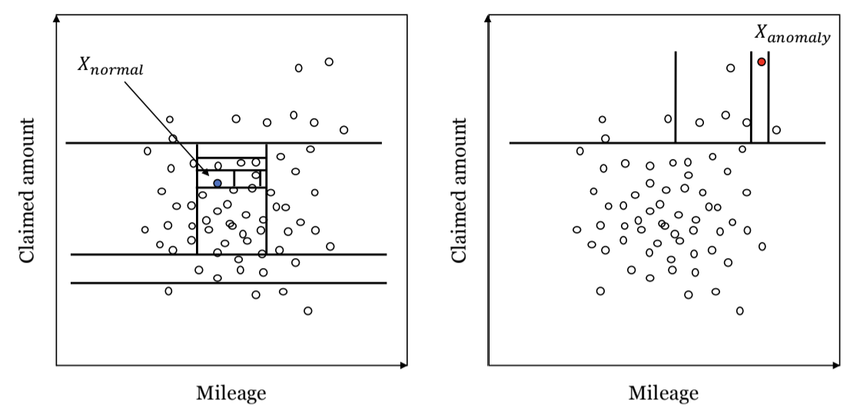
Figure 1: Conceptual visualization of isolation forests. This figure conceptually displays the iterative process of a single isolation tree in the context of insurance claim fraud.

anomaly scores for every insurance claim. The first isolation forest aims at detecting whether a claimed amount is anomalous. Thereby, we particularly address the case of soft fraud, which is character ized by inflating the reported damage from an unplanned accident (Picard, 1996). For this model,
we include as important variables the claimed amount, the car manufacturer, the age of the car, the mileage, the horsepower and the textual description of the damage zone of the car, which we preprocess using a separate isolation forest built on a term-document matrix of unigrams. The second isolation forest aims at detecting whether the accident itself is anomalous. This forest is intended to address hard fraud, which is characterized by planned behavior such as staging an ac cident (Viaene and Dedene, 2004). For the second model, we include the time and the country of the accident, an indicator whether police were at the scene, an indicator whether the driver is the policyholder, an indicator whether there are any misconducts by the driver that violate the contract conditions and a textual description of the accident, which we preprocess using a separate isola tion forest built on a term-document matrix of unigrams. Figure 2 illustrates both models and the according variables.
4. Data and Validation Approach
In order to investigate the potential of isolation forests in detecting insurance fraud, we use a new set of proprietary data which we obtain from a medium-sized German insurance company. The data covers 10,174 automobile insurance claims in the timespan from January 2020 to July 7
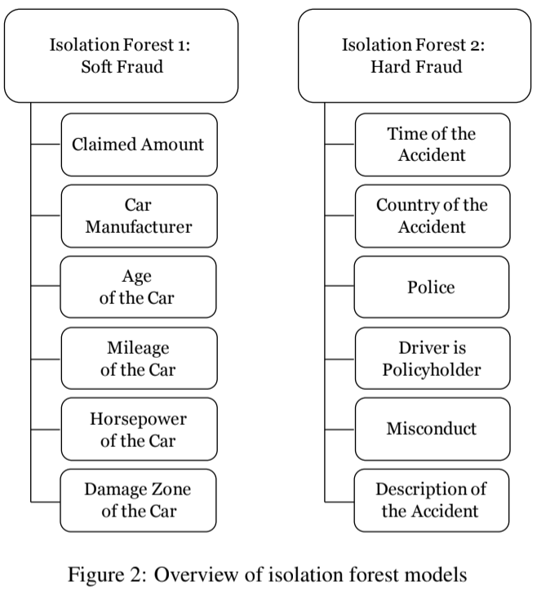
This figure depicts the two isolation forest models that are used to detect insurance claim fraud.
2020 with 52 identified cases of fraud. The number of actual fraudulent cases (including unidenti fied cases) may, in fact, be much higher. This illustrates the problem of using supervised learning in this domain.
The 10,174 claims cover different types of events. There are 5,696 claims related to glass damage, 930 claims related to collisions between cars, 2,453 claims related to collisions with no other car involved. 1,095 claims result from smaller event categories and are excluded. Since the patterns of fraud can differ substantially between types of events, we analyze the categories separately. In Section 5, we present results on glass damage as the largest group of claims. This category is further particularly interesting as these claims are comparably small and in this way less suited to be processed manually. The results for claims from collisions between cars and other collisions can be found in the Appendix and are qualitatively identical.
Table 1 presents summary statistics for the variables used in the two isolation forests for all three major claim-types. i f.score₁ and i f.score₂ represent the anomaly scores from the two iso lation forests. es.score represents a risk-score determined by an expert system that is already in

Table 1: Summary statistics for major claim-types 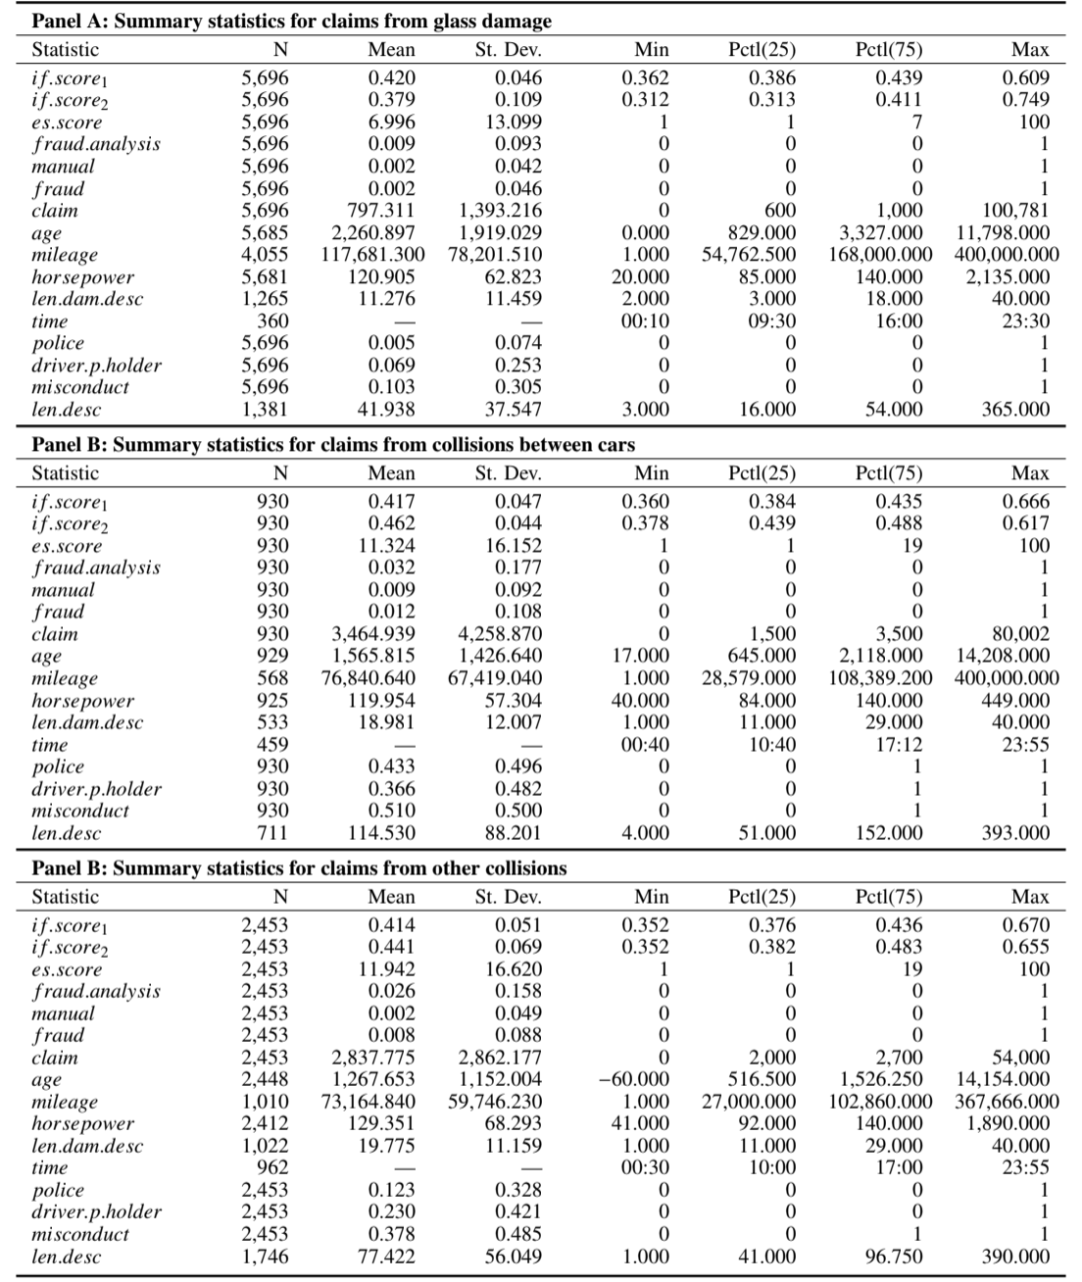

This table reports summary statistics for the anomaly scores and all variables that go into the isolation forests for the three major claim-types in the data, namely claims from glass damage, claims from collisions between cars, and claims from other collisions. ”N” denotes the number of non-missing values; ”Mean” the mean; ”St. Dev.” the standard deviation; ”Min” the minimum; ”Pctl(25),” ”Median,” and ”Pctl(75)” the first, second, and third quartiles, respectively; and ”Max” the maximum.

use. It has values between zero (fraud is unlikely) and 100 (fraud is very likely). f raud.analysis is a binary variable indicating whether the claim has been transferred to a special investigation unit by the responsible domain expert. With a mean ranging between 0.9% and 3.2%, rather few claims are investigated. This reflects the high costs associated with investigations. manual is a bi nary variable indicating whether a claim has been transferred only because of the domain experts suspicion (i.e., despite a low risk-score from the expert system.) The domain experts can overrule the es.score in both ways, meaning that the domain experts can decide to hand over claims with a low es.score and can decide to not hand over claims with a high es.score. f raud is a binary variable indicating whether a claim has been identified as fraudulent by the special investigation unit. claim indicates the claimed amount. age describes the age of the car in days. mileage de scribes the mileage of the car at the time of the accident. horsepower describes the horsepower of the car. len.dam.desc describes the length in words of the textual description of the damage zone. time indicates the time of the event. police is a binary variable indicating whether police was at the scene. driver.p.holder is a binary variable indicating whether the driver of the car is the policyholder. misconduct is a binary variable indicating whether any unreasonable behavior that violates conditions of the insurance contract is reported for the event. len.desc describes the length of the textual description of the accident. The data furthermore consists of two categorial variables, namely car.manu, which indicates the car manufacturer, and country, which indicates the country in which the accident happened.
We split the observations of each claim-type into a training and a test data set. The training data does not contain any observations of identified fraud. This is done in order to fully use the small number of identified fraud cases in testing the method. In this way, the isolation forest has never seen fraud cases but as it is an unsupervised approach, it does not require labeled data. For glass damage claims, the training data contains 4,238 random observation while the test data contains 1,458 random observations. For claims from collisions between cars, the training data contains 704 random observations and the test data contains 226 random observations. For claims from other collisions, the training data contains 1,580 random observations and the test data contains 603 random observations.

5. Validation Analysis and Results
5.1. Validation Analysis
In evaluating the usefulness of the isolation forests, we, relate the anomaly scores based on the methods described to the occurrence of identified fraud in the test sample. In order to validate whether our model significantly identifies fraudulent claims, we build three logistic regression models that address three different mechanisms of fraud detection using different dependent vari ables: f raud.analysis, manual, and f raud. The model using f raud.analysis as dependent variable identifies whether the i f.score_{m}, derived from the isolation forest of a certain fraud model m, is informative of whether domain experts are more likely to decide to hand over claim i to the special investigation unit as indicated in Equation 1. The domain experts’ decision is based on both, the expert system score es.score that is always displayed to the domain experts, and their own con sideration of the case. The domain experts can overrule the es.score in both ways, meaning that the domain experts can decide to hand over claims with a low es.score and can decide to not hand over claims with a high es.score.
P(fraud.analysis = 1|i f.score_{mi}, es.score_{i) =}exp(α + β₁i f.score_{mi} + β₂es.score_{i}) 1 + exp(α + β₁i f.score_{mi} + β₂es.score_{i)}(1)
The model controls for the existing risk score of the expert system es.score. When the detected anomalies are relevant, we expect that the i f.score_{m} has a positive and significant coefficient in the model. We further expect the es.score to have a positive and significant coefficient as it is built and successfully tested to identify fraud in the past. Claims with a high es.score are further much more likely to be handed over to the special investigation unit.
In order to put more emphasis on the so-far manual identification of fraud cases, we fit one additional model that particularly analyzes whether the i f.score_{m} is able to automatically identify claims that are labeled as suspicious by the domain experts but not by the expert system. We use the following model:
P(manual_{i} = 1|i f.score_{mi) =}exp(α + β₁i f.score_{mi})
1 + exp(α + β₁i f.score_{mi)}(2)
We expect the i f.score_{m} to have a positive and significant coefficient, when the isolation forest is capable of identifying fraud patterns that could previously only be identified by suspicion of the 11
domain experts. In this analysis, we do not include the es.score, as cases with a high es.score are mechanically less likely to be handed over by suspicion of the domain experts. Our final model then regresses a dummy of whether a claim was later decided to be a fraud case by the special investigation unit, f raud. In this analysis, the coefficient of i f.score_{m} should be positive and significant when the isolation forest score contains important information in excess of the existing expert system. We further expect the es.score to have a positive and significant coefficient.
P(f raud_{i} = 1|i f.score_{mi}, es.score_{i) =}exp(α + β₁i f.score_{mi} + β₂es.score_{i}) 1 + exp(α + β₁i f.score_{mi} + β₂es.score_{i)}(3)
5.2. Results
The central results to evaluate how well the anomaly scores derived from the isolation forest identify fraud are presented in Table 2 for glass damage as the largest group of claims. Table 3 and Table 4 in the Appendix present analogous results for collisions with another car and other collisions, respectively. The first section of Table 2 presents results for the step using the anomaly scores derived from isolation forests to predict whether the domain experts decide to transfer the claim to the special investigation unit (Equation 1). What we can infer from these results is that both anomaly scores have a significant and positive relation to the decision to transfer the claim to the special investigation unit, when the two scores are analyzed individually. When comparing the informativeness of these two scores, i f.score₁ has a higher coefficient and a higher significance compared to i f.score_{2When adding both,} ˙ i f.score₁ and i f.score₂ the first score is more predictive considering that it keeps its high level of significance, while i f.score₂ becomes insignificant in this model. The adjusted pseudo R²increases particularly strong from the first to the second and from the first to the fourth column, which is in line with these results.
The second section of Table 2 presents results from the analysis where we aim at predicting which cases are manually transferred to the special investigation unit (Equation 2). We see results that are similar to the first section of the table. Information that is used by domain experts is often related to the anomaly of the combination between the car, the event, and the claimed amount. This is indicated by a significant coefficient both in the second and in the fourth column for i f.score₁. In contrast, i f.score₂ is not significant.

Table 2: Regression results - Predictive power of anomaly scores (glass damage) 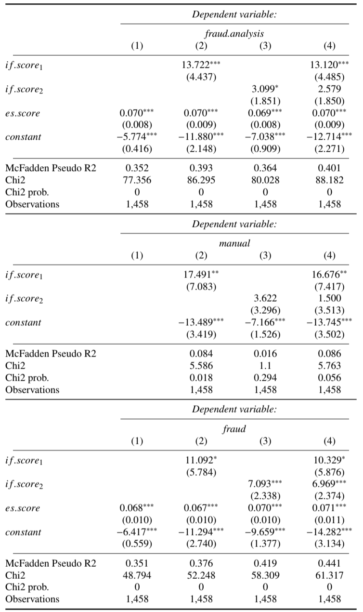
This table displays the logistic regression results for regressing f raud.analysis, manual, and f raud on i f.score₁, i f.score₂, and es.score in the case of glass damage claims. The three sections of the table report results for f raud.analysis, manual, and f raud as dependent variables, respectively. The table reports standard errors in paren theses. ∗p<0.1; ∗∗p<0.05; ∗∗∗p<0.01

The third section of Table 2 then presents the results analyzing how well the anomaly scores predict whether a case is an identified fraud case (Equation 3). Interestingly, both scores, i f.score₁ and i f.score₂, are significant in this analysis. What is also interesting is the fact that the event description now has a stronger content of information for predicting fraud. This is also the case when assessing the full model in the fourth column. The increase in the pseudo R²is further much stronger for including i f.score₂ compared to the i f.score₁.
Table 3 and Table 4 in the Appendix present similar results for claims related to collisions with cars and other collisions. As indicated in Table 3, the anomaly score i f.score₁ that models whether the combination of the car, the damage description and the claimed amount are unusual are highly informative of whether the claim is transferred to the special investigation unit, whether it is transferred by discretion of the domain experts, and whether it is finally determined to be a fraud case. This is indicated in the first, second, and third section of Table 3. Based on this type of claims, the i f.score₂ indicating whether the information on the event is anomalous is not significant. However, the number of claims is much smaller in this category. The results are qualitatively similar and strong for the i f.score₁ in the case of other collisions as indicated in Table 4. In contrast to Table 3, the anomaly score of the event description i f.score₂ is a strong predictor for f raud.analysis, manual, and f raud. This aspect is more similar to the results in Table 2.
In summary, we find that anomaly scores contain information about whether domain experts pass on claims to the special investigation unit. This is first the case when looking at general passing on of these claims based on either the suspicion of the domain experts or evaluation by an automated system. But it is also the case when looking in particular only at discretionary passing on of these claims based only on the suspicion of the domain experts. Therefore, we infer that the isolation forest captures information that is previously only captured by suspicion of the domain experts. Moreover, we see that the isolation forest anomaly scores significantly identify fraud, even when controlling for the judgment of existing automated systems. In this way, this information is helpful in identifying fraud. To that extent, the anomaly scores derived from unsupervised learning can augment existing systems that learned from past cases in a way that could further automate manual decisions and in this way human judgment.

6. Conclusion
Fraud is a significant problem to insurers and to their customers. It is, therefore, important to set up efficient processes that are capable of identifying fraudulent insurance claims. Previous literature has primarily addressed this problem from a supervised learning perspective. However, as we argue, this has several shortcomings: There are usually few labeled cases and verifying fraud is costly. Hence, it is difficult to fit supervised learning methods based on the few labeled cases and, therefore, unknown fraud patterns remain undetected. We argue that fraud detection systems should make more use of unsupervised learning methods. In particular, we suggest the use of isolation forests, which are a new method of unsupervised learning.
We build isolation forests for individual fraud patterns, which we identified from the literature, based on a new and proprietary sample of more than 10,000 automobile insurance claims. We evaluate the ability of isolation forests to identify fraud by assessing whether they can detect previously identified fraudulent claims. We find that isolation forests are significantly able to identify fraud and can bring improvements even when controlling for risk-scores from an existing expert fraud detection system. We further find that isolation forests capture information that is used by human domain experts and is not yet codified in the existing system. These results put emphasis on the usefulness of unsupervised learning in insurance fraud detection. Our results are valuable to academics working on methodological issues in fraud detection and to insurance companies aiming at developing their methods of fraud detection.

References
Ai, J., P. L. Brockett, L. L. Golden, and M. Guillen (2013). A robust unsupervised method for fraud rate estimation. ´ Journal of Risk and Insurance 80(1), 121–143.
Art´ıs, M., M. Ayuso, and M. Guillen (1999). Modelling different types of automobile insurance fraud behaviour in the spanish market. Insurance: Mathematics and Economics 24(1-2), 67–81.
Art´ıs, M., M. Ayuso, and M. Guillen (2002). Detection of automobile insurance fraud with discrete choice models ´ and misclassified claims. Journal of Risk and Insurance 69(3), 325–340.
Brockett, P. L., R. A. Derrig, L. L. Golden, A. Levine, and M. Alpert (2002). Fraud classification using principal component analysis of RIDITs. Journal of Risk and Insurance 69(3), 341–371.
Brockett, P. L., X. Xia, and R. A. Derrig (1998). Using Kohonen’s self-organizing feature map to uncover automobile bodily injury claims fraud. Journal of Risk and Insurance 65(2), 245–274.
Caudill, S. B., M. Ayuso, and M. Guillen (2005). Fraud detection using a multinomial logit model with missing ´ information. Journal of Risk and Insurance 72(4), 539–550.
Chandola, V., A. Banerjee, and V. Kumar (2009). Anomaly detection: A survey. ACM Computing Surveys (CSUR) 41(3), 1–58.
Cohen, L. E. and M. Felson (1979). Social change and crime rate trends: A routine activity approach. American Sociological Review 44(4), 588–608.
Crocker, K. J. and J. Morgan (1998). Is honesty the best policy? Curtailing insurance fraud through optimal incentive contracts. Journal of Political Economy 106(2), 355–375.
Cummins, J. D. and S. Tennyson (1992). Controlling automobile insurance costs. Journal of Economic Perspec tives 6(2), 95–115.
Derrig, R. A. (2002). Insurance fraud. Journal of Risk and Insurance 69(3), 271–287.
Dionne, G., F. Giuliano, and P. Picard (2009). Optimal auditing with scoring: Theory and application to insurance fraud. Management Science 55(1), 58–70.
Hariri, S., M. C. Kind, and R. J. Brunner (2021). Extended isolation forest. IEEE Transactions on Knowledge and Data Engineering 33(4), 1479–1489.
Insurance Europe (2019). Insurance fraud: Not a victimless crime. Technical Report.
Johnson, M. E. and N. Nagarur (2016). Multi-stage methodology to detect health insurance claim fraud. Health Care Management Science 19(3), 249–260.
Liu, F. T., K. M. Ting, and Z.-H. Zhou (2008). Isolation forest. 2008 Eighth IEEE International Conference on Data Mining, 413–422.
Picard, P. (1996). Auditing claims in the insurance market with fraud: The credibility issue. Journal of Public Economics 63(1), 27–56.
Schiller, J. (2006). The impact of insurance fraud detection systems. Journal of Risk and Insurance 73(3), 421–438.
Van Vlasselaer, V., T. Eliassi-Rad, L. Akoglu, M. Snoeck, and B. Baesens (2017). Gotcha! Network-based fraud detection for social security fraud. Management Science 63(9), 3090–3110.
Viaene, S., M. Ayuso, M. Guillen, D. Van Gheel, and G. Dedene (2007). Strategies for detecting fraudulent claims in the automobile insurance industry. European Journal of Operational Research 176(1), 565–583. Viaene, S. and G. Dedene (2004). Insurance fraud: Issues and challenges. The Geneva Papers on Risk and Insurance Issues and Practice 29(2), 313–333.
Viaene, S., R. A. Derrig, B. Baesens, and G. Dedene (2002). A comparison of state-of-the-art classification techniques for expert automobile insurance claim fraud detection. Journal of Risk and Insurance 69(3), 373–421. Weisberg, H. I. and R. A. Derrig (1991). Fraud and automobile insurance: A report on bodily injury liability claims in Massachusetts. Journal of Insurance Regulation 9(4), 497–541.

Appendix
Table 3: Regression results - Predictive power of anomaly scores (collision between cars)
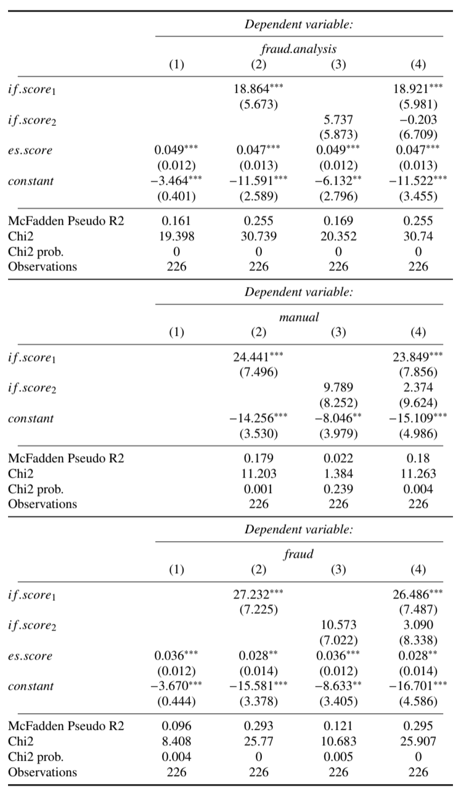
This table displays the logistic regression results for regressing f raud.analysis, manual, and f raud on i f.score₁, i f.score₂, and es.score in the case of collision between cars claims. The three sections of the table report results for f raud.analysis, manual, and f raud as dependent variables, respectively. The table reports standard errors in parentheses. ∗p<0.1; ∗∗p<0.05; ∗∗∗p<0.01
18
Table 4: Regression results - Predictive power of anomaly scores (other collision)
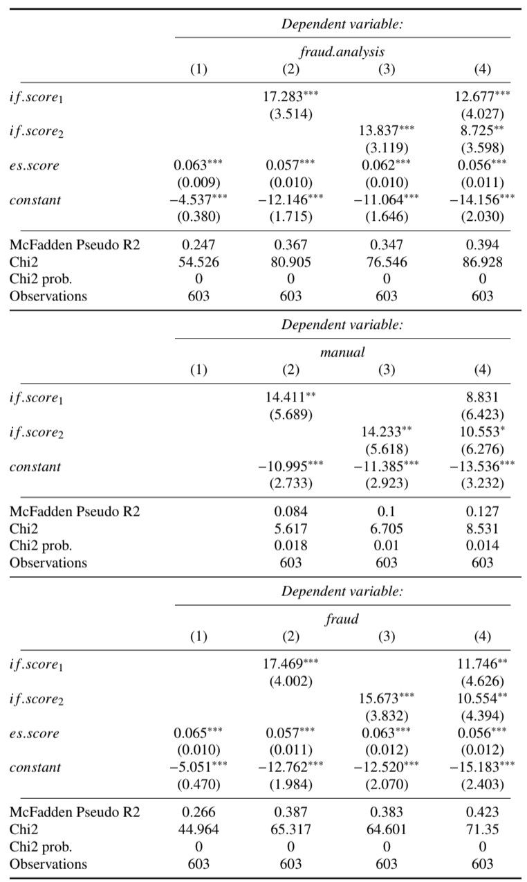
This table displays the logistic regression results for regressing f raud.analysis, manual, and f raud on i f.score₁, i f.score₂, and es.score in the case of other collision claims. The three sections of the table report results for f raud.analysis, manual, and f raud as dependent variables, respectively. The table reports standard errors in paren theses. ∗p<0.1; ∗∗p<0.05; ∗∗∗p<0.01

