Classical and Quantum Computing Methods for Estimating Loan-level Risk Distributions
Joseph L. Breeden
Deep Future Analytics LLC
Santa Fe, NM 87505
breeden@deepfutureanalytics.com
Eugenia Leonova
Deep Future Analytics LLC
Santa Fe, NM 87505
leonova@deepfutureanalytics.com
August 5, 2021
Abstract
Understanding the risk distribution for a single loan due to modeling and macroeconomic uncertainty could enable trule loan-level pricing. To implement such analysis, rapid real-time methods are required. This ar ticle develops a Monte Carlo method for estimating the loss distribution on classical computers. For this analysis, multihorizon survival models incorporating the competing risks of default and pay-off were created on Freddie Mac data. The Monte Carlo simulation results fit well to a Log normal distribution. Knowing in advance that a lognormal distribution is a reliable fit means that only tens of Monte Carlo simulations are needed to estimate tail risk in a single account forecast.
We also explored the feasibility of using quantum computers that may be available in the near future to perform the calculations. Leveraging previous quantum algorithms for value-at-risk estimation, we show that a simplified version of the problem has potential for significant speed en hancement, but the full competing risks approach will require additional quantum algorithm development to be feasible.
Keywords: Multihorizon Survival Model, Monte Carlo Simulation, Quantum Monte Carlo Simulation, Value-at-Risk
1 Introduction
When underwriting and pricing new loans, both consumer and commercial, the current best practice is to use forward looking lifetime loss, payment, and yield projections using macroeconomic scenarios. Admittedly, most of the industry is
1

not yet up to this best practice standard, but even the best practice ignores the account-specific uncertainty in these forecasts. Uncertainty in the future loan performance is left to economic capital calculations for the lender, or in best cases the product or perhaps major product segment. Account-level estima tion uncertainties are not being used for estimating account-level loss or yield distributions.
Account-level pricing cannot happen without account-level estimation of un certainty. We believe the future of the lending industry is in using both the expected forward-looking forecast for a prospective loan and the distribution of uncertainty about that estimate. In this paper, we develop a method to es timate this distribution using Monte Carlo simulation on classical computers and explore how this can potentially be done faster on the quantum computers that will be available within a few years. The current hype around quantum computing is that it ”will make everything run faster”. That is both untrue and irrelevant if the task at hand is offline, such as model development. For the lending industry, the greatest contribution of quantum computing may be in providing the real-time computation needed to facilitate true account-level underwriting.
Loan applicants can vary widely in their uncertainty. Two consumers with equivalent bureau scores could have very different performance uncertainties because of differences in the breadth and length of history available. Lenders often attempt to control for this by establishing a ”credit box” where they set boundaries within which they will originate loans beyond a simple range on their credit score. This credit box approach serves largely to control for the uncertainty where the credit score does not capture the tail risk of the loans. The difference between success and failure for a lender can be in developing a practical understanding of where their underwriting models are reliable and where they have excess risk.
The model developer has much of this needed information about forecast uncertainty, but it rarely gets expressed other than in model documentation for review by validators. Instead, the lending industry needs to move to an underwriting process where lenders have ready access to account-level risk dis tributions for lifetime loss and yield expectations. This would be equivalent to computing an account-level economic capital that could be used either to adjust loan pricing for uncertainty or to provide a quantitative approach to establishing the boundaries of the credit box for loan origination.
Creating a lifetime forecast of anything that incorporates macroeconomic scenarios necessarily means that each time step will have a separate forecast with its own prediction interval, prediction intervals being a combination of the confidence intervals of the model coefficients and the error in the fit to the historic data. If we focus on predicting the probability of default (PD), then the prediction interval about the forecast will not be normally distributed. Combining that with the complication of using a competing risks approach where the probability of attrition (pay-off) is simultaneously predicted means that error propagation cannot have a closed form solution, nor do we have a matrix algebraic solution that can be applied to discretized distributions.
2
Monte Carlo simulation is the best available solution to create the final distribution [17, 4, 14, 24]. At each time step, probability of default or attrite is drawn from their respective distributions at that time step and combined with all other time steps in order to gradually tabulate the final distribution. Although effective, combining the full forecast distributions through all the time steps of a lifetime forecast is computationally intensive. Modeling challenges aside, the computation time has historically been an impediment to predicting account level distributions for account decisioning. Speed issues are less important for such applications as estimating value-at-risk (VaR) at a portfolio level, but when employed for loan underwriting in a real-time environment, seconds matter.
Quantum computing is being promoted as the coming solution to compu tational speed limitations, but not all problems benefit or benefit significantly enough to matter when applied to quantum computers. Although few tests have gone beyond the proof-of-concept phase, the theoretical speed enhancements have been demonstrated in several areas. Several authors have demonstrated how quantum computing can be used in finance [32] with emphasis on option pricing [39, 27].
For building models, quantum-enhanced versions of support vector machines [35], deep neural networks [22], principal components analysis [27], and Fourier transforms [42] have all been demonstrated. In contexts of Big Data analysis, model development speed matters.
Although interesting, credit risk model development is a slow, tedious pro cess with many layers of review. The process is slow by design in order to minimize model risk around critical forecast failures, fair lending compliance, auditor acceptance, etc. In a process that often spans years from data col lection to deployment or months at the most nimble FinTechs, faster model development may not have much impact on the industry. Our goal is to use quantum computing to run the models built with classical computers, replacing the Monte Carlo simulation with methods based in quantum computing that can deliver the needed speed increase for real-time use. In this article we explore how this could be achieved and provide insights on how to optimize the classic computation version as well.
This article starts by building multihorizon survival models [9] of the prob ability of default (PD) and the probability of pay-off, a.k.a attrition, (PA) on publicly available Freddie Mac mortgage data. In developing the models, we are careful to follow the kind of rigorous development process expected by val idation teams, with all confidence intervals captured. The future environment is simulated with a second-order Ornstein-Uhlenbeck process [41, 10], like one might do for an economic capital calculation or lifetime loss reserves under IFRS 9 Stage 2 [23] or FASB’s Current Expected Credit Loss (CECL) [16].
Several sample accounts with diverse attributes were selected as test cases to be simulated classically via Monte Carlo simulation and then using quantum computing. This problem is actually beyond the capabilities of current quantum computers, so this is not a true head-to-head speed and features test, but rather a proof-of-principle to show how quantum computing can be employed in such a problem and what speed gains are expected relative to classical computing in
3

the coming years as hardware catches up to this application.
2 Data
Data was obtained from Freddie Mac for 30-year, fixed-rate, conforming mort gages. The data contained de-identified, account-level information on balance, delinquency status, payments, pay-off, origination (vintage) date, origination score, postal code, loan to value, debt to income, number of borrowers, prop erty type, and loan purpose. Risk grade segmentation was defined such that Subprime is less than 660 FICO, Prime is 660 to less than 780, and Superprime is 780 and above.
The data in this study represents more than $2 trillion of conforming mort gages. The data made available by Freddie Mac is a large share of their portfolio, but not the entirety.
3 Modeling Framework
Previous research has already built multihorizon survival models on Fannie Mae and Freddie Mac data [7]. That work was replicated here using the data de scribed in Section 2.
3.1 Multihorizon Survival Model
Multihorizon survival models combine the age, vintage, time effects of an Age Period-Cohort (APC) model [37, 28, 18, 6] with attributes common to behavior scores, such as delinquency, bureau scores, loan-to-value ratios, etc.
The target variables are probability of default (PD) and probability of attri tion (PA), a.k.a pay-off. Each of these probabilities is measured relative to the previous months’ active accounts in order to create a competing risks estimate [36].
_{P D(t) =} DefaultAccounts(t)
_{ActiveAccounts(t − 1)} (1)
_{P A(t) =} Pay − off Accounts(t)
_{ActiveAccounts(t − 1)} (2)
(3)
In this analysis, default is defined as any account that reaches 120 days-past due.
Loan performance can be described in an APC model as
_{log(}P D(a, v, t)
_{1 − P D(a, v, t}) = F(a) + G(v) + H(t) + (a, v, t) (4) 4
F(a), referred to as the lifecycle, measures the loan’s default risk as a func tion of age of the loan, a. The second function G(v) captures the unique credit risk of each vintage as a function of origination date, v. The function H(t) measures variation in default rates by calendar date t to capture environmental risks such as macroeconomic impacts.
These functions can be estimated via splines as in standard APC imple mentations or nonparametrically as in Bayesian APC [38]. Although nonpara metric estimation is appealing for the vintage and environmental functions, the Bayesian APC algorithms have proven to be less reliable when estimating confi dence intervals about these functions. Considering the importance of confidence intervals in the current work, we have chosen a spline estimation with coeffi cients and confidence intervals estimated by optimizing the maximum likelihood function.
Because the lifecycle, credit risk, and environment functions are summed, only one overall intercept term may be estimated. By convention, the estimates are constrained so that
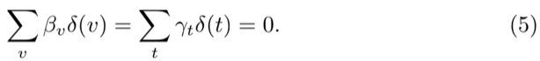
The relationship t = v + a also requires that an assumption be made about how to remove the linear specification error. Consistent with earlier work[8], this is accomplished using an orthogonal projection onto the space of functions that are orthogonal to all linear functions. The coefficients obtained are then transformed back to the original specification.
We know from the work by Holford [21] that once the constant and linear terms are appropriately incorporated, the nonlinear structure for F, G, and H is uniquely estimable.
When the data is prepared for APC estimation, accounts may be censored based upon the account having previously paid-off, also called attrition. The probability of attrition (PA) is modeled analogously to the probability of default
as
_{log(}P A(a, v, t)
_{1 − P A(a, v, t}) = F^{att}(a) + G^{att}(v) + H^{att}(t) + ^{att}(a, v, t) (6)
The functions obtained from APC analysis can measure vintage credit risk
but not explain it. Therefore, to enhance the usefulness of the model and to better predict default, origination and behavioral information are added to the formulation.
where s_{ij} (t₀) are the available attributes on the forecast snapshot date t₀ for account i. Such attributes include origination score, origination loan-to-value (LTV), and delinquency status, for example. The c_{jh} are the coefficients to be estimated. Vintage dummies are still included with coefficients β_{v} such that for a given v. To avoid colinearity problems between the APC and behavior scoring
5
components, the lifecycle and environment functions from the APC analysis, F(a) + H(t) are taken as fixed inputs when creating a logistic regression model in Eq. 7.
In Eq. 7, t = t₀ + h where h is the forecast horizon ∈ [1, N] where N is the end of the forecast. By including delinquency in the model, the coefficients c_{jh} will change with forecast horizon, just as seen in the structure of a roll rate model or as would result from iterating a state transition model. Therefore, one panel logistic regression model is estimated independently for each horizon h.
This approach was used to study root causes of the 2009 US Mortgage Crisis [8]
3.2 Mean Reversion
In a stress testing context, the environment function, H(t), would be correlated to macroeconomic factors [11]. That introduces a difficult-to-quantify uncer tainty around scenario generation. Since the goal here is to make the uncertain ties explicit and incorporate them into the forecasting process, we elect instead to use a mean-reverting process calibrated to the history of the environment function.
The solution to the 2nd order Ornstein-Uhlenbeck process can be written as
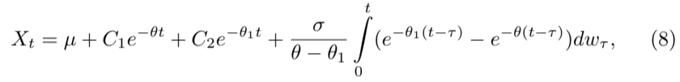

where w_{t} is the standard Wiener process.
The expectation values of mean µ_{t} and variance σ²_{t} of X_{t} are
µ_{t} = E(X_{t}) = µ + C₁e^{−θt} + C₂e^{−θ}₁^{t}; (9)
For the current problem, C₁ and C₂ are obtained as
δH(α) = H₀ − µ − σN⁻¹(α) (11)
C₁ = (δH(α) − exp(θ₁δt) δH(α))/(e^{θ δt} − e^{θ}₁^{δt}) (12)
C₂ = δH(α) − C₁ (13)
where N ⁻¹(α) is the inverse normal function.
Since X_{t} has a normal distribution, the cumulative distribution function of X_{t} is

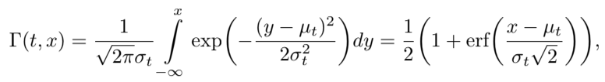

where
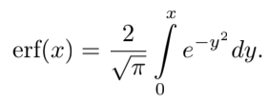
Let H_{t,α} be the solution of equation Γ(t, x) = α, i.e. Γ(t, H_{t,α}) = α. We get
H_{t,α} = µ_{t} + σ_{t}N⁻¹(α). (14)
4 Mortgage Model Estimation
The first step in the analysis was to create an APC model on the Freddie Mac mortgage default data. Then a multihorizon survival model was created with lifecycle and environment as fixed inputs from the APC decomposition. Lastly, a 2nd order mean reverting model was applied to the environment function.
4.1 APC Decomposition
Figures 1 and 2 show the APC decompositions for PD and PA respectively. The PD lifecycle follows the expected pattern for prime borrowers, wherein the risk of default continues to rise relative to active accounts even for later ages, because of a selection bias where the lowest risk borrowers will eventually refinance or move. The environment function, shown in units of log-odds of PD relative to the lifecycle, shows mortgage default peaks from the 2001 recession and 2009 recession. The vintage function, also in units of log-odds relative to the lifecycle, shows previous periods of risky loans being booked prior to the 2001 and 2009 recessions. Although the most recent vintages have less data, the dramatic rise in credit risk from 2018 to 2020 is ominous.
The decomposition for PA shows that pay-offs are rare in the first year of a mortgage, but rising quickly. By 24 months-on-books, PA slows but remains high. As a consequence of this pay-off rate, the average life of a 30-year mortgage is closer to 7 years.
The environment function for PA is more closely tied to changes in interest rates than recessions. Rising rates cause fewer refinancing opportunities whereas falling rates create more opportunities. For the vintage function, loans initially booked with higher interest rates are more likely to refinance later.
4.2 Score Estimation
To estimate the coefficients of the multihorizon survival model, a panel logistic regression model is created for each forecast horizon h with the previously es timated lifecycle and environment as fixed inputs as in Equation 7. This was done for h ∈ [1, 12], because the most dynamic period is the first six months, and the coefficients largely reach saturation levels by horizon 12. Table 1 has the coefficients for the full model estimated for probability of default, except the coefficients for vintage residuals which were a constant for all horizons and are shown in Table 2.
7
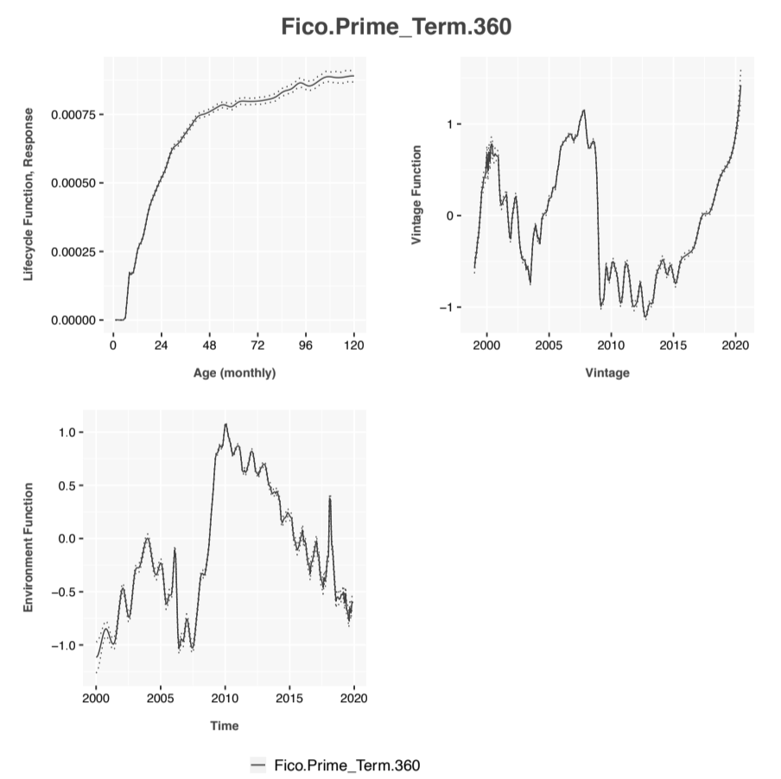Figure 1: An Age-Period-Cohort decomposition of the probability of default (PD) for 30-year Prime mortgage data from Freddie Mac.
8
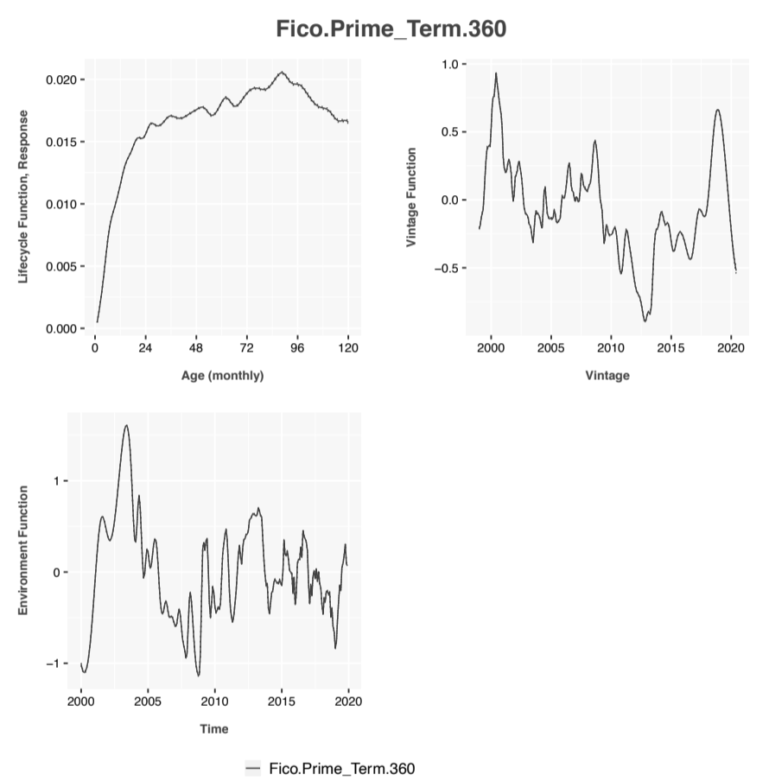Figure 2: An Age-Period-Cohort decomposition of the probability of attrition (a.k.a pay-odd) (PA) for 30-year Prime mortgage data from Freddie Mac.
9

Variable | H1 | H2 | H3 | H4 | H5 | H6 | H7 | H8 | H9 | H10 | H11 | H12
(Intercept)  Occupancy StatusP | −48245±02416 | −50121±02315 | −52877±02634 | −51176±0248 | −43878±01713 | −07497±01079 | −06421±01095 | −09159±01018 | −08389±01035 | −07934±01056 | −08013±01086 | −07454±01113
Occupancy StatusI | 0 | 0 | 0 | 0 | 0 | 0 | 0
Occupancy StatusS | 01856 ±  01121 | 03004 ±  00905 | 02084 ±  00795 | 01724 ±  0074 | 00892 ±  00734 | −0126±  00732 | −01968±0076
Orig Bal gte5 lt75 | −00278±01653 | −00527±01356 | −00971±01221 | −01425±01162 | −01869±01151 | −02728±01158 | −02872±01179
Orig Bal gte75 lt100 | 0 | 0 | 0 | 0 | 0 | 0 | 0
Orig Bal gte100 lt120 | −04334±01077 | −01944±00835 | −01375±00736 | −01898±00684 | −02589±00667 | −03101±00676 | −03213±00692
Orig Bal gte120 lt140 | −06894±01082 | −03615±00856 | −03028±0076 | −02586±00712 | −03 ±  007 | −03643±00702 | −03658±00719
Orig Bal gte140 lt160 | −06553±01129 | −04362±00888 | −02971±00795 | −02401±00749 | −02968±00731 | −04105±00736 | −04181±00753
Orig Bal gte160 lt190 | −06778±01192 | −02604±00966 | −02499±00857 | −0307±  00799 | −04186±00786 | −05699±00793 | −05672±00806
Orig Bal gte190 lt220 | −05869±01096 | −03489±00862 | −03007±00766 | −02499±00717 | −03753±00705 | −0515±  00716 | −05146±00731
Orig Bal gte220 lt265 | −05025±01145 | −01943±00911 | −01237±00808 | −00944±00755 | −01723±00741 | −03963±00751 | −04079±00768
Orig Bal gte265 lt330 | −06289±01108 | −01704±00891 | −01609±00787 | −01801±00736 | −02636±00723 | −04787±00734 | −0466±  00746
Orig Bal gt330 | −07677±01109 | −03891±00892 | −02689±00801 | −02328±00752 | −02958±0074 | −05444±00756 | −05493±00772
Number Of Borrowers1 | −05515±01061 | −01592±00842 | −01455±00747 | −00655±00691 | −01319±00677 | −04071±00701 | −04251±00717
Number Of Borrowers2 | 0 | 0 | 0 | 0 | 0 | 0 | 0 | 0 | 0 | 0 | 0 | 0
 | −02217±00526 | −02899±00438 | −03166±00396 | −03523±00375 | −03979±0037 | −05929±00374 | −06113±00381 | −06821±00379 | −07063±00386 | −07225±00395 | −07166±00405 | −0731±  00416
Delinquency0 | 0 | 0 | 0 | 0 | 0 | 0 | 0 | 0 | 0 | 0 | 0 | 0
Delinquency1 | 28012 ±  05502 | 31795 ±  04655 | 4231 ±  0379 | 48836 ±  03076 | 82587 ±  01508 | 35399 ±  00442 | 34937 ±  00435 | 32699 ±  00453 | 31437 ±  00467 | 29706 ±  00496 | 29484 ±  00511 | 27598 ±  00549
Delinquency2 | 44286 ±  05028 | 48737 ±  04185 | 65664 ±  03115 | 109798±02435 | 85854 ±  01544 | 4929 ±  00473 | 45586 ±  00524 | 42742 ±  00567 | 40018 ±  00625 | 38721 ±  00658 | 36908 ±  00726 | 34391 ±  0081
Delinquency3 | 57576 ±  04217 | 67822 ±  0306 | 122865±02591 | 103959±0247 | 95473 ±  01558 | 53004 ±  00646 | 48397 ±  00765 | 43757 ±  00912 | 39797 ±  01075 | 37824 ±  01175 | 37032 ±  01239 | 37436 ±  01208
Delinquency4 | 73972 ±  02999 | 128727±02249 | 11259 ±  02627 | 110995±02481 | 90933 ±  01709 | 46609 ±  01223 | 43839 ±  01342 | 39907 ±  01558 | 38228 ±  01654 | 32891 ±  02111 | 37283 ±  01724 | 34464 ±  01956
Delinquency5  Loan PurposeP | 137358±0231 | 116586±02295 | 115122±02664 | 99846 ±  02741 | 83607 ±  02271 | 39838 ±  02388 | 3851 ±  02456 | 38038 ±  02389 | 34039 ±  02802 | 38039 ±  02273 | 33881 ±  02805 | 35953 ±  02536
Loan PurposeC | 0 | 0 | 0 | 0 | 0 | 0 | 0 | 0 | 0 | 0 | 0 | 0
Loan PurposeN |  |  |  | −00866±00437 | 0157 ±  005 | 03619 ±  0051 | 03906 ±  0052 | 04015 ±  00527 | 03902 ±  00538 | 0399 ±  00551 | 04148 ±  00564 | 04047 ±  0058
LTV gt0 lt0 55 |  |  |  | 0026 ±  00404 | 01084 ±  00447 | 01362 ±  00459 | 01379 ±  00468 | 01204 ±  00473 | 01012 ±  00481 | 00955 ±  00493 | 00931 ±  00507 | 00694 ±  00521
LTV gte0 55 lt0 65 |  |  |  |  | 0 | 0 | 0 | 0 | 0 | 0 | 0 | 0
LTV gte0 65 lt0 7 |  |  |  |  | 01206 ±  0096 | 02125 ±  0097 | 02205 ±  00985 | 01851 ±  00991 | 01708 ±  01009 | 01696 ±  01028 | 01769 ±  01056 | 02006 ±  01082
LTV gte0 7 lt0 75 |  |  |  |  | 00312 ±  01048 | 02201 ±  01053 | 02251 ±  01071 | 01612 ±  01082 | 01601 ±  011 | 01337 ±  01131 | 01503 ±  01159 | 01404 ±  012
LTV gte0 75 lt0 8 |  |  |  |  | 01324 ±  00941 | 03172 ±  00946 | 03378 ±  0096 | 02806 ±  00966 | 02879 ±  0098 | 03025 ±  00997 | 03043 ±  01025 | 03076 ±  01057
LTV gte0 8 lt0 85 |  |  |  |  | 02191 ±  0086 | 04263 ±  00868 | 04377 ±  00882 | 03872 ±  00884 | 03865 ±  00897 | 03896 ±  00915 | 04039 ±  00939 | 03869 ±  00971
LTV gte0 85 lt0 9 |  |  |  |  | 02615 ±  00795 | 04787 ±  00803 | 04905 ±  00815 | 04291 ±  00819 | 0418 ±  00831 | 04087 ±  00848 | 04262 ±  00871 | 04343 ±  00897
LTV gte0 9 lt0 95 |  |  |  |  | 03153 ±  01033 | 06227 ±  01038 | 06267 ±  01059 | 05898 ±  01066 | 05971 ±  01083 | 06047 ±  01105 | 06005 ±  01141 | 06088 ±  01176
LTV gte0 95 lt1 |  |  |  |  | 04287 ±  009 | 07175 ±  00912 | 0743 ±  00927 | 07046 ±  00933 | 07226 ±  00945 | 07252 ±  00965 | 07573 ±  00989 | 08065 ±  01011
LTV gt1 |  |  |  |  | 06489 ±  00863 | 09709 ±  00872 | 10009 ±  00886 | 09594 ±  00886 | 09513 ±  009 | 09543 ±  00918 | 0963 ±  00945 | 09787 ±  0097
 |  |  |  |  | 0695 ±  00981 | 10583 ±  00987 | 10851 ±  01005 | 1011 ±  01009 | 10333 ±  01024 | 10565 ±  01043 | 10505 ±  01077 | 10915 ±  01105
ChannelB |  |  |  |  | 0 | 0 | 0 | 0 | 0 | 0 | 0 | 0
ChannelC |  |  |  |  |  | −0094±  00721 | −01099±00734 | −01079±00748 | −01012±00765 | −0103±  00783 | −01154±00806 | −01328±00825
ChannelR |  |  |  |  |  | −00112±00669 | −0018±  00681 | 00459 ±  00688 | 00581 ±  00704 | 00596 ±  00721 | 00652 ±  00741 | 00542 ±  00758
ChannelT |  |  |  |  |  | 01942 ±  00768 | 02523 ±  00783 | 04245 ±  00784 | 04987 ±  00802 | 0544 ±  00821 | 05768 ±  00843 | 06332 ±  00861

Table 1: Coefficients with 95% confidence intervals for the multihorizon survival model of probability of default. The columns H1 through H12 refer to the fore cast horizon. Reference levels for binned variables are shown with 0 coefficients and no uncertainty.
10

Vintage | Coeff
1999 | 0
2000 | −01556 ± 01732
2001 | −0505 ± 01338
2002 | −04057 ± 01212
2003 | −03721 ± 01126
2004 | −02557 ± 01153
2005 | −01975 ± 01113
2006 | −03272 ± 01145
2007 | −03216 ± 01115
2008 | −04645 ± 01144
2009 | −05043 ± 0112
2010 | −05399 ± 01129
2011 | −04509 ± 01136
2012 | −06582 ± 01101
2013 | −04544 ± 01088
2014 | −03358 ± 01093
2015 | −03245 ± 0108
2016 | −00863 ± 01073
2017 | 02849 ± 01091
2018 | 07491 ± 01208
2019 | 13845 ± 06759

Table 2: Coefficients for the vintage dummies in the multihorizon survival model. These coefficients capture the residual structure not captured by the coefficients in Table 1.
An essential part of the later analysis is that all coefficients include 95% confidence intervals. When the forecasts are created for the simulations, the prediction interval is computed about the forecast. The prediction interval incorporates the coefficient confidence intervals and in-sample goodness of fit. The confidence intervals for the coefficients and final prediction intervals are assumed to be normally distributed in logit space.
The same process was followed for the probability of attrition, not shown here.
4.3 Environment Extrapolation
As described in Section 3.2, the environment functions were extrapolated using a 2nd order Ornstein-Uhlenbeck process. This was done instead of the common stress testing approach of correlating the environment functions to macroeco nomic factors. Examples of stress testing models for the environment functions from Fannie Mae and Freddie Mac can be found in [7]. The goal of this anal ysis is to consider all possible paths for computing a lifetime PD. Although a probabilistic model could in theory be applied to a stress test model rather than individual scenarios, that is significantly more difficult than going directly to a distributional approach.
Figures 3 show the 95% confidence intervals for the environment functions under an O-U process. 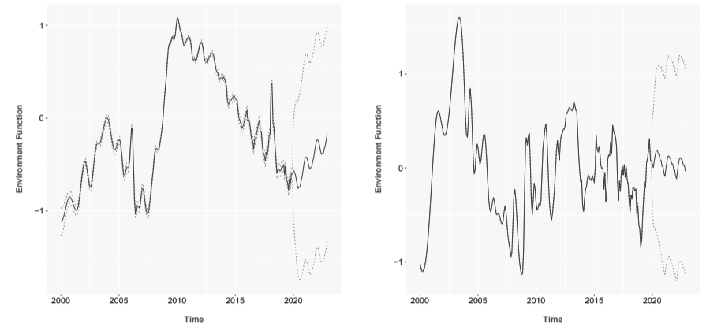
Figure 3: Extrapolations for the PD and PA environment functions using a 2nd order Ornstein-Uhlenbeck process with the 95% confidence bands shown as dashed lines.
12

4.4 Classical Monte Carlo Simulation
The forecast begins on a snapshot date t₀. Using information available for account i at t₀, we construct conditional distributions of the probability of default or attrition at each time t = t₀ + h where h is the forecast horizon.
In units of log-odds, all of the multihorizon survival model coefficients rep resent the mean of a normal distribution of the possible values for those co efficients. The values for the environment H^{ˆ} (t) generated from the Ornstein Uhlenbeck process are approximately normally distributed. Therefore, the con ditional probability density functions can be expressed as
Lifecycle : F(a) ± ∆F(a) (15)
_{Environment :} _{H}^{ˆ} _{(t) ± ∆H}^{ˆ} (t) (16)
AccountRisk : s_{i}(t) ± ∆s_{i}(t) (17)
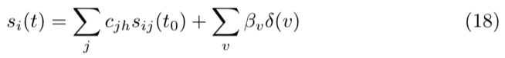
where a = t − v(i), v(i) being the account’s origination date. The account risk is obtained from the scoring component of the multihorizon
survival model as
and ∆s_{i}(t) is the confidence interval of the scoring prediction. Since all of the forecast components in Eqs. 15 to 17 are normally dis tributed, the combined forecast is normally distributed φ_{D}(t) = N (µ_{D}(a, t), σ_{D}(t)) where
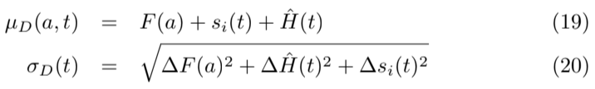
and the probability distribution ψ_{D}(t) for P D(t) will be a logit-normal distri bution [29]
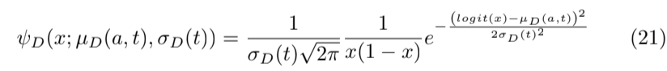
and the cumulative distribution function is

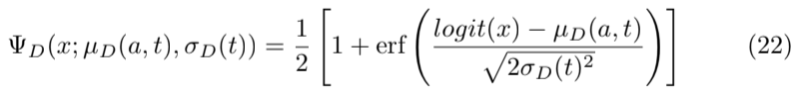
Similarly, we can obtain the distribution for the probability of attrition p_{A}(t) at each time t as Ψ_{A}(x; µ_{A}(a, t), σ_{A}(t)). The distributions ψ_{D}(a, t) and ψ_{A}(a, t) are conditional on the account not having defaulted or attrited in any previous t⁰, t₀ < t⁰ < t.
For the Monte Carlo simulation, the conditional probabilities of default and attrition, P D(a, t) and P A(a, t), are randomly sampled from ψ_{D}(a, t) and
13
ψ_{A}(a, t). To obtain the unconditional probability of default or attrition at time t, UP D(t = t₀ + h) and UP A(t = t₀ + h) are computed as
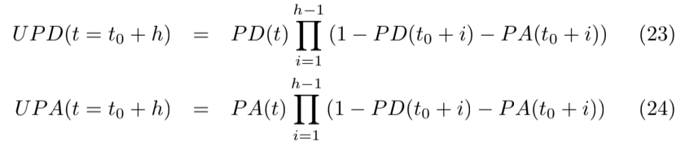
Eqs. 23 and 24 impose a normalization that P D(t₀ + i) + P A(t₀ + i) <= 1. The final goal of the analysis is to compute the lifetime probability of default LP D or attrition LP A as
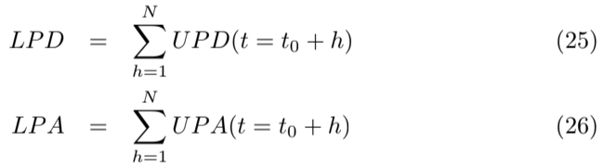
LP D and LP A represent samples from the distributions f_{D} and f_{A} of possi ble lifetime probabilities, where lifetime is defined as N steps into the future. To understand the shape of the distributions, we need to propagate the logit-normal distributions through the calculation of UP D and accumulation to LP D.
The Monte Carlo simulation continues for each iteration j to generate sam ples for the conditional probability of default P D_{j} (a, t) from Ψ_{D}(x; µ_{D}(a, t), σ_{D}(t)) and conditional probability of attrition P A_{j} (a, t) from Ψ_{A}(x; µ_{A}(a, t), σ_{A}(t)), which are processed via Eqs. 25 and 26 to produce the sampled values of life time default and attrition probabilities, LP D_{j} and LP A_{j} . The density functions f_{D} and f_{A} are then tabulated from these samples, although the primary inter est for this paper is f_{D}, since eventually all loans pay-off that did not default, LP A = 1 − LP D.
4.5 Classical Results
We ran a 36 month forecast from the last months-on-books of each account. Table 3 lists the loan attributes for four accounts specifically selected to have different risk profiles.
These accounts were predicted with the multihorizon survival model under Monte Carlo random samples from the prediction intervals, lifecycle confidence intervals, and environment function extrapolation intervals to produce the re sults in Figure 4. 10,000 simulations were run to produce the smooth distribu tions shown. Lognormal distributions are fit to each account estimate, showing very strong visual agreement.
For each of these test accounts, a Cullen and Frey plot [13] was created to compare the distributions to a range of known types. Figure 5 shows one such example. In each case, the Lognormal distribution was the best fit.
14

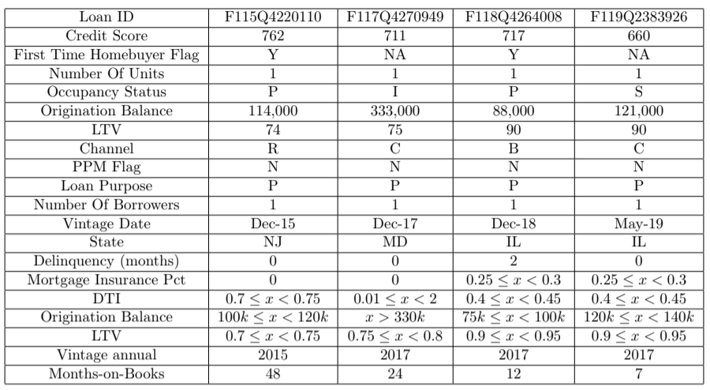

Table 3: Scoring attributes for four test accounts from the Freddie Mac dataset.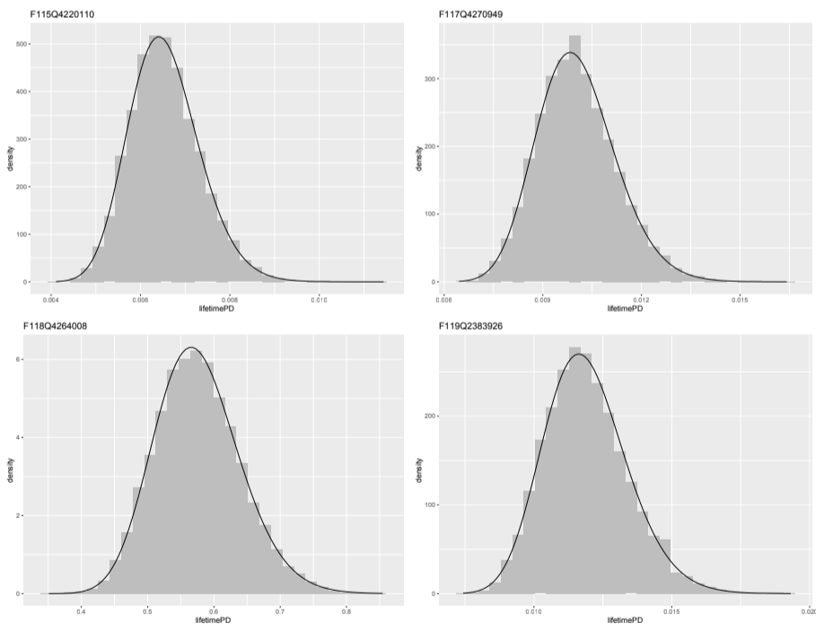
Figure 4: Distributions of the lifetime probability of default for the accounts shown in Table 3 tabulated from 10,000 Monte Carlo simulations with log normal fits overlaid.

Cullen and Frey graph 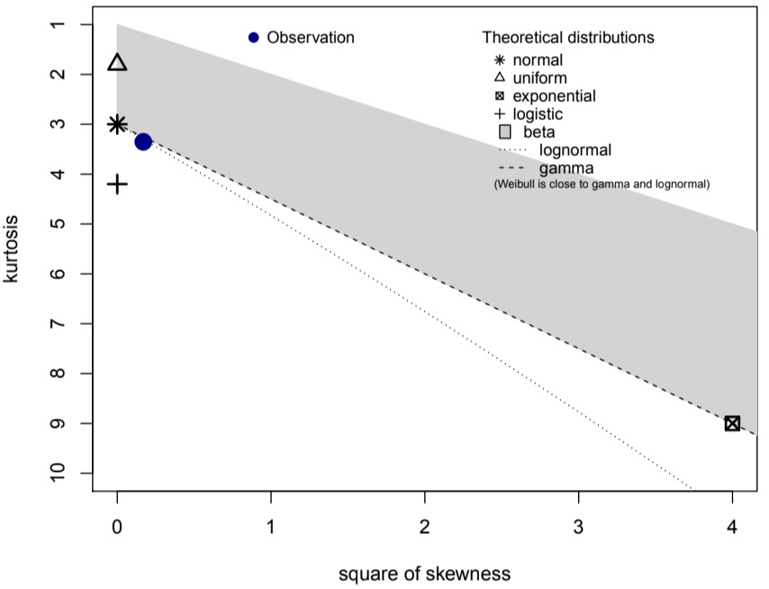
Figure 5: A Cullen and Frey plot comparing the data for account F115Q4220110 with a range of distribution types. The observed values lie on top of the log normal distribution line.
16

Table 4 provides three test statistics (Kolmogorov-Smirnov, Cramer-von Mises, and Anderson-Darling) for fitting Normal and Lognormal distributions to the simulated data [40]. The 5% critical values show that in every case, the Lognormal distribution was accepted, and the Normal distribution was rejected. This finding should be true as long as the probability of default is relatively low, so that the bound at LP D <= 1 is not approached. That is true for typical loan applications and mostly fails only for severely delinquent existing accounts.
Account | Distribution | Kolmogorov-Smirnov | Cramer-von Mises | Anderson-Darling
F115Q4220110 | Normal  Lognormal | 0.0245  0.0061 | 2.1697  0.0311 | 14.6173  0.2655
F117Q4270949 | Normal  Lognormal | 0.0266  0.0066 | 2.5913  0.0560 | 17.1901  0.4996
F118Q4264008 | Normal  Lognormal | 0.0302  0.0096 | 3.3810  0.1867 | 21.7311  1.3975
F119Q2383926 | Normal  Lognormal | 0.0253  0.0060 | 2.6618  0.0597 | 18.0056  0.5074
 | 5% Critical Value | 0.014 | 0.220 | 0.787

Table 4: Test statistics for the four test accounts. In each case, all three tests showed the Normal distribution to be rejected and Lognormal to be accepted.
The effectiveness of fitting these distributions with a lognormal distribution is important. If we know before running the simulation that a lognormal distri bution will be a good fit to the final distribution, we do not need thousands of simulations. Tens of simulations would be sufficient to estimate the mean and variance of the distribution in order to estimate the confidence interval about the forecast. When the number of Monte Carlo simulations was set to M = 50, only 1.9 seconds was required to estimate the distribution for an account.
5 Quantum Simulation
Every step of creating a forecast generates uncertainties. What we call a forecast is no more than the median (hopefully) of a distribution of all possible outcomes once we include everything we do not know or only know approximately. The Monte Carlo simulation used in classical computing is an attempt to tabulate that distribution piece by piece. Although the approach can be effective, it is notoriously expensive, so that practitioners never implement such systems in operational settings for lending.
The original motivation of this research was to determine if quantum com puting could be used to compute entire distributions instead of laboriously tab ulating them. The first things we discovered were that the competing risks approach outlined in Section 3 is deceptively complicated and would use far more qubits than will be available in the next couple years given current trends. Therefore, this discussion of how quantum computing could be applied is more theoretical than originally hoped, but we have managed to create a roadmap to the eventual solution.
5.1 Quantum Computing Basics
The basic computational unit for quantum computing is a qubit. As opposed to the 0 or 1 state of a classical transistor, each qubit represents a quantum system with an associated two-dimensional Hilbert space. The basis vectors of this space are written in the bra-ket notation of quantum mechanics as |0i and |1i, the x and y axes of our space. As a unit vector, qubits map easily
α
to discussions of probability, because given a vector β

, the probability of
obtaining either a 1 or 0 upon sampling the qubit is |α|² and |β|², respectively with the condition |α|² + β|² = 1.
To move beyond this weighted coin flip to encoding a full distribution, we use an m-qubit register[26]. Each individual qubit functions as above, but a set of qubits is used via a binary representation to encode 2^{m} sample points along the probability density function we wish to represent. The amplitudes of the
register serve to bin the probability.
α
For illustration, take m = 2. With two qubits β

and
γ δ

, the tensor
product creates four possible states
αγ αδ βγ βδ

. Written in bra-ket notation,
these states are |00i, |01i, |10i, and |11i with probabilities |αγ|²+|αδ|²+|βγ|²+ |βδ|² = 1. These four states can represent quartile sampling points along the probability density function. For greater computational accuracy, the number of qubits, m, is increased.
An important consideration for later, is that quantum registers cannot be copied the way a classical value is copied. If one of these m-qubit registers is replicated, the two registers will be independent of each other, producing different answers when sampled in the end. For conditional calculations as with Equations 1 and 2 where previous values must be remembered and reused, the quantum mechanical concept of entanglement is required[33]. Each time a quantum register is sampled, its quantum state is destroyed. With entangled copies, the samples will be identical and can be used in separate parts of the calculation.
In classical implementations of Monte Carlo simulation, the goal is to sample from all possible combinations of the relevant variables with probability given by the joint probability distribution. In quantum computing, that joint distri bution can be created by superimposing those distributions. In a case of two distributions u and v, the superposition is written as |ui ⊗ |vi or in matrix no tation as uv^{T}. When we are considering a sequence of time steps t ∈ [1, N], this leads to a N dimensional space.
As a general rule of thumb, if the final answer can be represented as a sin gle expression in matrix algebra, quantum computers can operate on this N dimensional space extremely rapidly as compared to a classical Monte Carlo simulation. Unfortunately, the sum of samples from the N-dimensional super position of the N time steps is not the sum of the distributions. To find the final distribution for lifetime probability of default, a quantum algorithm for Monte

Carlo simulation is needed.
Ironically, one could think of the potential speed-ups of quantum computing as a return to the analog computing of pre-transistor computation. Modern computers discretized analog systems with high enough speed and precision that we forgot about analog computation. Being able to perform calculations on a qubit with a continuous probability of values between 0 and 1 harkens back to those analog computations.
For a more thorough introduction to quantum computing, see the appendices of Rebetrost, et. al. [34].
5.2 Quantum Computing with Unconditional Distributions
Before considering the full completing risks approach, let us consider a simpli fied version of the problem where the model is redefined from the conditional probability of default in Equation 1 to an unconditional estimation
_{P D(t) =} DefaultAccounts(t)
_{BookedAccounts(t = 0)} (27)
By modeling P D(t) as a fraction of booked accounts, the attrition probability is implicitly incorporated into the P D modeling.
P D(t) can be modeled with APC decomposition as was done before. How ever, the combination with behavior scoring as in the multihorizon survival approach is not available, because the panel logistic regression that is used to solve for the coefficients would need to include previously defaulted or paid-off accounts at every time step without censoring in order to preserve the denom inator as booked accounts. Those post-default or post-pay-off accounts would be undefined in terms of behavioral variables such as delinquency or utilization, so the regression becomes ambiguous. Even if behavioral scoring factors are excluded, this approach is less preferred, because correlating the P D(t) envi ronment function to macroeconomic factors becomes complicated as impacts from both default and pay-off are blended together. The overall result is sub optimal, but is found in use by some practitioners.
Nevertheless, this approach has the advantage in this context of making the distribution for P D at each time step t independent of the other time steps. So, assume that this was done, and we have a direct expression for UP D(t) at each forecast horizon t = 1, · · · N and a logit-normal distribution ψ_{D}(t) for which UP D(t) is the mean. A classical Monte Carlo simulation would randomly sample independently from the unconditional P_{D}(t) at each time step and sum them to tabulate the final distribution.
The works of Egger, et. al. [15] is directly applicable here. They created a quantum algorithm to run Monte Carlo simulations [30] for estimating value-at risk (VaR). Their problem assumed a weighted sum of loss distributions for a set of assets from which a risk level such as 99.9% would be measured. In our case, we have a single asset, but a set of time steps to be summed. Determining the confidence interval about this forecast is equivalent to a 95% VaR calculation.
19

Therefore, we need to design a quantum algorithm, A that can be represented with three components. Following the notation of Egger, et. al.:
• U Load the distributions UP D(t) onto N, m-qubit registers.
• S Sum the registers to a lifetime P D estimate.
• C Include a qubit for the condition that the value of the sum exceeds a test value x.
For operator U, the ability to load distributions efficiently into an m-qubit register is important and non-trivial. Grover’s algorithm [19] proves that any log-concave distribution [2, 20] can be efficiently loaded, which includes the exponential and normal families.
Our logit-normal distributions could be loaded efficiently as normal distri butions in logit space. An inverse logit-function could be applied to transform them to distributions in probability space, but the states of the qubit would no longer be uniformly spaced. That becomes a problem, because each time step t distribution would then have different measurement points.
The logit-normal distributions routinely found in models of P D can be closely approximated with lognormal distributions, as seen in Figures 4. Un fortunately, lognormal distributions are also not log-concave [3]. The normal distribution is the only log-concave distribution that provides a reasonable ap proximation to the P D distributions. So, we have a choice of inefficiently load ing the quantum registers or having a mediocre approximation to the original distribution.
Quantum computing algorithms for Monte Carlo simulation [25, 1], not to be confused with the ”Quantum Monte Carlo” [12, 31] used to simulate quan tum mechanical systems in physics and chemistry, have already been applied to problems in finance.
The quantum algorithm is defined as A = USC. To estimate expected values such as the 95% confidence interval, α, a Quantum Amplitude Estimation (QAE) algorithm is applied [5]. That approach creates a quantum operator Q(A) that accelerates the determination of an expectation value. (The full discussion of QAE is presented well in Brassard, et. al. [5] and Egger, et. al. [15].)
In the VaR application, an additional loop is created that estimates the probability for all outcomes less than a given value x. In our problem, x would be the confidence interval to significance α. A bisection search is conducted to find the smallest x such that the probability for a lifetime loss is less than α.
As described in detail by Egger, et. al., the key benefit to quantum comput ing comes from the speed gain in the QAE algorithm for obtaining expectation values. Every application of Q(A corresponds to one quantum sample. QAE allows us to estimate the confidence interval for α with an estimation error that
is bounded by
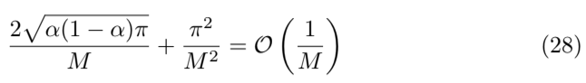

where M is the number of quantum samples. When compared to the O(1/√M) convergence rate of classical Monte Carlo methods [17], the speed increase is apparent.
Aside from speed, another feasibility consideration is the number of qubits required. For N time steps, the N separate UP D(t) do not need to be loaded simultaneously. The QAE algorithm can be performed in-place using a single m-qubit register. Other qubits are required for parts of the estimation, but a toy problem could be implemented on existing quantum computers.
Not considered here are the challenges with decoherence in current quantum computers and the efforts at quantum error correction. The results could be largely noise because of these issues, but hardware improvements are being made quickly. Algorithmically, a solution is possible.
5.3 Quantum Computing with Conditional Distributions
The quantum VaR work [15] considered the case of correlated asset distributions, but a competing risks model is more complicated. Considering just one step in the calculation, Equations 23 and 24 can be written as
S(t) = S(t − 1) · (1 − CP D(t − 1) − CP A(t − 1)) (29)
UP D(t) = CP D(t) · S(t) (30)
where t = t₀ + h refers to the forecast h time steps into the future. In the above equations, UP D(t) is the multiplication of two independent distributions. CP D(t) is the conditional default probability distribution for the current time step, and S(t) measures the probability that the account has sur vived to this time step. Although CP D(t) and S(t) are independent, S(t) is dependent upon all previous time steps, so the UP D(t) are no longer indepen dent as in the unconditional analysis of the previous section. A key issue in the competing risks framework is that CP D(t) is used twice: once to compute UP D(t) and again to compute S(t + 1). If we were to make a copy of the m-qubit register for CP D(t), the distribution would be preserved, but the two registers, the original and copy, must be perfectly correlated. The result is that the in-place register-saving calculations done for the summation in the previous step would no longer work. At each time step, two new registers for CP D(t) and CP A(t) must be loaded along with an entangled copy of the register for CP D(t).
Also, note that a register containing S(t) is used in calculation at every time step to compute UP D(t) and an entangled copy would be needed to compute S(t + 1). If at each time step a quantum multiply operator M can be used to compute S(t) and then replicated, the best case for the total number of registers needed for each quantum Monte Carlo sampling is 4N and the number of qubits is 4Nm. If we were simulating a five-year auto loan with an m = 8 qubit register allowing 2^{m} = 256 bins in the probability distribution, the number of registers is 240 registers and 1, 920 qubits. That far exceeds the number of qubits available for commercial applications over the next couple of years.
21
To make quantum computing plausible for the the competing risks case, an in-place algorithm is needed to compute the sum across time steps while carrying forward the adjustment for the probability of survival. One possible short-cut for both the unconditional and competing risks versions of the model is to know the shape of the distribution in advance. Just as this knowledge provides an advantage in the classical Monte Carlo simulation, that information may be used to optimize the quantum algorithm.
6 Conclusion
Model estimation uncertainties are rarely used in lending beyond validation, yet two loan applicants with the same modeled score could have very differ ent uncertainties depending upon the attributes that combined to create those scores. Although claims of loan-level pricing abound in the industry, prediction intervals and environmental uncertainties are almost never incorporated into underwriting and pricing decisions.
The goal of this work was to develop a framework using the best available forecasting models to create account-level distributions of lifetime probability of default, and to implement this in a framework that with the computational efficiency necessary to be part of a lender’s real-time decisioning. Testing the approach with a toy model would not have proven that a realistic model could be run fast enough to estimate the distribution. Our final run time using Monte Carlo simulation on a classical computer of 1.9 seconds is clearly fast enough for real-time use.
Although the model was complete, it covered only the lifetime probability of default. Incorporating balance dynamics, revenue, and expenses would be needed to get to an estimate of yield and uncertainty in yield. Adding those pieces may cause the distribution to no longer be a good fit to lognormal, in which case our classical Monte Carlo shortcut would not work.
When starting the project, we did not know that a lognormal approximation would be possible, so our starting assumption was that a full classical Monte Carlo simulation would be too slow for real-time use. To address that possibility, we wanted to look at the promise of quantum computing. Although the available hardware can only run simplified problems, rapid advances are being made, so it would not be premature to explore what will be possible with quantum computing in the next couple years.
To that end, we were also able to demonstrate that algorithms do exist for simulating a model that folds the estimation of probability of default and probability of previous survival (not previously defaulted or attrited) into a single model. Such algorithms should show a speed enhancement relative to classical algorithms on the order of the square root of the number of simulations needed.
Lastly, by going through this detailed exercise, we were able to show that the full competing risks simulation using currently available quantum algorithms requires a large number of quantum registers. That requirement pushes such
22

an approach several years into the future. Instead, further research should be conducted to determine if a quantum circuit can be developed to perform these calculations in-place with a relatively small number of qubits.
References
[1] Dorit Aharonov, Andris Ambainis, Julia Kempe, and Umesh Vazirani. Quantum walks on graphs. In Proceedings of the thirty-third annual ACM symposium on Theory of computing, pages 50–59, 2001.
[2] Mark Yuying An. Logconcavity versus logconvexity: a complete character ization. Journal of economic theory, 80(2):350–369, 1998.
[3] Søren Asmussen and Jaakko Lehtomaa. Distinguishing log-concavity from heavy tails. Risks, 5(1):10, 2017.
[4] K. Binder and D. Stauffer. A simple introduction to monte carlo simulation and some specialized topics. In K. Binder, editor, Applications of the Monte Carlo Method in Statistical Physics. Springer-Verlag, New York, 1984.
[5] Gilles Brassard, Peter Hoyer, Michele Mosca, and Alain Tapp. Quan tum amplitude amplification and estimation. Contemporary Mathematics, 305:53–74, 2002.
[6] Joseph L. Breeden. Reinventing Retail Lending Analytics: Forecasting, Stress Testing, Capital and Scoring for a World of Crises, 2nd Impression. Risk Books, London, 2014.
[7] Joseph L. Breeden. Living with CECL: Mortgage Modeling Alternatives. Prescient Models LLC, 2018.
[8] Joseph L. Breeden and Jose J. Canals-Cerd´a. Consumer risk appetite, the credit cycle, and the housing bubble. Journal of Credit Risk, 14(2):1–30, 2018.
[9] Joseph L Breeden and Jonathan Crook. Multihorizon discrete time survival models. Journal of the Operational Research Society, pages 1–14, 2020.
[10] Joseph L. Breeden and Sisi Liang. A mean-reverting model to create macroeconomic scenarios for credit risk models. Journal of Risk Model Validation, 9(4):1–12, 2015.
[11] Joseph L. Breeden and Lyn C. Thomas. The relationship between default and economic cycle for retail portfolios across countries: identifying the drivers of economic downturn. Journal of Risk Model Validation, 2(3):11 – 44, 2008.
[12] David Ceperley and Berni Alder. Quantum monte carlo. Science, 231(4738):555–560, 1986.
23

[13] Alison C Cullen, H Christopher Frey, and Christopher H Frey. Probabilistic techniques in exposure assessment: a handbook for dealing with variability and uncertainty in models and inputs. Springer Science & Business Media, 1999.
[14] Bruno Dupire. Monte Carlo: methodologies and applications for pricing and risk management. Risk, 1998.
[15] Daniel J Egger, Ricardo Garc´ıa Guti´errez, Jordie Cahue Mestre, and Stefan Woerner. Credit risk analysis using quantum computers. IEEE Transac tions on Computers, 2020.
[16] FASB. Financial Instruments Credit Losses (Subtopic 825-15). Financial Accounting Series, December 20 2012.
[17] Paul Glasserman, Philip Heidelberger, and Perwez Shahabuddin. Efficient Monte Carlo methods for value-at-risk. IBM Thomas J. Watson Research Division, 2000.
[18] Norval D. Glenn. Cohort Analysis, 2nd Edition. Sage, London, 2005.
[19] Lov Grover and Terry Rudolph. Creating superpositions that correspond to efficiently integrable probability distributions. arXiv preprint quant ph/0208112, 2002.
[20] Ramesh C Gupta and N Balakrishnan. Log-concavity and monotonicity of hazard and reversed hazard functions of univariate and multivariate skew normal distributions. Metrika, 75(2):181–191, 2012.
[21] T R Holford. The estimation of age, period and cohort effects for vital rates. Biometrics, 39(2):311–324, 1983.
[22] Wei Hu, James Hu, et al. Reinforcement learning with deep quantum neural networks. Journal of Quantum Information Science, 9(01):1, 2019.
[23] IASB. IFRS 9 financial instruments. Technical report, IFRS Foundation, 2014.
[24] Peter Jaeckel. Monte Carlo methods in finance. John Wiley and Sons, 2002.
[25] Julia Kempe. Quantum random walks: an introductory overview. Con temporary Physics, 44(4):307–327, 2003.
[26] Matthias Klusch. Toward quantum computational agents. In International workshop on computational autonomy, pages 170–186. Springer, 2003.
[27] Ana Martin, Bruno Candelas, Angel Rodr´ıguez-Rozas, Jos´e D Mart´ın- ´ Guerrero, Xi Chen, Lucas Lamata, Rom´an Or´us, Enrique Solano, and Mikel Sanz. Toward pricing financial derivatives with an ibm quantum computer. Physical Review Research, 3(1):013167, 2021.
24

[28] W.M. Mason and S. Fienberg. Cohort Analysis in Social Research: Beyond the Identification Problem. Springer, 1985.
[29] R Mead. A generalised logit-normal distribution. Biometrics, 21(3):721– 732, 1965.
[30] Ashley Montanaro. Quantum speedup of monte carlo methods. Proceedings of the Royal Society A: Mathematical, Physical and Engineering Sciences, 471(2181):20150301, 2015.
[31] M Peter Nightingale and Cyrus J Umrigar. Quantum Monte Carlo methods in physics and chemistry. Number 525. Springer Science & Business Media, 1998.
[32] Roman Orus, Samuel Mugel, and Enrique Lizaso. Quantum computing for finance: Overview and prospects. Reviews in Physics, 4:100028, 2019.
[33] Roger Penrose. Quantum computation, entanglement and state reduction. Philosophical Transactions of the Royal Society of London. Series A: Math ematical, Physical and Engineering Sciences, 356(1743):1927–1939, 1998.
[34] Patrick Rebentrost, Brajesh Gupt, and Thomas R Bromley. Quantum com putational finance: Monte carlo pricing of financial derivatives. Physical Review A, 98(2):022321, 2018.
[35] Patrick Rebentrost, Masoud Mohseni, and Seth Lloyd. Quantum sup port vector machine for big data classification. Physical review letters, 113(13):130503, 2014.
[36] Marek Rutkowski and Silvio Tarca. Regulatory capital modeling for credit risk. International Journal of Theoretical and Applied Finance, 18(05):1550034, 2015.
[37] Norman B. Ryder. The cohort as a concept in the study of social change. American Sociological Review, 30(6):843–861, 1965.
[38] Volker Schmid and Leonhard Held. Bayesian age-period-cohort modeling and prediction - bamp. Journal of Statistical Software, Articles, 21(8):1–15, 2007.
[39] Nikitas Stamatopoulos, Daniel J Egger, Yue Sun, Christa Zoufal, Raban Iten, Ning Shen, and Stefan Woerner. Option pricing using quantum com puters. Quantum, 4:291, 2020.
[40] Michael A Stephens. Tests based on edf statistics. In Goodness-of-fit Tech niques, pages 97–194. Routledge, 2017.
[41] G. E. Uhlenbeck and L. S. Ornstein. On the theory of brownian motion. Physical Review, 38:823 – 841, 1930.
25

[42] Yaakov S Weinstein, MA Pravia, EM Fortunato, Seth Lloyd, and David G Cory. Implementation of the quantum fourier transform. Physical review letters, 86(9):1889, 2001.
26

